4th semester 2006 Midterm 1 BS/Ethics Review
OUTLINE TOPICS ON EXAMS:
What I did: Here is the outline of the review. At the end of the review, is the complete review based on the outline. Good luck. I wish you the best.
50 questions:

40 behavioral science

25 BS made by Dr. Omar & 10 ethics Omar
Therefore 15 additional questions made by other professors.

Topics for medical ethics:
- most are in clinical case scenario i.e. USMLE step 1
- topics covered in 4 lectures:
  - are important: 5 lectures
- apply that knowledge in clinical scenario:
  - introduction:
    - general principle of ethics
      - read it and the primary principles of ethics: and special issues we discussed: i.e. abortion, pediatric cases
  - malpractice:
    - what you can do to decrease your chances in being involved in malpractice cases
      - hand writing, and communication
    - the 4 D’s associated with malpractice
      - duty: deviating the duty or dereliction and cause damage and directly b/c the PT deviated from his duty
      - damage
      - deviation
      - dereliction
        - if someone cases against doctor, the physician was deviating his duty, caused damage, and deviated against his duty
    - DONALD COWART: involved with 3rd degrees burnt: and withdrawal of life support: but physician imposed treatment and the court and the PT has the right for their treatment and can refuse treatment if they are well oriented and know the consequences and he is a practicing lawyer: and what the physicians did was wrong.
  - Importance of Hippocratic oath: apply those point and read from different sources,
    - JUST READ THE POWERPOINTS and apply them.
  - DISCLOSURE: Tuskegee case: about syphilis and PT African American not provided with treatment: and filed against class discrimination
  - Importance of regulatory bodies:
    - AMA: American medical association and licensing body and THEIR ROLE!!!
      - i.e. GMC, AMA, American psychiatry association
      - focus on AMA and state licensing body
  - ABORTION: when the PT has the right for Abortion, what is the significance of the 1st, 2nd 3rd trimester
Termination of pregnancy
1st trimester: PT has right for abortion, regardless of reason
2nd trimmest: have right of abortion if it is not endangering their life:
3rd trimester: abortion is illegal, unless continuation will cause some threat for the mother
before 21 weeks, PT can go for abortion
After 21 weeks, PT cannot have abortion
- this may be modified later on

  - Jehovah witness: SHOULD BE able to apply the information in clinical scenario: there were 4 or 5 examples: if they are wearing a bracelet or t-shirt: just read that.
  - ELEMENT OF CONSENT: of informed consent: prerequisites
  - Today we will cover two more cases:
    - ROE VERSUS WADE case
    - TYRELL DUECK case
Tyrel Dueck: 1999
- Parents refused medical treatment for 13 y.o.boy
- parents are in charged: GIVE THE treatment for the child,
- refer it to a court
- if you had this PT earlier: and the court decided earlier

ROE vs WADE:

-child may have meningitst: mom calls and says baby has meningitis: brief history of PT and symptoms, then maybe child may have meningitis:
meningoc cocus is important Neisir. Mengingitis and can cause skin rash:
- ask about skin rash and orientation of child and symptoms
- if life threating refer for emergency and do not advice for a RX
- if child needs emergency RX refer to emergency, you can ask for a follow up
- parents usually call 911, but if you are a family practitionare ask them to go to emergency

For behavioral science we will discuss those on Thursday; for BS

09-02-06 BS review tt1

There are 40 questions from BS:
What to focus on:
All 40 are not from topics, but most of them from the things I’m telling you: if you focus on this you’ll be alright

Doctor patient relationship: questions about what the right answer is to give patients and right response: briefly on history taking

KNOW THESE TERMS:
Transference:
counter transference
Illusion
delusion
hallucination
formation on how you would develop a rapport with your patient
what’s the meaning of these terms and significance of these terms: i.e. different types of dlusion and illusion and their significance

dr. gall: growth and development:
focus on developmental milestones: very important: interpret the age of the pt depending on the mile stone and the age and the findings and development of milestones

Tannis stage of development:: what stage has child reached: stage 1, 2 or 3: depending on findings of examination of extragenital: be able to differentiate the different stages

Learning theories and conditions:
Difference between operant and classical conditioning
Psychoanalytic theory and ALL THE DEFENSE MECHANISMS!!!
Should be able to differentiate: some examples and asked what defense mechanism is showing:
Then Freud’s theory: toprogialh and
Super ego, ego: what’s the difference between superego and ego,
What the difference is between conscious, unconscious
Differentiate between amnesia: i.e. mini status examination

Biological assessment of psychiatric PT’s:
Ie.. significance of CT scan, GCS (glascow scale) what are the scoring system:

Then aging death and bereavement:
Cobler Ross:
Stages of death and dying:
-she intervied many PT what the response wherei ie.. denial, anger, bargaining, how you would differnetiatewhether they are grieve or major depression and focus on the class i.e.major depression i.e. committing suicide and different between grieve and major depression.

How you manage a person or person: loved one died in family: what support you can provide for those circumstances

Gorss anatomy and biochemistr y and behaviour: focus on anaomtical difference based on gender: in CNS: if you do a CT scan: anatomically differences:
Maybe few neurotransmitters that play an important rule in psychiatry
-role of neurotransmitter

brain lesion: depending on portion of scar and cerebral hemisphere: i.e. frontal lobe lesion, parietal, or occipital lesion, what are the findings.

Mini mental status examination:
Mental status examination:

What is the significance of a MMSE: why do we do it? And what is the significance if it’s impaired…!!!

How do you differentiate between dementia and pseudodementia

Then sleep:
EEG is very important: asked what are the finding in different cases of sleep: REM, nonREM sleep what are the phases, what are the EEG finding?
What are th changes that do occur that correspond to the phases of the sleep: i.e. REM, PT may move eyelids: i.e. excitation of body, palpitations, bodily changes that occur

Pathology:
All the disorders discussed by DR. Gall: i.e. sleep disorders

You can leave CFS and Neurostamia:

I WILL BE SUCCESSFUL

NOW FOR THE REAL COMPETE REVIEW
Topics for medical ethics:
- most are in clinical case scenario i.e. USMLE step 1
- topics covered in 4 lectures:
  - are important: 5 lectures
- apply that knowledge in clinical scenario:

  - introduction:
    - general principle of ethics
      - read it and the primary principles of ethics: and special issues we discussed: i.e. abortion, pediatric cases
Definition of clinical ethics-

Clinical ethics is the systematic identification, analysis and resolution of ethical problems associated with patient care. Its goal includes protecting the rights and interests of patients, assisting clinicians in ethical decision making and encouraging co-operative relationships among patients and those close to patients, clinicians and health care institutions.

Introduction & principles
Medical Ethics
Course objective
• Intended to develop a knowledge base of
the basic legal & ethical principals which
govern practice in the USA.
• Review established legal parameters in US
court system & engage student in a personal
debate over issues which physicians face
daily.
• Issues: death,dying, end of life care, living
wills, power of attorney, malpractice
• Medical insurance & hospital based
committee which insure physician & patient
protection from abuse
• Series of cases reviewed which throughout
history have added to the practice
guidelines in place today
Defining clinical ethics
• Clinical ethics is an interdisciplinary
activity to identify,analyze, & resolve
ethical problems that arise in the care of
particular patients (Fletcher,1991)
• Jonsen(1998),LaPuma(1990)
Introduction
• A set of principles guiding a person in his/her
professional decision Making
• Moral is personal and Law is social; Ethics is
between the two
• Law prescribes restriction on behavior; Ethics is
enhancement of appropriate behavior
• What is legal not always ethical and vice versa
• Hippocratic Oath

Medical ethics
• More traditional term than CE
• Ambiguous though

• ME-May refer to rules of conduct of the
formal bodies of medical profession(AMA).
E.g. ethical dilemmas confronting Dr’s -like
decision on the point to cease life-sustaining
measures for dying patients
Clinical ethics
• Similarly, this term which is an outgrowth
of ME can refer either to uncontroversial
codes of conduct governing all clinicians or
to ethical dilemmas.

Advent of Medical ethics
• Hippocratic Oath- dates back around 2,500
yrs ago
• Historical purposes but not technically
binding
• Is for physicians- to guide behavior
• Graduations
I solemnly pledge myself to consecrate my I solemnly pledge myself to consecrate my life to the service of humanity;
I will give to my teachers the respect and gratitude which is their due;
I will practice my profession with conscience and dignity;
The health of my patient will be my first consideration;
I will respect the secrets which are confided in me, even after the patient
has died;
I will maintain by all the means in my power, the honour and the noble
traditions of the medical profession;
My colleagues will be my brothers;
I will not permit considerations of religion, nationality, race, party politics
or social standing to intervene between my duty and my patients;
I will maintain the utmost respect for human life from its beginning even
under threat and I will not use my medical knowledge contrary to the laws
of humanity;
I make these promises solemnly, freely and upon my honour.

Special Issues
• Physician- Patient sexual relationship
• AIDS risk/testing/etc.
• Advertising
• Fee Splitting
• DNR
• The impaired physician
• Resource allocation
• Conflict of interest
• Research related problems
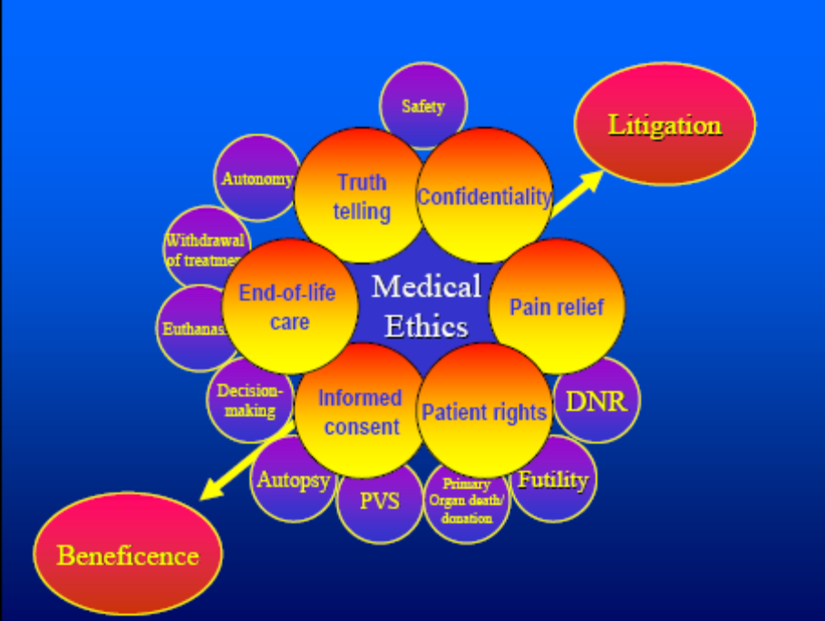
  - malpractice:
    - what you can do to decrease your chances in being involved in malpractice cases
      - hand writing, and communication
    - the 4 D’s associated with malpractice
      - duty: deviating the duty or dereliction and cause damage and directly b/c the PT deviated from his duty
      - damage
      - deviation
      - dereliction
        - if someone cases against doctor, the physician was deviating his duty, caused damage, and deviated against his duty
malpractice and 4 D’s associated with malpractice – Dereliction or negligence [i.e. deviation from normal standards of care], duty (established patient- physician relationship that causes damages), damage (i.e. injury), directly to the patient [i.e. the damages were caused by the negligence, not by another factor.

Legal Issue: Malpractice
Malpractice
•Definition
•Features/Facts
•Malpractice Insurance Crisis
•Consequences
•Solutions
•Avoiding Litigation
•Establishing a Duty of Care
•Emergencies & Non-Patients
•Medical Student Liability
Malpractice: Any deviation from accepted
medical standard of care that causes harm to a
patient.
(4 Ds) of Malpractice
•Duty
•Dereliction
•Damages
•Directly
Key Elements of Malpractice
1) Duty of care: Was there an established
physician-patient relationship?
• What actually creates a PPR– having seen
the patient? Scheduling the patient? Giving
advice about a patient who you’ve never
seen?
2) Dereliction of Duty (negligence): Was there
a deviation from the accepted medical
standard of care?
• need testimony from expert witnesses to
establish current medical custom (i.e., the
quality of care expected of reasonable
practitioners in similar circumstances)
• often must bring in expert from another
community (this can become expensive)
• ethical obligation to participate if asked
3) Damages: Was there harm to the patient?
4) Direct (causation):
Was the harm directly due
to the physician’s dereliction of duty?
(not all adverse outcomes indicate
malpractice— need to show that damages
resulted from negligence)
􀂾If any of 4 Ds are not proven, then there
is no judgment of malpractice.

Features/Facts of Malpractice Cases
Features of Malpractice cases
•malpractice is a tort (i.e., a civil wrong
resulting in personal injury)
•results in financial costs (not jail time):
• compensatory damages (including
actual costs & “pain and suffering”)
•& sometimes punitive damages.
•Malpractice cases are increasing
(more informed, less tolerant pts.)
•44,000-98,000 deaths/yr due to
medical mistakes
•Common reasons for suits:
•Improper dx, failure to dx or to
reveal dx
􀂃Surgical error
􀂃Lack of informed consent
􀂃Medication errors (wrong
prescription, dose, etc.)
1500 pts/yr with tools
Boston Globe Health
Columnist, died of
chemo OD, ‘94
•Surgeons, anesthesiologists & OBGYN
most accused of malpractice
•States are passing legislation to make
malpractice history public knowledge
National Practitioner’s Data Base:
Confidential list of suits that have
resulted in jury awards or $ settlements
Facts about Medical Malpractice Cases
•Time Involved: 1-2 years to resolve a case
•Typical Cost: $40,000-$75,000
•Mediation: A settlement conference often
occurring before a trial. Many cases are settled
out of court in this manner.
Medical Malpractice Insurance Crisis
•Rates have increased dramatically in the
last few years (rate depends on specialty and
location) – rates range from $5,000/yr to
over $200,000/yr.
•Due to:
•Large number of suits
•Large jury awards
•Example:
•Across the U.S.
•Median jury award in 1999 was $800,000
•45% of awards from ‘98-’99 were $1
million or more
Solutions to Crisis?
1) capping non-economic
damages to $250,000 (known
as “tort reform”)
• argument that still want ability
to award large sums if an
egregious error was made
(physicians are striking in various
states in protest of rising premiums–
hoping to catalyze tort reform) Jessica Santillan, heartlung
transplant patient
(wrong blood type)
•How to Avoid Malpractice Suits •Why do some patients sue after adverse
outcomes and other don’t?
􀂾Depends on the quality of the PPR
(communication and trust)
􀂾For an optimal PPR, physicians need to:
•Convey information at patient’s level of
understanding
•Check patient for understanding
•Show emotional affect (empathize)
•Follow-up (be available, keeping informed if
prolonged situation)
•Discuss problems thoroughly (explain why
adverse outcome occurred)
􀂾Honesty is supposed to reduce likelihood of
being sued
􀂾Important Note:
Documentation: Essential to demonstrate
that care was given. Defense cases are often
compromised due to inadequate
documentation (re: phone calls, consults)
􀂾“if it wasn’t documented… ”
•Example case: patient denied informed
consent about procedure, but medical records
had proof that sketch was given.
10
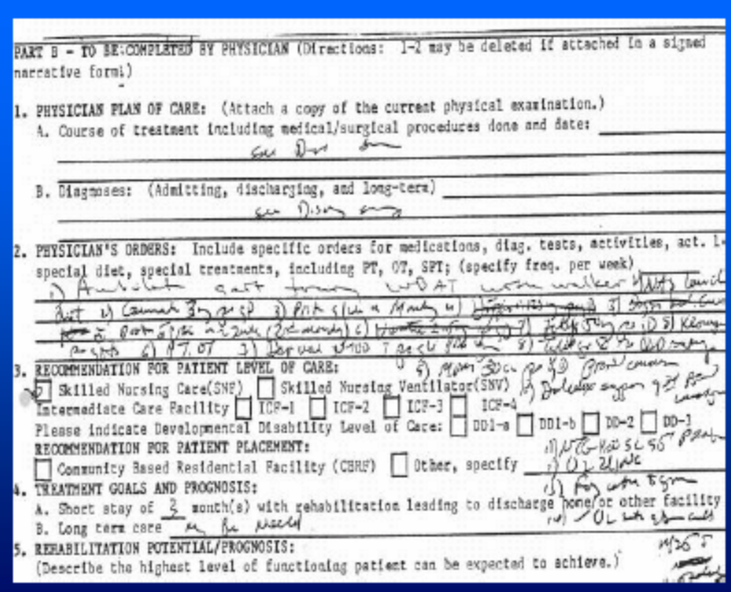
• Communication.
• Acronyms
• SOB
• MS
• Acronyms.
• FLK
• GOK
• OAP
• TF BUNDY
11
•Establishing a Duty: When does a
physician-patient relationship exist? •Do informal consults create a PPR?
•Case: Professor lectured to hospital-based
physicians and subsequently gave surgical
advice regarding patient
•professor sued treating physician and
professor for malpractice
•Was there a PPR with the professor?
•Court said NO
•No direct contact, no control over treating
physicians
12
•Courts have generally ruled that consulting
physicians are NOT liable for subsequent
harm, even if treating physician relied on
negligent advice of consultant.
(liability does exist if consulting physician
accepts a referral, writes orders, or
provides treatment to the patient)
•Does acceptance of a referral create a
PPR, even if physician never saw patient?
•Case: Physician saw pt in ER
•X-ray showed malignant neoplasm in knee
•Surgeon referred patient to orthopod but
didn’t tell patient the diagnosis
•orthopod was told the patient’s diagnosis and
accepted referral
•pt cancelled appointments (x3) and patient
refused to reschedule
• Pt died— malpractice suit filed by estate
•Was there a PPR with the orthopod?
•Court said Yes!
•PPR began when accepted referral and
scheduled patient
•How could have orthopod discharged his
duty?
13
•Does having a patient drop-in to your
private-practice office create a PPR?
•Case: man brings newborn baby with
respiratory problems into private practice
•physician refused care but referred to peds
hospital
•baby died, lawsuit followed
•Was there a PPR?
•Court said “no”
•“A physician is not to be held liable for
arbitrarily refusing to respond to a call of a
person even urgently in need of medical or
surgical assistance provided that the PPR
does not exist at the time.”
•Does a PPR exist with a patient who was
referred by a 3rd party for the examination?
(insurance companies, employers, Workers’
Compensation Boards)
14
•Case: Pt referred by insurance co. to internist
after woman applied for disability benefit
•Hilary mass on X-ray was found and reported to
insurer but not to patient (or patient’s
physician)– just employer.
•Did a PPR exist between the patient and the
examining physician?
•Court said No! Physician’s duty was only to the
agency that requested the evaluation.
•General: performing an exam at the request of a
3rd party generally does NOT establish a PPR.
•However, if a physician offers medical advice or
treatment beyond the scope of the 3rd-party
exam (thus acting as a physician with an
expectation of treatment by the individual), then
courts have found the physician liable.
•This trend is changing, as per more
recent court decisions in which PPRs are
considered to be established during 3rd
party examinations!!!
•ACTS THAT CREATE A PPR
15
PPR created when:
•scheduling or agreeing to see a walk-in patient,
even if done by staff
•accepting a referral, even if the patient fails to
show
•making any contact with a patient of another
physician for whom you’re providing coverageCont.:
•discussing your medical findings with or
providing records to a patient you’ve examined
on behalf of a 3rd-party
•providing an informal consult and your
managed care contract indicates that you have
a PPR with all enrollees
•if you bill patients for any service
•Suggestions
􀂾learn limits of responsibility when giving
advice to treating physicians (review
contracts!)
􀂾document nature of any consults (may
help to limit liability)
•Don’t assume because a court in one state
has ruled that a physician is not liable in a
particular situation that the court in other
jurisdictions will reach the same
conclusion. The outcome often depends
heavily on the facts of the specific case.
16
•Malpractice & “Non-Patient”
Emergency Cases
􀂾In most states, physicians are not required
to provide assistance, even in an emergency,
to a “non-patient.” However, Good
Samaritan Laws may protect those who do
help.
Good Samaritan Laws
•Laws that limit a person’s liability when
physicians help at an accident (some laws are
written to protect anybody who helps; others
are specific to physicians)
•Every state has its own adaptation of this law.
But, typically physicians are shielded from
liability if:
•there is no PPR
•actions are within the scope of physician’s
competence/confidence
•physician remains at scene after starting tx
until relieved by competent personnel
•no compensation exchanges hands
􀂾Cases from several jurisdictions in the
last few years have extended immunity to
physicians who voluntarily respond to
non-patient emergencies WITHIN the
hospital.
17
Saks Study
• A negligent doctor who causes injury has a
probability of sued of 3 out of 100.
• A non-negligent doctor has a probability of being
sued for a non-negligent injury of 13 out of
10,000.
• Thus, for every malpractice claim in response to a
negligent injury there are 15-30 malpractice
victims who bring no suit but there are 4-5 claims
brought by non-negligently injured patients.

    - DONALD COWART: involved with 3rd degrees burnt: and withdrawal of life support: but physician imposed treatment and the court and the PT has the right for their treatment and can refuse treatment if they are well oriented and know the consequences and he is a practicing lawyer: and what the physicians did was wrong.

• In the summer of 1973 Donald "Dax"
Cowart was critically injured in an explosion
in which his father lost his life. Dax was left
blind, with third-degree burns over more
than sixty-five percent of his body. Despite
his repeated demands that they be stopped,
Dax was ignored and forced to undergo
excruciating medical treatments and
surgeries for more than a year. In the end he
suffered severe disfigurement, the loss of his
fingers, permanent hearing loss, and
blindness.
Why have ethical guidelines for
clinical practice?
  - Importance of Hippocratic oath: apply those point and read from different sources,
    - JUST READ THE POWERPOINTS and apply them.

Hippocratic oath- I will prescribe regimens for the good of my patients according to my ability and my judgement and never do harm to anyone (euthansia). To please no one will I prescribe a deadly drug nor give advice which may cause his death. Nor will I give a woman a pessary to procure abortion.

Beneficiance (doing good) is closely associated with the traditional hypocratic obligation at least not to harm the patient, or the principle of nonmaleficence (doing no harm).

  - DISCLOSURE: Tuskegee case: about syphilis and PT African American not provided with treatment: and filed against class discrimination

Bad Blood: The Tuskegee Syphilis
Study
• For forty years, from 1932 to 1972, 399 African-American
males were denied treatment for syphilis and deceived by
officials of the United States Public Health Service.
• As part of a study conducted in Macon County, Alabama,
poor sharecroppers were told they were being treated for
“bad blood.”
• In fact, the physicians in charge of the study ensured that
these men went untreated. In the 25 years since its details
first were revealed, the Tuskegee Syphilis study has
become a powerful symbol of racism in medicine, ethical
misconduct in human research, and government abuse of
the vulnerable.
• Tuskegee Syphilis Study
• Compensation $10m(equivalent) in 1974
• Unethical cases- Therefore now have
Guidelines for Ethics Conduct of Biomedical
Research
Guidelines for Ethical Conduct of
Biomedical Research
• State recommendations guiding physicians
in biomedical research involving human
subjects.

Basic Principles of guidelines
1) Conduct only if benefit exceeds cost
2) Qualified scientists only
3)Informed consent obtained
4)Withdrawal at any time
In the US…...
National Commission for the Protection
of Human Subjects of Biomedical &
Behavioural Research -1974
• Consist of Internal/Institution Review
Board (IRB)
• Federally mandated councils
• Human clinical studies must elect these
committees to oversee all research.
• Composed of professionals, attorneys &
lay-people
• For protection of rights & welfare
• Prior approval needed for research
Problems with IRBs
• Lack training
• Overworked
• Conflict of interests
• No monitoring of IRBs

  - Importance of regulatory bodies:
    - AMA: American medical association and licensing body and THEIR ROLE!!!
      - i.e. GMC, AMA, American psychiatry association
      - focus on AMA and state licensing body
Medical Ethics
Regulations and Regulatory
bodies.
AMA Ethical Guidelines
• The American Medical Association
(AMA) publishes an ethics guide
for physicians
– Code of Medical Ethics: Current
Opinions with Annotations
– Standards geared to physicians, but
applicable to any health care
practitioner
AMA Ethical Guidelines
• Abortion
Encourage minors to discuss pregnancy
with parent(s)
Parental consent for an abortion is not
considered mandatory
Not prohibited if performed in a legal manner
and consistent with good medical practice
• Parental Consent
Abuse
• Spouses, Children, Elderly Persons,
and Others at Risk
Recommended intervention:
•suggesting abuse has occurred
•discussing safety methods available
•discussing community resources
•providing support
•documenting incident for future reference
Physicians should should know and abide by state
reporting laws - - report incidents even if not
required by law
Allocation, Cost and
Service Issues
• Allocation of Limited Medical
Resources
• Medical Futility in End-of-Life
Care
• Provision of Adequate Health
Care
• Unnecessary Services

Allocation, Cost and
Service Issues
Benefit to the patient is the physician’s
primary factor in determining resources
for medical treatment.
Medical treatment should not be provided
if, in the physician’s professional
judgment, the patient will not benefit.

Criminals and Capital Punishment
• Capital Punishment
• Treatment of Criminals
• Physicians should not participate in
legally authorized executions.
• Physicians may treat prisoners if
• treatment will benefit the patient
• informed consent is obtained
• treatment is for therapeutic purposes
(not punishment or social control).

Research-Related Issues
• Clinical Investigation
• Research should produce data that is
valid and significant
• Subjects should be treated with same
concern for health and safety as those
patients not in a study
• Physician-patient relationship must
• remain a priority
• Written consent must be obtained

Research-Related Issues
In addition to the clinical research
guidelines,
• Animal studies should be performed prior
to fetal research.
• Fetal material should not be purchased.
• Fetal Research

Research-Related Issues
• Patenting the Human Genome
• Gene Therapy
• Genetic Counseling
• Genetic Testing by Employers
• Insurance Companies and Genetic
Information
• Genetic Testing of Children

Research-Related Issues
Granting patent protection should not hinder
the development of beneficial technology.
Genetic manipulation to enhance desirable
characteristics is not acceptable.
Genetic counseling may be appropriate for
parents with increased risk for genetic
disorders.

Research-Related Issues
Genetic testing should not be used to
screen employees
Physicians should not perform genetic
testing for insurance companies to predict
a person’s predisposition for disease
Benefits for genetic testing of children
should outweigh the risks

Assisted Reproduction
• Artificial Insemination by Known
Donor
• Artificial Insemination by
Anonymous Donor
• Surrogate Mothers
• In Vitro Fertilization
• Embryos
– Frozen pre-embryos
• Human Cloning

Assisted Reproduction
Artificial insemination requires informed
consent.
Donor sperm must be prescreened for
infectious or inherited disease.
Surrogacy contracts should allow the birth
mother the right to void the agreement.
Gestational agreements should not be
voidable.

Assisted Reproduction
Fertilized ova not used for implantation
should not be used for research.
Both donors should provide written informed
consent before disposition of frozen embryos.
Physicians should not participate in human
cloning at this time.

Organ and Tissue Donation &
T• rCaonmspmlaenrtcaiatilo Unse of Human Tissue
• Financial Incentives for Organ
Donation
• Mandated Choice and Presumed
Consent for Cadaveric Organ
Donation
• Organ Procurement Following
Cardiac Death
• Organ Transplantation Guidelines
Organ and Tissue Donation &
Transplantation
• It is unethical to participate in a plan
that pays a donor for an organ to be
transplanted.
• A donor may be reimbursed for the
expenses incurred in removal of the organ.
• Physicians should encourage voluntary
organ donation.

Organ and Tissue Donation &
Transplantation
• Medical Applications of Fetal
Tissue Transplantation
• Anencephalic Neonates as
Organ Donors
Organ and Tissue Donation &
Transplantation
Safeguards should be taken so a decision to
have an abortion is not influenced by the
decision to donate fetal tissue.
Anencephaly is congenital absence of most
of the brain, skull, and scalp. Until
determination of death is made, lifesustaining
measures may be used to
maintain organ viability for transplantation.

Choices for Life or Death
• Withholding or Withdrawing
Life-Sustaining Medical
Treatment
• Euthanasia
• Physician-Assisted Suicide
Choices for Life or Death
Euthanasia or physician-assisted suicide
is not compatible with physician’s role
as healer and is considered unethical.
Physicians are committed to sustaining life
and relieving suffering. If there is a
conflict with these two objectives, the
patient’s wishes should prevail.

Choices for Life or Death
• Treatment Decisions for Seriously
Ill Newborns
• Do-Not-Resuscitate Orders
• Optimal Use of Orders-Not-To-
Intervene and Advance Directives

HIV Testing
• Encourage voluntary testing
• Testing may be performed without consent
when health care workers are at risk
because of exposure to body fluids.
• Publication of data from unethical
experiments should be provided only if
human lives could be saved or benefit
from findings.

  - ABORTION: when the PT has the right for Abortion, what is the significance of the 1st, 2nd 3rd trimester
Termination of pregnancy
1st trimester: PT has right for abortion, regardless of reason
2nd trimmest: have right of abortion if it is not endangering their life:
3rd trimester: abortion is illegal, unless continuation will cause some threat for the mother
before 21 weeks, PT can go for abortion
After 21 weeks, PT cannot have abortion
- this may be modified later on

  - Jehovah witness: SHOULD BE able to apply the information in clinical scenario: there were 4 or 5 examples: if they are wearing a bracelet or t-shirt: just read that.
Jehovah’s witnesses- patients reject blood transfusion so you must inform them of the real nature of her condition and the risks of not having transfusion……if they insist on alternative therapy, then try other nonsurgical invasive procedures or embolize the uterine artery. Another acceptable alternative is to collect autologous blood during surgical procedure rather than before, mix the blood with appropriate amount of crystalloid (NOT albumin) to maintain normovolemia and then reinfuse at end of surgery. If patient has cancer then granulocyte colony stimulating factor (GCSF) is used as adjunctive treatment to delay duration of neutropenia. In any case, avoid medical delay…..the patient’s right cannot be ignored however a physician may decide to refuse to administer the alternative treatment, so transfer to another physician.

  - ELEMENT OF CONSENT: of informed consent: prerequisites

- Informed consent- with exceptions of life threatening emergencies, physicians must obtain consent from competent, informed adult patients before proceeding with any medical or surgical threatment.

Informed consent- elements

Threshold requirement:- Competence (Determination of whether or not a patient has the capacity to either consent or refuse a proposed intervention )
Information requirement:- Information (Diagnosis, prognosis, risk of no therapy, outcomes), Understanding (How will the available options affect his or her life? )
Consent requirement:- Consent (The voluntary & uncoerced choice of the patient ) and Authorization (This takes place when an individual with the appropriate authority gives approval. It may also be done by patient or a representative of the patient)

Legal elements of informed consent:

–Discussion of pertinent information
–Obtaining agreement for plan of care
–Freedom from coercion

–PATIENT MUST UNDERSTAND RISKS, BENEFITS, AND ALTERNATIVES (INCLUDING NO INTERVENTION)

EXCEPTIONS TO INFORMED CONSENT
Patient lacks decision making capacity
Implied consent in an emergency
Therapeutic privilege- when a disclosure would severely harm the patient
Waiver-when a patient waives the right

Substitute decision maker- Durable power of attorney for health care (surrogate decision maker) and (healthcare agent), who has the authority to make virtually all medical decisions that the patient would have made were he or she able to express a preference. Eg in alzheimer’s disease, coma and psychiatric disorders (NOT including developmental disabilities and mental retardation, for those individuals have never been able to exercise their self determination). Parent are the presumptative decision makers for children……If evidence of abuse or neglect, court appoints a guardian eg social services commisioner…Unlike adoptive parents, foster parents do not automatically have decisional authority for children in their care.

Involuntary hospitalization- you can’t keep a patient longer than 3 days under psychiatry without consent…..after 3 days, should have court order.

Informed Consent
1.Is an ethical standard
2.Respect for patient autonomy
3.2Legal requirement
4.Is a process with several steps:
– Deontology: Ethical theory concerned with
duties and rights.
– utilitarianism
the theory that the rightness or wrongness
of an action is determined by its usefulness
in bringing about the most happiness of all
those affected by it.

Case
• A 32-year-old female is brought to the
ER with headache, nausea, vomiting,
and fever.
• On physical examination she is having
severe rigidity of neck.
• An LP was done which showed Gram
positive diplo-cocci.
• She was prescribed injectible antibiotics
which he refused.
Case
• She thinks that the nurse is trying to
poison her.
Case
• What is the medical indication for
treatment?
• Is this a life threatening emergency?
• What goals of medicine can be
achieved?
• Does he has the capacity to make
decision?
Informed consent
• Purpose
• Risk
• Benefits
• Alternative
Exceptions
• Emergencies
• Not competent
• Threshold requiremThreshold requirement
• Competence
• Information requirements
• Information
• Understanding
• Consent requirements
• Consent
• Authorisation
Legal elements of informed consent
• Threshold requirement
• Competence
The legal determination of whether or not a patient has the
capacity to either consent to or refuse a proposed
intervention
Appropriate criteria for determining competence is unclear
Once a person reaches the age of majority(18y.o-USA) it is
generally considered that they are competent
If competence is in doubt a physician may call upon the help
of a psychiatrist to determine competence
Legal elements of informed consent
• Information requirements
• Information
A patient is entitled to all the information available about their
case which may be pertinent to making a properly
informed decision about treatment.
Overt attention to cost of treatment by the physician may
indicate to the patient that there is a conflict of interest
Although financial information should be made available to the
patient if requested, it may not be the role of the
physician to provide this information
The desire to deliver information sympathetically should not
preclude the provision of all necessary information
The successful delivery of information may be facilitated by
involving the patients spouse or adult children in the
information process
Legal elements of informed consent
Has adequate info been provided to
pt?
3.2 sorts of information:
4.1)Professional Practice Standard- same
medical info given by all other
physicians e.g. appendicits.
5.2)Reasonable Person- Dr provides
enough info so reasonable person can
decide to consent RX. Pt can make
prudent decision
• Information requirements
• Understanding
A patient may not always be able to adequately understand
medical processes, and thus it may not be possible to fully
inform them of the exact nature of a specific course of
treatment – this draws into question the whole notion of
informed consent
Information should be conveyed in functional rather than
scientific terms so that the patient is at least able to
understand the principle of how a speciiffiic ttrreattment will
affect their life.
Written info/leaflets. Don’t ask,just give patient the leaflet.
Legal elements of informed consent
10
• Consent requirements
• Consent
The voluntary and uncoerced choice of the patient
Should involve deliberation and reflection based on
one’s own values
The effect overt and covert constraints and
facilitators, such as medication, mechanical
restraint, family pressure, financial pressure,
have on the patients choices should be
considered by the physician
Legal elements of informed consent
• Consent requirements
• Authorisation
The presence of a written declaration of consent will
not be ethically or legally valid if it does not
represent actual informed consent(clearly state
rx/side effects)
The verbal declaration of consent may be a valid,
even in the absence of a written document,
however, the latter usually supports the former
Witnessing the signing of a consent form does not
ensure that the patient has actually understood
the nature of their consent, only that they did
actually sign on the dotted line. Eg of consent
form:
Legal elements of informed consent
Emergencies
• What if not able to give consent in
emergency?
• Beneficence overrides autonomy in life
threatening case. Dr has right to rx in
this case without consent.
• Time is critical(VF-defibrillate)
• Incompetent pt without substitute
decision maker (transfusion/intubate)
Substitute Decision Makers
• Supports autonomy- Dr & family make
decision, not just Dr.
• Surrogate Decision Makers:
• 1)Legal guardian with express authority
to make health care decision
• 2)Adult child of the patient
• 3)A parent of the patient
• 4)Domestic partner
11
• 5)Brother or sister
• 6)Close friend
• If no friends/no family: Ethics
committee(2 DR’s consultation).
Decision based on substitute judgment
& best interest.
• Best interest Standard= quality of life
vs treatment If quality decrease
significantly ,is the rx best interest?
Involuntary Hospitalization
• Ethical justification- beneficence
overrides autonomy
• Standards-
– mental illness
– Dangerous: to others or self
– grave disability
Commitment Process
• 1)Application for admission
• 2)Examination
• 3)Court hearing
• 4)Right to least restrictive environment
• Physician detains 72hrs (hold until
judge says otherwise)
• Court Judge committs 60-90 days
• Then another hearing for reassessment
for further necessary hospitilization
• Note: hospitililization vs Treatment
– Not the same
– eg. 72hrs-court order for committing due
to danger. But if now pt refuses treatment,
then:
– Is pt competent to refuse treatment?
– Now another hearing takes place(wks…)
12
Case
“Do everything”: Physician obligations
in the face of family demands
• Evelyn, 86y.o. widow
• Dementia, severe ischemic
cardiomyopathy
• Nursing home,bedridden 1 yr
• Poor communication
• Recognize loved ones-uncertain
• SOB developed & increasing- Admitted
• Rxed for pneumonia & CHF
• Despite resolution of conditions,still
poorly- dypnea,tachycardia,bilateral
pleural effusions. EF=18%
• Thoracentesis-200ml fluid removed.
Tolerated well but no significant
improvement. Pulse ox^/sat rate= 70-
80% on O2
• Physician decides to speak with family
regarding resus status since poor short
& long term prognosis.
• Family want “everything done”
• Grandson dermatologist insists on
cardilogic & pulmonary consultation &
ICU transfer. Wants 2nd thoracentesis
to drain completely effusions.
• Requests chemical pleurodesis to
prevent fluid reaccumulation or drum
catheter inserted for withdrawal of fluid
PRN.
• Evelyn’s DR is hesitant. States fluid will
raccumulate & mechanical restraints
needed to keep devices in-situ.
Pleurodesis painful & unsafe
• Certain cardiac or respiratory arrest soon.
• CPR would fail. But if revived would face
uncomfortable few days on respirator.
• Family adamant. “nothing worse than death” Admit
Evelyn did not express RX wishes.
• ICU attending physician refuses to admit. States
family is crazy.
• ICU Dr advises Evelyn’s physician to not do ABG,
since poor result gives family more ammunition.
13
Medical considerations
• What is the prognosis for a pt with
advanced CHF who is 80yrs old?
• Has intractable,chronic CHF & class iv
sx of New York Heart Association
• Cardiac mortality highest in pt’s with EF
<20%. Increases with age.
• Medicare aged people CHF prognosis is
limited- 6yr survival= approx 13-25%
(ist hospitilization)
• Evelyn is very elderley, functionally impaired
& intractable sx of HF. Satisfies all National
Hospice Organization prognostic criteria for
early mortality in heart dz & has grave
prognosis.
• 2)What benefit could Evelyn derive if she
were admitted to an ICU?
• For chronic CHF has no benefit. No palliative
advantage to an ICU admission.
• Invasive rx,noisy monitoring devices,
frequent
• Monitoring & overall ICU environment
may reduce comfort level.
• NO CLINICAL BENEFIT
• 3)What would be the value of a drum
catheter or chemical pleurodesis?
• Procedure to prevent fluid accumulation
• Temporary & partial palliation prodused
but no long-term benefit in this
incurable illness.
• Painful procedure
• Better= drug management of HF & O2 nasal
cannula
• 4)What would be the rationale for performing
an ABG?
• To determine the need for intubation
• Supply important info about pt’s prognosis
• Will define how to proceed BUT reluctance in
Evelyn’s case because a poor ABG result
might fuel the family’s demands
14
What needs to be frankly defined with
the family?
• 1)Which interventions,if any provide
relief of sx’s or restoration of funx &
• 2)Which prolong her dying & in fact
may cause discomfort in the process
Ethical & Legal considerations
• 1)How should discussion proceed with
this family?
• Need meeting with key involved family
members & critical members of health
care team.
• Involved physicians explain objectively
& in understandable language the pt’s
current clinical status,short & long term
prog & options available for sx
management.
• Explain clinical experience has shown
that pt’s in Evelyn’s condition survive
few days-weeks only
• Clarify motivation behind family’s
demands(“everything be done”)
– Based on religion?
– Do they feel Evelyn would wish to be alive
for family occasion-wedding/birth?
– Explain their emotional needs may
obsecure best interest of pt
• Tell family directly, Evelyn is dying
regardless of rx rendered.
• Family role is to illuminate as best as
possible what Pt would want for herself
given her fatal condition. Role is not to
prevent her from dying.
• 2)Are the physicians obligated to follow
the demands of this family?
• Evelyn’s physicians are under no
obligation to eccede to either pt’ or
family demands
15
• For rx that is useless in the context of
the pt’s illness.
• Physicians can not be forced to provide
rx they believe is outside of the
accepted standard of care under the
circumstances.
• Accepted standard is derived from
physicians medical expertise & not from
personal value system
Jehovah’s witness
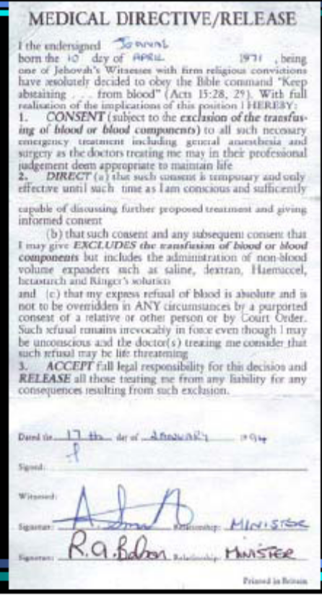Case of Catherine Shine
• 1999-USA
• Severe asthma
• Did not want intubation.
• Attendant intubated
• At approximately 7 A.M. on Sunday, March 18, 1990, twenty-nine year old
Catherine Shine arrived at the MGH emergency room seeking medical help for
an asthma attack. Catherine had been asthmatic throughout most of her life, a
condition she controlled through prescription medication. The daughter of a
physician, Catherine had educated herself about her condition and was well
informed about her illness. Her asthmatic attacks were characterized by rapid
onset, followed by a rapid remission. She had never required intubation in the
past. Earlier that morning, Catherine had suffered a severe asthma attack at
her sister Anna's apartment. Despite believing that her condition was
improving after using her prescription inhaler, Catherine agreed with Anna's
suggestion to go to MGH, but on the condition that she be administered only
oxygen. After Anna received assurances from an MGH representative that
Catherine would be treated with just oxygen, Catherine entered the MGH
emergency department, accompanied by Anna.
Catherine initially was given a nebulizer, a mask placed over her mouth which
delivered oxygen and medication. She complained to Anna that the medication
was giving her a headache, removed the mask and indicated that she wished
to leave the hospital. Catherine's behavior alarmed the nurse who was treating
her. An arterial blood gas test, measuring the levels of oxygen and carbon
dioxide in her blood, was drawn at approximately 7:15 A.M. The results,
obtained at approximately 7:30 A.M., showed that Catherine was "very sick."
Dr. Vega, the only emergency room attending physician on staff at MGH that
morning, examined Catherine and concluded that she required intubation.
Catherine resisted, and Dr. Vega initially agreed to try more conservative
treatment with the oxygen mask. Catherine continued to disagree with the
medical staff concerning her treatment.
• Anna, frustrated by what she felt was a medical staff
unwilling to listen to her sister, telephoned their
father, Dr. Shine, who was in England. Dr. Shine had
treated Catherine when she was a child and was
familiar with Catherine's condition. Dr. Shine spoke to
an MGH physician and told him that Catherine was
intelligent and "very well-informed" about her illness,
and he urged the physician to listen to Catherine and
to try to obtain her consent for any treatment. Dr.
Vega testified that he told Dr. Shine that Catherine
was in "the midst of an extremely severe asthma
attack," and that he unsuccessfully had tried to avoid
intubation. Dr. Vega testified that Dr. Shine asked
him to wait until he flew to Boston before intubating
Catherine. He also testified that he had made a
"conscious decision" not to tell Catherine that her
father had opposed intubation.
• Anna returned to Catherine's room to find her in a "heated" argument with the
MGH staff. Catherine's condition had improved somewhat, and she was able to talk
and to breathe more easily. At approximately 7:40 A.M., during a moment when
the doctors left Catherine and Anna alone together, Catherine told Anna to "run."
They ran down the corridor to the emergency room exit doors, where they were
forcibly apprehended by a physician and a security guard. Catherine was "walked
back" to her room where Dr. Vega immediately ordered that she be placed in fourpoint
restraints, in part because she had refused treatment and attempted to leave
the emergency room. Catherine and Anna were forcibly separated. Dr. Vega
initiated the process of having Catherine intubated. At approximately 8 A.M., the
results of a second blood gas test became available, showing that Catherine's
condition had improved somewhat. Dr. Vega testified that the results, even if he
had read them (he had not), would not have changed his decision to intubate
Catherine. At approximately 8:25 A.M., the intubation procedure commenced,
approximately forty-five minutes after Catherine had been strapped in four-point
restraints. Catherine never consented to this treatment. Dr. Vega testified that he
never discussed with Catherine the risks and benefits of intubation. Neither Anna,
who was still at the hospital, nor Dr. Shine was asked to consent to the intubation.
Catherine was released from MGH the following day.
17
• In this death case, we must resolve the conflict between
the right of a competent adult to refuse medical
treatment and the interest of a physician in preserving
life without fear of liability. Dr. Jose Vega, an emergency
physician at Massachusetts General Hospital (MGH),
initiated the intubation without Catherine's consent and
over her repeated and vigorous objections. In 1993, Dr.
Ian Shine, Catherine's father and the administrator of
her estate, brought a multi-count complaint against Dr.
Vega and MGH seeking damages for tortious conduct
and the wrongful death of his daughter.He alleged that
Catherine was traumatized by this painful experience,
and that it led to her death two years later. On that
occasion, Catherine again suffered a severe asthma
attack but refused to go to a hospital because, it was
claimed, she had developed an intense fear of hospitals.
Her father alleged that Catherine's delay in seeking
medical help was a substantial factor in causing her
death.
• At trial the defendants took the position that,
confronted with a life-threatening emergency,
Dr. Vega was not required to obtain consent
for treatment from either Catherine or her
family. A Judge in the Superior Court agreed,
and charged the jury that no patient has a
right to refuse medical treatment in a lifethreatening
situation. She also instructed that
in an emergency the physician need not
obtain the consent of the patient or her
family to proceed with invasive treatment. A
jury returned verdicts for the defendants on
all counts.
• The jury returned a verdict in favor of Dr. Vega and
the hospital, and Dr. Shine appealed.
• There is an emergency exception to the "informed
consent" requirement, said the Supreme Court. If it is
impractical to confer with the patient and a splitsecond
decision must be made in order to save her
life, consent is not necessary.
• To determine whether an "emergency" existed
sufficient to insulate Dr. Vega and the Hospital from
liability, the jury should have been required to decide
whether Catherine was capable of consenting to
treatment, and, if not, whether the consent of a
family member could have been obtained.
• In short, was there an emergency and did Catherine
have the capacity to consent?
• The Massachusetts Supreme Court therefore
disagreed with the trial judge's instructions and sent
the case back for retrial.

  - Today we will cover two more cases:
    - ROE VERSUS WADE case
- Roe vs Wade case- termination of pregnancy

Under Roe vs Wade, a woman in her 1st trimester of pregnancy, in consultation with her physician, has complete discretion as to whether or not to continue the pregnancy. She may have an abortion during this time for whatever reason she chooses. During the second trimester, as maternal risks from abortion increase, the woman’s right to obtain an abortion is accompanied by the interests of the state in protecting her health and well being, and thus ensuring that abortions are performed according to that goal. At this stage, the state has the right to decide depending on the situation, although the woman still has her fundamental rights to abortion. In the third trimester, the interests of the fetus which is approaching viability begins to take hold. A state can withhold abortion at this stage unless to save the life of the mother. Fetal viability is usually considered to occur at approximately the start of the third trimester, even if viability requires advanced medical attention or life support.
Most of these restrictions have been upheld by the supreme court, even while it still defines as fundamental the right of a woman to have an abortion.

ROE vs WADE:

-child may have meningitst: mom calls and says baby has meningitis: brief history of PT and symptoms, then maybe child may have meningitis:
meningoc cocus is important Neisir. Mengingitis and can cause skin rash:
- ask about skin rash and orientation of child and symptoms
- if life threating refer for emergency and do not advice for a RX
- if child needs emergency RX refer to emergency, you can ask for a follow up
- parents usually call 911, but if you are a family practitionare ask them to go to emergency

Ohio vs akron
Ohio vs. Akron involve parental notification as a requirement before an abortion is performed on a minor.
The issue of a woman's "fundamental right to an abortion," which is a key element sustaining Roe, may be reexamined by the Court.

Abortion
• Prior to 1970’s, there was restriction of
reproductive freedom.
• Roe vs Wade-1972
• Roe challenged anti-abortion law of
Texas (14th Amendment)
• Supreme Court supported Roe.
• Under Roe the following apply:
• 1st trimester- abortion legal (whatever
the mothers reason)
• A mother call in the middle of night…….
Mary Jane is upset because she was
turned away from her last scheduled
appointment with her doctor.
The Case
The Case, continued
Upon registration with the receptionist,
she was informed of the clinic’s “copayment
in advance” policy. Mary
Jane did not have money or her
checkbook with her.
The Case, continued
Even though she had a good payment
record, her physician refused a request
to make an exception to this policy.
The physician’s response to this request
was, “You take your checkbook with
you when you go to the grocery store
or gas station, don’t you?”
What Do You Think?
• Was the physician’s office acting in an
ethical manner?
• Why or why not?
• What legal implications could result
from this action?
Ethical Issues
• Physicians have an ethical duty to treat
sick and injured persons.
• Does this ethical duty reach to all
persons in every circumstance?
• What exceptions can you list?
Legal Issues
• There are often contractual agreements
with health plans preventing physicians
from waiving co-payments.
• It is illegal under Medicare regulations
to waive co-payments.
What the Experts Say
• The challenge is to strike a humane
balance between cost control and
genuinely needy patients.
• Exceptions should always be made for
patients who have urgent or emergent
symptoms.
What the Experts Say, continued
• Cooperative and creative solutions from
the office staff can result in positive
outcomes.
For example:
• Mary Jane did not appear needy; she
just needed to be informed of the policy
in advance and to be treated
courteously.
The Case
The patient was brought to the hospital
emergency room with a gunshot
wound to the chest.
Upon arrival, the nurse called the first oncall
surgeon on the list. He was at
another hospital with an emergency
and was not available to operate on this
patient.
The Case, continued
The nurse then paged the second
emergency physician on the list.
He returned the call but was
hesitant to come to the hospital.
He did not believe the first on-call
physician truly had an emergency
at another hospital.
The Case, continued
The nurse finally convinced the second
on-call physician to come to the
emergency room and minutes later he
was on his way.
The Case, continued
While the second on-call physician was
en-route, the patient was taken to
surgery.
The patient died a short time later, before
the physician arrived at the hospital.
A Suit Filed
The patient’s family sued the hospital, its
emergency nurses, and the physicians
for wrongful death.
What Do You Think?
• What legal term would describe why
the family would sue not only the
nurses, but the physicians and hospital
as well?
• What outcome would you expect from
this case?
The Initial Outcome
• All of those involved either settled with
the family out of court or were
dismissed from the complaint EXCEPT
the second on-call physician.
• The second on-call physician filed for
summary judgment on the ground that
he had no physician-patient relationship
with the patient and therefore no duty
of care.
What Do You Think?
• Do you think there was a physicianpatient
relationship? Why or why not?
• Did the physician owe the patient duty
of care in this case? Why or why not?
• Did the physician fulfill his ethical
obligations? Explain your answer.
The Court
The court granted summary judgment in
favor of the physician on the grounds
that there was no physician-patient
relationship.
The family contended that a duty of care
was established when the physician
agreed to come to the hospital to treat
the patient and appealed the case.
The Appeal
The summary judgment for the physician
was upheld for the following reasons:
• The physician never saw the patient.
• The physician never talked to the
patient.
• The physician never gave advice to
anyone in the ER about him.
Ortiz v. Shah, 905 S.W. 2d 609 (Texas Ct. of App., June
8, 1994: rehearing overruled Aug . 31, 1995).
The Case
A Boston physician has a patient who
has presented with changes in her
fibrocystic breast condition. The
patient’s insurance covers some
examinations for this condition, but
the patient fears an early-stage
cancer would be easy to miss if she
were examined at the frequency
allowed by her insurer.
The Case, continued
The patient states she cannot afford to
pay out of pocket for the extra
examinations that the physician
agrees are desirable.
The physician successfully got the
insurer to pay for the most recent
visit by coding it as an “evaluation for
breast mass” rather than as a routine
monitoring.
• The physician now wonders if this was
a correct way to handle this situation
and if it is wise to continue this
practice.
• Do you think the physician handled the
situation correctly? Why or why not?
• What recommendations would you give
this physician?
Legal Issues
• In general, physicians should avoid
chronic upcoding.
• A physician who knowingly states an
incorrect diagnosis or billing code on an
insurance form to obtain an
unauthorized level or kind of
reimbursement commits fraud.
Legal Issues, continued
• Major initiatives against fraud are under
way from both federal and private
health plans.
What penalties can be imposed on
physicians found guilty of fraudulent
billing?
10
Legal Issues, continued
• Penalties include
–Loss of participation in insurance
plans
–Fines
–Civil monetary penalties
–Imprisonment
Legal Issues, continued
• There may also be other negative
outcomes of miscoding.
– In a malpractice suit, a physician’s
dishonesty in coding can undermine
his credibility. This can occur even if
the upcoding does not directly relate
to the claim being litigated.
Ethical Issues
• Deliberate miscoding is dishonest and
potentially harmful in several ways.
– Mistrust between physicians and
health plans
– Mistrust between physicians and
patients
– Harm to patients
Ethical Issues, continued
• Mistrust between physicians and health
plans fuels a mutual gamesmanship
that ultimately makes it more difficult,
not easier, to secure the care a patient
needs.
11
Ethical Issues, continued
• Patients may develop the fear that a
physician who would openly lie for a
patient might also sometimes lie to
them.
Ethical Issues, continued
• Insurance dishonesty can also harm
patients, as in the following case of
Stafford v. Neurological Medicine,
Inc.
Stafford v. Neurological Medicine, Inc.
• Physicians performed a CT scan prior
to chemotherapy to determine if a
patient’s lung cancer had
metastasized to her brain. Believing
the insurance company would not
pay for a “screening” CT scan, the
physician entered a diagnosis of
“brain tumor” on the claim form.
Stafford v. Neurological Medicine, Inc.
• The patient was told the exam was
negative, but when she received a
statement from her insurance
company explaining the benefits
paid, she saw “brain tumor” under
“diagnosis” and became acutely
distressed.
The patient committed suicide.
12
What Should a Physician Do?
• Chronic upcoding is unwise, unethical
and illegal.
• What options do physicians have?
What the Expert Says
• Linda Emanual, MD, PhD, director of
the AMA Ethics Institute suggests
further investigation, combined with
some creative problem-solving.
• She outlines three areas for problemsolving
in this case...
What the Expert Says, continued
First,
• Establish a reasonable frequency for
screening for this patient.
• If anxiety is what prompts the patient
to request more frequent visits, then
more education and reassurance may
be in order. This could prevent
excessive screening.
What the Expert Says, continued
Second,
• Determine if there actually is a
reimbursement problem.
• Don’t assume you must upcode to
receive payment. Contact the insurer
and talk to someone who knows the
reimbursement system. More
documentation may be required, but
there may be reimbursement.
13
What the Expert Says, continued
Third,
• Find out what the patient means by
“can’t afford.”
– Today patients are accustomed to
first-dollar coverage and may believe
they should never have to pay for
medical care.
What the Expert Says, continued
If a physician’s charges are
comparable to other costs of
everyday living, then a decision not
to purchase extra medical services
may be just that -- a spending
decision.
What the Expert Says, continued
If this is the case, the patient should
be informed by the physician why the
exams are important and the
consequences of not having the
exams.
Payment plans may then be offered.
What the Expert Says, continued
• When costs present a true obstacle,
– A physician may discount her own
fees.
– A physician may wish to negotiate
discounted fees from other required
services, such as mammography.
14
Summary
• Physicians must recognize dilemmas
such as this cannot be avoided.
Patients’ needs are diverse and payers
must limit what they will cover.
• The challenge is not to bypass the
problem, but to live with it in morally
credible ways.
Ethics Forum, American Medical News, February 23,
1998.

    - TYRELL DUECK case
Tyrel Dueck: 1999
- Parents refused medical treatment for 13 y.o.boy
- parents are in charged: GIVE THE treatment for the child,
- refer it to a court
- if you had this PT earlier: and the court decided earlier

Tyrell Dueck- osteosarcoma- when the patient is a competent adult, there is legal mandate and moral obligation to involve him in decisions that affect his care. Patient involvement should also be a guiding principle for physicians who care for children. While parents are usually the integral part of the decision making process for a minor, it is essential for physicians to remember that it is the child who is their patient and to whom they have the greatest obligation., limb sparing surgery and intensive preoperative and postoperative chemotherapy have improved the outlook for many patients with osteosarcoma. Alternative treatment- DIALYSIS in anticipation of a possible kidney transplant and better health may be better for him than no future at all.

Substitute Decision Making
• Parents make decisions
• Based on best interest (not substituted
judgement)
• Extensive legal authority parents have
(not absolute)
• If not in “best interest” parental wishes
may be disregarded.
• Eg’s….
Examples of violating best interest
• Tyrell Dueck- 1999
• Canada
• 13 y.o. boy
• Bone cancer-Knee
• Parents refused medical/surgical rx (&
child agreed with parents)
• Want alternative rx/medicine(like
vitamins)
• Case evaluation by courts.
• Patient asked/evaluated understanding of medical
condition
• Father had not told truth to child & not explained
seriousness of cancer. Child was unduly influenced)
• Court ordered RX b/c best interest to rx & patient not
mature enough
• Due to parents & court delays cancer later spread to
lungs.
• Since 10% survival rate now, court said do what you
want.

For behavioral science we will discuss those on Thursday; for BS

09-02-06 BS review tt1

There are 40 questions from BS:
What to focus on:
All 40 are not from topics, but most of them from the things I’m telling you: if you focus on this you’ll be alright

Doctor patient relationship: questions about what the right answer is to give patients and right response: briefly on history taking
Behavioral Science
Doctor patient relationship and interviewing techniques.

Psychiatry History taking……
THE PSYCHIATRIC HISTORY
• The psychiatric history is the record of the patient's life; it allows a psychiatrist to understand who the patient is, where the patient has come from, and where the patient is likely to go in the future.

THE PSYCHIATRIC HISTORY
• The history is the patient's life story told to the psychiatrist in the patient's own words from his or her own point of view.
• The most important technique for obtaining a psychiatric history is to allow patients to tell their own stories in their own words in the order that they
feel is most important.
• A psychiatric history differs slightly from histories taken in medicine or surgery.
• In addition to gathering the concrete and factual data related to the chronology of
symptom formation and to psychiatric and medical history, a psychiatrist strives to
derive from the history the elusive picture of patients' individual personality characteristics, including both their strengths and their weaknesses.

Three Functions of the Medical Interview
• I. Determining the nature of the problem
• II. Developing and maintaining a therapeutic relationship
• III. Communicating information and implementing a treatment plan

Outline of the APA Practice Guideline for Psychiatric Evaluation
• INTRODUCTION
• I. PURPOSE OF EVALUATION
• A. General psychiatric evaluation
• B. Emergency evaluation
• C. Clinical consultation
• D. Other consultations
• II. SITE OF THE CLINICAL EVALUATION
• A. Inpatient settings
• B. Outpatient settings
• C. General medical settings
• D. Other settings
Outline of Psychiatric History
• Identifying data
• Chief complaint and Problem
• History of Present illness
– Onset
– Quantity
– Severity
– Aggravating and alleviating factor
– Associated manifestations

• Past illnesses
– Psychiatric
– Medical
– Personal developmental history
– Previous admissions, surgeries, accidents
– Allergies
• V. Personal history ( anamnesis )
A. Prenatal and prenatal
B. Early childhood (through age 3)
C. Middle childhood (ages 3–11)
D. Late childhood (puberty through
adolescence)
• Family history
• Ob/Gyn history
• Sexual history
– Sexually active
– No. of patners
– Male/female
– Contraception
– STD’s
• Social History:
– Smoking
– Alcohol (Cage questionaire)
• Need to cut down
• Feels angry due to criticism
• Feel guilty
• Need an eye opener
– Use of recreational drugs
– Work situation
– Home life

Psychiatric Questions:
• Source of unhappiness
• Support system
• Appetite and weight
• Daily routine
• Sleep pattern
• Interest/activities
• Concentration and memory
• Optimism/Pessimism
• Suicidal Ideation and Plan
• Abuse
• Delusion
• hallucinations
• III. DOMAINS OF THE CLINICAL EVALUATION
• A. Reason for the evaluation
• B. History of the present illness
• C. Past psychiatric history
• D. General medical history
• E. History of substance use
• F. Psychosocial developmental history (personal history)
• G. Social history
• H. Occupational history
• I. Family history
• J. Review of systems
• K. Physical examination
• L. Mental status examination
• M. Functional assessment
• N. Diagnostic tests
• O. Information derived from the interview process
• IV. EVALUATION PROCESS
• A. Methods of obtaining information
• B. The process of assessment
• V. SPECIAL CONSIDERATIONS
• A. Interactions with third-party payers and
their agents
• B. Privacy and confidentiality
• C. Legal and administrative issues in
institutions
• D. Evaluation of elderly persons
• VI. DEVELOPMENT PROCESS

KNOW THESE TERMS:
what’s the meaning of these terms and significance of these terms: i.e. different types of dlusion and illusion and their significance

Transference:
Transference
• generally defined as the set of
expectations, beliefs, and emotional
responses that a patient brings to the
doctor–patient relationship.
Transference reflects not necessarily
who a doctor is or how a doctor acts in
reality but, rather, what persistent
experiences a patient has had with
other important authority figures
throughout life.

TRANSFERENTIAL ATTITUDES.
• A patient's attitude toward a physician is apt
to be a repetition of the attitude he or she
has had toward authority figures.
• The attitude may range from one of realistic
basic trust, with an expectation that the
doctor has the patient's best interests at
heart, through one of overidealization and
even eroticized fantasy, to one of basic
mistrust, with an expectation that the doctor
will be contemptuous and potentially abusive.

counter transference
Countertransference
• Just as patients bring transferential attitudes
to doctor–patient relationships, doctors
themselves often have countertransferential
reactions to their patients.
• Countertransference may take the form of
negative feelings that are disruptive to the
doctor–patient relationship but may also
encompass disproportionately positive,
idealizing, or even eroticized reactions.

Countertransference
• Just as patients have expectations—such as
competence, lack of exploitation, objectivity, comfort,
and relief—physicians often have unconscious or
unspoken expectations of patients.
• Most commonly, physicians think of patients as good
when their expressed severity of symptoms
correlates with an overtly diagnosable biological
disorder, when they are compliant and generally do
not challenge the treatment, when they are
emotionally controlled, and when they are grateful.
• If these expectations are not met, physicians may
blame patients and experience them as unlikable,
untreatable, or bad.

delusion
What’s a Delusion?
• Fixed false belief, not culturally
sanctioned
• Inappropriate for level of education
– Ex. A High School graduate still believes in
the tooth fairy
• Incorrigibility: not altered with proof
to the contrary
• Preoccupies the patient
More on Delusions
• Egocentric: patient is center of events
• Range from implausible (unlikely but
non-bizarre) to impossible (bizarre)
– When non-bizarre, may need collateral
information to confirm or refute beliefs
Common Delusional Themes
• Persecution/Paranoia
• Passivity and Control, Reference
• Jealousy
• Grandiosity
• Hyper-religiosity
• Somatic
• Erotomanic
Persecutory Delusions
• These individuals tend to be
hypervigilant
• Fine line between Paranoid
Personality Disorder and delusional
paranoia.
13
Common Paranoid Themes
• Personal items have been stolen or
tampered with while patient is away
• Being poisoned or drugged
• Reputation has been ruined or maligned
• Being followed, monitored
Grandiose Delusions
• Impossibly great wealth, fame, power,
privilege, or ability
• Can have religious theme (special
connection with, or mission from God)
Grandiose Delusions
• Very self-referential, egocentriceverything
happening around them
must have something to do with them
• Narcissistic personalities are not
delusional- their self-proclaimed abilities
are within the realm of possibility
Delusions of Jealousy
• Unfounded conviction that spouse or
lover is unfaithful
14
Erotomanic Delusions
• Conviction that someone of higher
social status (often famous) is in love
with them
• Can be nuisance to public figures
• More often in women
Somatic Delusions
• Aka Hypochondriacal Delusions
• Examples include:
– Delusions of odor: patient is convinced they
smell foul
– Delusion of infestation
– Delusion of appearance (body
dysmorphism)
Delusions of Passivity or Control
• Thought Broadcasting
• Thought Insertion
• Thought Withdrawal
• Delusion of Control- submission to an
external controlling force
Delusions of Reference
• Ascribing personal meaning to
innocuous stimuli
• Often involves TV, newspapers, or the
radio delivering special messages for
patient
• Ideas of Reference: Same thing, but
not held with same conviction
15
Delusion vs. Overvalued Idea
• Overvalued ideas are similar to
delusions but:
– Held with less conviction
– Usually less absurd
• Beliefs become “overvalued” when they
preoccupy the person’s thoughts
– (ex. superstitions or magical thinking)

hallucination
Illusion
Perceptual Abnormalities
• Illusions
• Hallucinations
• Derealization/ Depersonalization
• Déjà vu, Jame Vu
Illusions
• Misperceptions of external sensory
stimuli
• Common manifestations of an “organic”
psychosis (due to a general medical
condition, substance; ex. delirium)
Hallucinations
• False sensory perceptions in the
absence of external stimuli
• In “primary” psychotic disorders (ex.
Schizophrenia), auditory hallucinations
are most common, followed by visual
• Hallucinations in other sensory
modalities are more suggestive of an
underlying medical cause or the effect
of an ingested substance
16
Hallucinations: Modalities in Summary
• Auditory
• Visual
• Tactile
• Olfactory
• Gustatory
Sensations of the unreal
• Derealization: A sense that the
outside world is unreal; dreamlike state
• Depersonalization: A sense that one
is disconnected from their physical
existence; as though observing oneself
from above or out of body
“Haven’t we Been Here Before?”
• Deja vu: Unrealistic familiarity with
novel situation or setting
• Jame vu: Sensation of novelty or
newness in a familiar situation or
setting

formation on how you would develop a rapport with your patient
History taking of psychiatry and psychiatric history?

- Establish rapport as early as possible, determine patient’s chief complaint
- Use chief complaint to develop a provisional differential diagnosis
- Rule various diagnosis possible out by using focus detailed questions.
- Follow up on vague or obscure replies with enough persistence to accurately determine answer to question.

- Psychiatric history is the record of the patient’s life; it allows a psychiatrist to understand who the patient is, where they have come from and where the patient is likely to go in the future.
- The patient is the patient’s own life story told the psychiatrist from the patient’s own mouth and his point of view.
- The most important technique to allow the patient to tell their own story in their own word. In addition to gathering this information, a psychiatrist should strive to determine patient’s strength and weaknesses.

The patient history is outlined as follows:

- Identifying data
- Chief complaint and problem
- Present illness (onset and precipitation factors)
- Past illness (Psychiatric, medical, alcohol or other substance history)
- Personal history (childhood, occupation, current living situation, marital status, religion etc)
- Sexual history.

Rapport
• Establishing rapport is the first step of a
psychiatric interview, and interviewers
often use their own empathic responses
to facilitate the development of rapport.

Rapport: Checklist
• Yes No N/A
• 1. I put the patient at ease.
• 2. I recognized the patient's state of mind.
• 3. I addressed the patient's distress.
• 4. I helped the patient warm up.
• 5. I helped the patient overcome suspiciousness.
• 6. I curbed the patient's intrusiveness.
• 7. I stimulated the patient's verbal production.
• 8. I curbed the patient's rambling.
• 9. I understood the patient's suffering.
• 10. I expressed empathy for the patient's suffering.
• 11. I tuned in on the patient's affect.
• 12. I addressed the patient's affect.
• 13. I became aware of the patient's level of
insight.
• 14. I assumed the patient's view of the
disorder.
• 15. I had a clear perception of the overt and
the therapeutic goals of treatment.
• 16. I stated the overt goal of treatment to the
patient.
• 17. I communicated to the patient that I am
familiar with the illness.
• 18. My questions convinced the patient that I am
familiar with the symptoms of the disorder.
• 19. I let the patient know that he or she is not alone
with the illness.
• 20. I expressed my intent to help the patient.
• 21. The patient recognized my expertise.
• 22. The patient respected my authority.
• 23. The patient appeared fully cooperative.
• 24. I recognized the patient's attitude toward the
illness.
• 25. The patient viewed the illness with distance.
• 26. The patient presented as a sympathycraving
sufferer.
• 27. The patient presented as a very important
patient.
• 28. The patient competed with me for
authority.
• 29. The patient was submissive.
30. I adjusted my role to the patient's role.
• 31. The patient thanked me and made
another appointment.

dr. gall: growth and development:
focus on developmental milestones: very important: interpret the age of the pt depending on the mile stone and the age and the findings and development of milestones

Developmental milestones table 1.5 and 1.6

2-3 months - smiles, coos (response to human attention), lifts head
4-6 months – turns over, sits unassisted, grasps with hand, forms an attachment to primary caregiver and recognizes familiar people
7-11 months – crawls, stands, transfers toy from one hand to another (10 months), grasps with finger, peek a boo, waves bye bye, shows stranger anxiety, responds to name, imitates sounds
12-15 months – walks unassisted, shows separation anxiety, says first word, object permanence.

1.5yrs - says own name, uses about 10 words, moves away from and then returns to mother (reproachment), scribbles on paper, throws ball.
2 yr – shows negativity (favourite word is no), plays alongside but not with another child (2-4ys), names body parts and objects, feeds self with fork/ spoon.
3yrs – rides a tricycle, has sense of self as male or female.
4yrs - has imaginary companions, has nightmares, curious about sex differences
5yrs – draws a person in detail, romantic feelings about opposite sex parent.
6yrs - Ties shoe laces, rides two wheeled bicycle, understands finality of death, copies a triangle.

Developmental Milestones
- Milestones are the history of a child from minute one to the present time; absence or delay signals potential abnormalities

- Just as important is achieving a milestone, then losing it.

- Areas of development: Physical, Motor, Language, Social, Cognitive
BIRTH
CHARACTERISTICS AND REFLEXES PRESENT AT BIRTH
CAPABILITIES OF INFANT PRESENT AT BIRTH
- REACHING AND GRASPING BEHAVIOR
- ABILITY TO IMITATE FACIAL EXPRESSION
- ABILITY TO SYNCHRONIZE THEIR LIMB MOVEMENTS WITH THE SPEECH OF OTHERS
- ATTACHMENT BEHAVIORS, SUCH AS CRYING AND CLINGING.
NEWBORN PREFERENCES
- LARGE BRIGHT OBJECTS WITH LOT OF CONTRAST
- MOVING OBJECTS
- CURVES VERSES LINES
- COMPLES VERSUS SIMPLE DESIGNS
- PRFERENCE FOR FACIAL STIMULI
- PREFERENCE FOR LANGUAGE STIMULI
INNATE REFLEXES

Blinking (Dazzle) Reflex
- Disappears by 1 year
- The eyelids close in response to bright light
- Absence – might be blindness
Acoustic Blink
(Cohleopalpebral) Reflex
- Disappears by 1 year old, but time is variable
- Both eyes blink in response to a sharp loud nose.
- Absence – might be hearing loss
Palmar Grasp Reflex
- Disappears at 2 – 3 months
- Place your fingers in babies hands
- The baby flexes all his fingers around yours
- Compare both hands
- Presence beyond 4 months – cerebral dysfunction
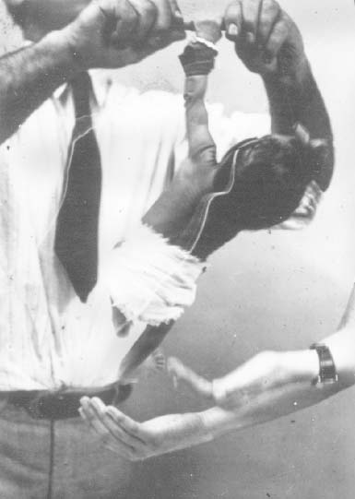
Rooting/ Sucking Reflex: child’s head turns in direction of a stroke on the cheek when seeking a nipple to suck
- Appears at 32 weeks
- Disappears at 3 – 4 months
- May be present longer during sleeping
- Stroke the perioral skin
- Baby will open the mouth and turn head on the side of stimulation
- Absence – severe generalized or central nervous system disease

Trunk Irritation
(Galant’s) Reflex
- Disappears at 2 months
- Hold baby horizontally in one hand
- Stimulate baby’s back by moving fingers along the paravertebral line from the shoulders to the buttocks.
- Baby curves his back forward
- Absent – transverse spinal cord lesions or injuries.
Placing/ Stepping Response
- Disappears at 2 months
- Hold the baby upright from behind
- Allow the dorsal surface of the foot to touch the undersurface of the table
- The baby flexes hip and knee, opposite foot steps forward. The baby makes few “steps”
- Absence – paresis, babies from the breech delivery.
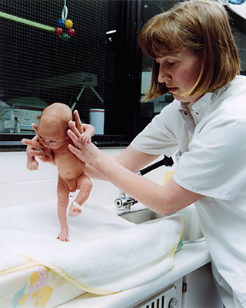
Rotation Test Reflex
- Disappears at different time
- Hold the baby under axillae
- Turn him in one direction and then other
- The head turns in the direction in which you turn the baby
- If you restrain the head with your fingers, the baby’s eyes will turn in the direction in which you turned.
- Abnormal – vestibular dysfunction.
Tonic Neck Reflex
- Appears between birth and 2 months
- Disappears at 6 months
- The baby is supine
- Turn the head on one side
- The arm and leg on the side to which the head is turned extend, opposite side flexed
- Persisting after 6 months old – cerebral damage
Tonic Neck Reflex
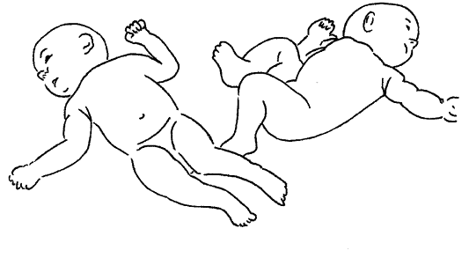
Crawl Reflex
- The baby lies on his abdomen
- Flex his knee and hips
- Place your hand to his feet.
- The baby pushes forward – “crawls”
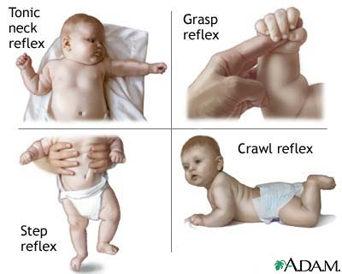
Moro Reflex
- Disappears at 4 months
- Hold the baby and suddenly move your hands down
- The arms abduct and extend with hands open and fingers extended, the legs flex. The arms return forward, the baby cries
- Persistence after 4 months – neurologic disease
- Asymmetric in arms – hemiparesis, brachial plexus injury, fracture
- Absence of the leg response – low spinal injury, congenital dislocation of the hip
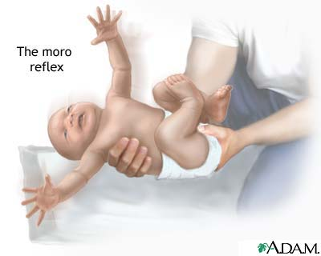
Babinski Reflex
- Appears at 32 weeks gestation
- Disappears within 1 year
- Plantar response – dorsiflexion of the big toe, fanning of the other toes.
- Persisting after 2 years of age – CNS lesion in the corticospinal tract
Tracking Reflex
- Child visually follows a human face
- Present at birth and continues
Physical Development
Gross Motor
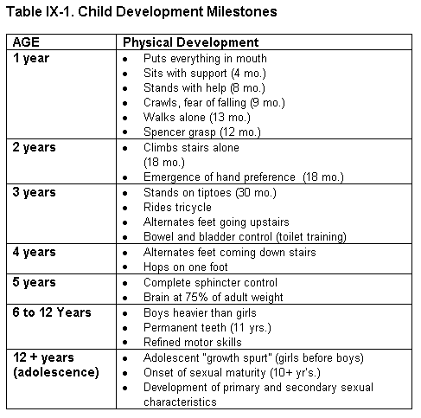
Physical Development - Gross Motor
- Newborn Reflex head turn, moves head side-to-side
- 1 month Lifts head when prone
- 2 months Lifts shoulders up when prone
- 3 months Lifts up on elbows, head steady when upright
Newborn
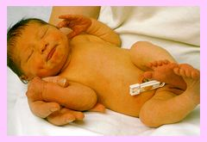
Physical Development
- 4 months Lifts up on hands, rolls from front to back, no head lag when pulled to sitting from supine position. Sits with support
- 5 months Rolls back to front
- 6 months Sits alone 30 seconds or more
- 7 months Sits well
Physical Development
- 8 months Pulls to a stand
- 9 months Crawls, fear of falling
- 10-11 months Cruises (walks holding on to furniture)
- 12 months Walks
- 15 months Walks backwards

Physical Development
- 18 months – 2 years Runs and kicks a ball, climbs stairs. Emergence of hand preference
- 3 years Walks up stairs alternating steps, rides a tricycle, stands on tiptoes. Bowel and bladder control training
- 4 years Walks down stairs alternating steps, hops on one foot.
Physical Development
- 5 years Skips, using feet alternately. Complete sphincter control
- 6 years Rides bicycle. Boys heavier than girls. Refines motor skills
- 12 + years Adolescent. Girls grow before boys. Onset of sexual maturity. Development of sexual characteristics

Social Development
Personal and Social
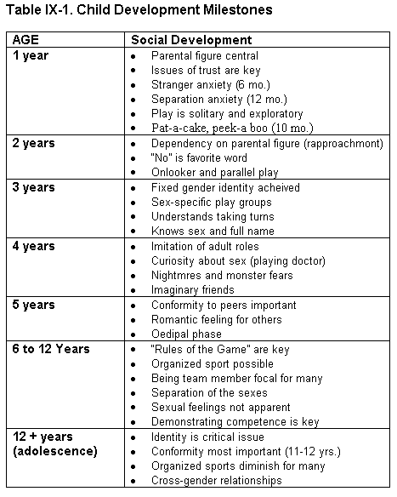
Social
- Newborn endogenous smile
- 1 week knows mother’s smells
- 4 - 8 weeks Spontaneous social smile
- 4 - 6 months Discriminates social smile
- 6-12 months Stranger anxiety
- Distress in the presence of unfamiliar face
- First appears at 6months, peaks at 8 months and disappears by 12 months.
- 10 months ----Plays peek-a-boo
- 12 – 24 months Separation anxiety.
- Distress of infant following separation from primary caregiver
- Begins to disappears by 20-24 months
- Failure to resolve separation anxiety result in school phobia.
- Treatment focuses on child’s interaction with parents.
Social
- ANACLITIC DEPRESSION:
- CONTINUED ABSENCE FROM PRIMARY CAREGIVER BEYOND 6 MONTHS RESULT IN ANACLITIC DEPRESSION
- SEEN EVEN WHEN PRIMARY CAREGIVER IS PHYSICALLY AND EMOTIONALLY UNRESPONSIVE AND DISTANT
- CHILD BECOMES WITHDRAWN AND UNRESPONSIVE
- DEPRESSED INFANT SHOW POOR FEEDING HABITS, POOR PHYSICAL GROWTH AND POOR HEALTH.

- Play is solitary and exploratory (2 years)
- 15-18 months Dependency on parental figure. Caries or hugs a special toy.
Imitates some behavioral pattern with slight delay.
- 2 years “NO” is favorite word.
Onlooker and parallel play
Demonstrates love and protest
Social
- 3 years Gender identity. Sex-specific play groups. Understands taking turns.
Knows sex and full name
- 4 years Imitation of adult roles. Curiosity about sex (playing doctor). Nightmares, monsters. Imaginary friends. Associate or joint play (cooperative)

Social
- 5 years Peers are important. Romantic feelings
- 6-12 years Sports, team member. Separation of sexes, sexual feelings not apparent. Demonstration competence.
- 12 + years Adolescence Identity is critical issue. Cross-gender relationships
Motor Development
Fine Motor/ Adaptive

Motor
- 1 month Tracks horizontally to midline
- 2 months Tracks past midline, tracks vertically
- 4 months Reaches for bright objects, brings object to mouth
- 5 months Feet in the mouth
- 6 months Transfers object from one hand to the other
Motor
- 18 months Tower of 3 cubes. Scribes spontaneously and imitates writing
- 2 years Copies vertical and horizontal line, tower of 6 cubes. Pulls on a simple garment.
- 3 years Copies circle. Stacks 9 cubes. Cuts paper with scissors. Unbutton buttons. Puts on shoes. Feeds self well.
Motor
- 4 years Copies "+“. Grooms himself.
- 5 years Copies square, draws a recognizable man (3 parts). Dresses and undresses himself. Catches ball with 2 hands
- 6 years Copies triangle. Rides bicycle. Prints letters. Gains athletic skills. Improves coordination
- 7years Copies diamond
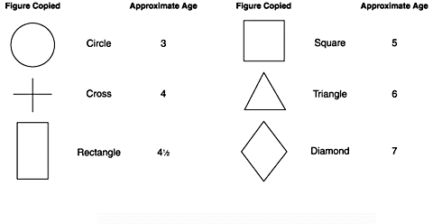
Language Development
Comprehension
Expression

Language
- Newborn Alerts to bell
- 4 months Laughs aloud
- 6 months Has differential cries for hunger, pain, attention. Recognize warning, angry, and friendly voices. Responds to name. Babbling
- 8 months Repetitive responding. Listen to music or singing with interest
Language
- 10 months Mama/dada non-specific. Understands the word “no”. Looks at pictures being named for one minute. Listens for speech without being distracted by other sounds.
- 12 months Mama/dada specific, follows one step commands with gesture, 3-5 word vocabulary
- 18 months Understands basic body parts, simple objects. Understands up to 150 words.

Language
- 2 - 3 years Telegraphic sentences, 2 word sentences. 250 words vocabulary. Understands small body parts (elbow, chin), family name categories (grandma, baby). Understands size (one little, one big)
Understands functions (why do we eat, sleep)
- 3 years Complete sentences, 900 words vocabulary. Understands 4x that
Language
- 4 years Can tell stories, uses plurals, prepositions. Compound sentences. Understands analogies (bread is to eat, milk is to --- ). Can repeat a 12-syllable sentence correctly.
- 5 years Ask the meaning of the words. Is able to categorize items.
- 6-12 years Shift from egocentric to social speech. Vocabulary expands geometrically.

Tanner’s stage of development:: what stage has child reached: stage 1, 2 or 3: depending on findings of examination of extragenital: be able to differentiate the different stages
p.13t
TANNER STAGES OF SEXUAL DEVELOPMENT
Stage 1:
GENETALIA AND ASSOCIATED STRUCTURES ARE SAME AS CHILD HOOD, NIPPLES ARE SLIGHTLY ELEVATED IN GIRLS
Stage 2
SCANT, STRAIGHT PUBIC HAIRS, TESTES ENLARGE, SCROTUM DEVELOPS TEXTURE,SLIGHT ELEVATION OF BREAST TISSUE IN GIRLS
Stage 3
PUBIC HAIRS INCREASE OVER THE PUBIS AND BECOME CURLY, PENIS INCREASES IN LENGTH AND TESTES ENLARGE
Stage 4
PENIS INCREASES IN WIDTH, GLANS DEVELOP, SCROTAL SKIN DARKENS; AREOLA RISES ABOVE THE REST OF THE BREAST IN GIRLS
Stage 5
MALE AND FEMALE GENITALIA ARE LIKE ADULT, PUBIC HAIRS ARE NOW ALSO ON THE THIGHS , AREOLA IS NO LONGER ELEVATED ABOVE THE BREAST IN GIRLS

Learning theories and conditions:
Difference between operant and classical conditioning
Difference between classical and operant conditioning

Classical – natural and reflexive response is elicited by a learned stimulus e.g. woman who has undergone three session of chemotherapy becomes nauseated as she enters hospital for the fourth session….Its elements include
- Unconditioned stimulus- something that produces response automatically without having to be learned e.g. odor of food.
- Unconditioned response – natural reflexive behavior that does not have to be learned e.g. salivation in response to the odor of food.
- Conditioned stimulus – Something that produces response following learning e.g. sound of the lunch bell
- Conditioned response – learned behavior e.g. salivation in response to lunch bell

Operant – Behavior is determined by its consequence for the individual…The likelihood that behavior will occur is increased by reinforcements and decreased by punishment.

Positive reinforcement- introduction of positive stimulus that result in increased behavior.
Negative reinforcement- removal of averse stimulus that results in an increase in rate of behavior.
Punishment – introduction of averse stimulus aimed at reducing unwanted behavior.

More stuff….

Classic conditioning: person is put in relaxed state then shown that phobia isn’t harmful.
Biofeedback (operant conditioning): through process of operant conditioning, the person is given ongoing physiological information (e.g. b.p measurement), which acts as reinforcement when bp drops.

Low yield facts:
Averse conditioning: Pairs maladaptive but pleasurable stimulus with an averse or painful stimulus (e.g. shock) so that the two become associated…..eg used for paedophiles
Systemic Desensitization: increasing dose of fear- provoking stimulus are paired with a relaxing stimulus to induce a relaxation response.
Flooding: The person is exposed to actual (flooding) or imagined (implosion) overwhelming dose of the feared stimulus.

LEARNING THEORY
Classical Conditioning
&
Operant (Instrumental) Conditioning

Ivan Pavlov

Classical conditioning:
- basic form of learning in which simple responses (e.g. salivation) are associated with a new or conditioned stimulus
- forming an association between the neutral stimuli of the waiting room and the painful stimuli of immunizations or teeth drilling
- now it’s the neutral stimuli that triggers the fear

Basic Findings:
- Ivan Pavlov (1849-1936)
  - Unconditioned reflex: unlearned reflex, an association between the unconditioned stimulus and unconditioned response
  - Unconditioned stimulus: a stimulus that produces an unconditioned response in the absence of learning (food in mouth)
  - Unconditioned response: an unlearned response to an unconditioned stimulus (salivation)
  - Conditioned stimulus: a stimulus that becomes associated through learning with the unconditioned stimulus (i.e. tone- a neutral stimulus)
  - Conditioned reflex: the new assoc between the conditioned stimulus (the tone) and the unconditioned stimulus (sight of food) causing the conditioned response (salivation)
  - Conditioned response: a response (salivation) which is produced by the conditioned stimulus after a learning process

Pavlov’s apparatus:
-Diagram of the apparatus used by Pavlov for his study of conditioning with dogs (adapted from Yerkes & Morgulis, 1909)

Operant conditioning:
- a form of learning in which behavior is controlled by rewards or positive reinforcers or by unpleasant or aversive stimuli
- Can you think of any examples?

B.F. Skinner (1904-1990)
- skinner believed that what we learn and how we behave in everyday life are both very heavily influenced by the conditioning experiences we have had throughout our lives
  - the training of circus animals
  - the treatment of PT’s suffering from various mental disorders: token economies
  - biofeedback

TOKEN ECONOMIES:
- Here Pt’s who behave in desirable ways receive tokens which can be exchanged for various rewards
- Token economies have proved useful in the treatment of Pt’s with schizophrenia or anti-social personalities

Basic findings:
- skinner box for rates, showing chart recording of lever pressing.

Skinner: Schedules of Partial Reinforcement:
- fixed ratio schedule
- variable ratio schedule
- fixed interval schedule
- variable interval schedule

To recap….
- learning is acquisition of new behavior pattern
- method of learning include classical and operant conditioning
- classical and operant conditioning are the basis of behavioral techniques, such as, systematic desensitization, aversive conditioning, flooding, biofeedback, token money and cognitive therapy.
Classical (Pavlovian) Conditioning
Behaviors are linked to external stimuli, and are likely to reoccur in the presence of those stimuli
- Ex. Pavlov’s Dog
- Ex. Fear of nurse and needles
- Ex. Fear of white beards after being assaulted by a man with a white beard
Operant (Instrumental) Conditioning – behavioral responses occur more frequently or less frequently as a function of a pleasurable or noxious consequence

- Ex. Touching a hot stove negatively reinforced
- Ex. A man’s working out is positively reinforced by positive feedback from females
- Ex. An individual who receives secondary gain by playing the sick role is more likely to take on the sick role

Some Learning Terminology
- Reward
- Operant
- Superstitious conditioning;
- Stimulus generalization
- Extinction
- Positive reinforcement
- Negative Reinforcement
- Systematic Desensitization
- Aversive Conditioning
- Successive Approximations/Shaping
- Learned Helplessness

Learning Theory and Behavior
- The principles of conditioning are clearly relevant to clinical medicine, and classical conditioning is especially important in the acquisition of physiological responses and behavioral responses
- Behavior and physiology are intimately linked
- maladaptive responses can lead to psychosomatic disease.
CLASSICAL CONDITIONING
- A NATURAL OR REFLEXIVE RESPONSE IS ELICTED BY LEARNED STIMULUS AFTER REPEATED PAIRING OF NATURAL AND LEARNED STIMULUS
- THE PAVLOVIAN EXPERIMENT PAIRED THE RINGING OF BELL WITH THE BRINGING OF FOOD SO THAT, EVENTUALLY, SOUND OF THE BELL ELICTED THE SALIVATORY RESPONSE, WHICH PREVIOUSLY OCCURRED ONLY AT THE SIGHT OF THE FOOD.
- PATIENT RECEIVING CHEMOTHERAPY, WHICH INDUCES NAUSEA. EVENTUALLY, SIGHT AND SOUND OF THE HOSPITAL ALONE ELICIT NAUSEA.
- 4 ELEMENTS OF CLASSICAL CONDITIONING.
Classical Conditioning
- UCS
- CS
- UR
- CR

CERTAIN FACTORS ASSOCIATED WITH CLASSICAL CONDITIONING

STIMULUS GENERALIZATION:
- AN ORGANISM’S TENDENCY TO RESPOND TO SIMILAR STIMULI WITH SIMILAR RESPONSE.
- A NEW STIMULUS RESEMBLING THE CONDITIONED STIMULUS CAUSES THE CONDITIONED RESPONSE
- PATIENT ON CHEMOTHERAPY, MEETING THE PHYSICIAN OUTSIDE THE HOSPITAL CAUSES NAUSEA.
EXTINCTION
- AFTER LEARNING HAS OCCURED , REMOVAL OF THE PAIRING BETWEEN THE UCS AND CS RESULTS IN DECREASED PROBABILITY THAT THE CONDITIONED RESPONSE WILL OCCUR
- BREAKING THE PAIRING BETWEEN CHEMOTHERAPY AND THE HOSPITAL ANDMEDICAL SETTING BY GIVING CHEMOTHERAPY AT HOME
- IF THE FOOD IS GIVEN WITHOUT RINGING THE BELL FOR A TIME

DISCRIMINATION:
- THE PROCESS OF RECOGNIZING AND RESPONDING TO DIFFERENCES BETWEEN SIMILAR STIMULI
- LEARNED OVER TIME

B. F. Skinner
OPERANT CONDITIONING
- BEHAVIOR IS DETERMINED BY ITS CONSEQUENCES FOR THE INDIVIDUAL.
- A BEHAVIOR THAT IS NOT A PART OF INDIVIDUAL NATURAL REPERTOIRE CAN BE LEARNED THROUGH REWARD AND PUNISHMENT
- IN THE B. F. SKINNER EXPERIMENT, PRESSING THE LEVER RESULTED IN DELIVERY OF FOOD. AFTER RECEIVING FOOD, THE BAR PRESSING BEHAVIOUR INCREASED.
TYPES OF REINFORCER
A POSITIVE REINFORCER:
- IS A STIMULUS THAT, WHEN APPLIED FOLLOWING AN OPERANT RESPONSE, STRENGTHENS THE PROBABILITY OF THAT RESPONSE OCCURING.
- INCREASED PAY RESULTS IN INCREASED WORK BY THE EMPLOYEES
- INCREASED COMPLAINING LEADS TO INCREASED ATTENTION FROM THE NURSING STAFF

A NEGATIVE REINFORCER:
- IS THE STIMULUS THAT, WHEN REMOVED FOLLOWING A OPERANT RESPONSE, STRENGTHENS THE PROPABILITY OF RESPONSE OCCURING.
- CHILD LEARNS THAT HE CAN STOP HIS PARENT NAGGING BY CLEANING UP THE ROOM
- ACTIVE AVOIDENCE OF AN AVERSIVE STIMULI INCREASES DESIRED BEHAVIOR
- AVERSIVE STIMULI SUCH AS LOUD NOISE, BRIGHT LIGHT, SHOCK CAN OFTEN BE NEGATIVE REINFORCERS.

PUNISHMENT:
- BEHAVIOR IS DECREASED BY SUPPRESSION
- LIKE NEGATIVE REINFORCEMENT USES A NOXIOUS STIMULI
- PHYSICAL PUNISHMENT OF CHILD WILL SUPRESS NAUGHTY BEHAVIOR
- DELIVERY OF AN AVERSIVE STIIMULUS DECREASES UNWANTED BEHAVIOR RAPIDLY BUT NOT PERMANANTLY.
EXTINCTION:
- BEHAVIOR IS ELIMINATED BY NON REINFORCEMENT
- CHILD STOPS HIS HITING BEHAVIOR WHEN BEHAVIOR IS IGNORED BY PARENTS
- EXTICTION IS MORE EFFECTIVE THAN PUNISHMENT FOR LONG TERM REDUCTION OF UNWANTED BEHAVIOR
REINFORCEMENT SCHEDULES
CONTINOUS REINFORCEMENT:
- EVERY RESPONSE IS FOLLOWED BY REINFORCEMENT (REWARD)
- RESULTS IN FAST LEARNING
- RESULTS IN FAST EXTINCTION WHEN REINFORCEMENT IS STOPPED
- A TEENAGER RECIEVES A CANDY BAR EACH TIME SHE PUTS A DOLLAR INTO THE VENDING MACHINE. ONE TIME SHE PUT A DOLLAR IN AND NOTHING CAME OUT. SHE NEVER BUYS CANDY FROM THAT MACHINE AGAIN.

- FIXED RATIO REINFORCEMENT:
- DELIVERS REINFORCEMENT AFTER FIXED NUMBER OF RESPONCES
- PRODUCES HIGH RESPONSE RATE
- MAN IS PAID A CERTAIN AMOUNT FOR EVERY FIVE SHIRTS MADE. HE MAKES AS MANY SHIRTS AS POSSIBLE DURING HIS SHIFT

- FIXED INTERVAL REINFORCEMENT:
- DELIVERS REINFORCEMENT AFTER DESIGNATED PERIOD. IRRESPECTIVE OF AMOUNT OF WORK DONE.
- THE RESPONSE RATE INCREASES TOWARDS THE END OF EACH INTERVAL
- CRAMMING BEFORE THE EXAM OR WORKING EXTRA HARD BEFORE BONUS AT THE HOLIDAYS.

VARIABLE RATIO REINFORCEMENT:
- DELIVERS REINFORCEMENT AFTER RANDOM AND UNPREDICTABLE NUMBERS OF RESPONSES
- PRODUCES GREATEST RESISTANCE TO EXTINCTION
- GAMBLING: A LARGE NUMBER OF RESPONSES MAY BE MADE WITHOUT A REWARD. SINCE ANY RESPONSE MAY BE A LUCKY ONE, PERSON KEEPS OM TRYING SLOT MACHINES
VARIABLE INTERVAL REINFORCEMENT:
- DELIVERS REINFORCEMENT AFTER RANDOM AND UNPREDICTABLE TIME PERIOD
- HIGH RESISTANCE TO EXTINCTION
- HIGHER STEADY RATE OF RESPONDING
- POP QUIZES OR SURPRISE BONUS AT WORK
- FISHING
MODELING & OBSERVATIONAL LEARNING

- WATCHING SOMEONE ELSE GET REINFORCED IS ENOUGH TO CHANGE BEHAVIOR
- FOLLOWS THE SAME PRINCIPLE AS OPERANT CONDITIONING
- CORRELATING THE EFFECTS OF WATCHING VIOLENCE ON TV WITH COMMITING VIOLENCE IN THE REAL WORLD STEMS FROM THIS CONCEPT
- PARTLY WHY GROUP THERAPY WORKS
- OTHER APPLICATIONS:
- ASSERTIVENESS TRAINING
- SOCIAL SKILLS TRAINING
- PREPARING CHILDRENS FOR PAINFUL SURGICAL AND MEDICAL PROCEDURE.
BEHAVIORAL THERAPIES

THERAPIES BASED ON CLASSICAL CONDITIONING
SYSTEMATIC DESENSITIZATION:
- USED TO TREAT ANXIETY AND PHOBIAS
- INDIVIDUAL IS EXPOSED TO FRIGHTENING STIMULI IN INCREASING DOSE IN CONJUNCTION WITH RELAXATION TECHNIQUES.
- WORKS BY REPLACING ANXIETY WITH RELAXATION

THERAPIES BASED ON CLASSICAL CONDITIONING
EXPOSURE (flooding or implosion):
- SIMPLE PHOBIAS CAN SOMETIMES BE TREATED BY FORCED EXPOSURE TO THE FEARED OBJECT
- EXPOSURE IS MAINTAINED UNTIL THE FEAR RESPONSE IS EXTINGUISHED
- Exposed to actual (flooding) or imagined (implosion)
- FEAR OF HIEGHT TREATED BY HAVING TO RIDE UP IN THE ELEVATOR

THERAPIES BASED ON CLASSICAL CONDITIONING
AVERSIVE CONDITIONING
- OCCURS WHEN A STIMULUS THAT PRODUCES DEVIANT BEHAVIOR IS PAIRED WITH AN AVERSIVE ATIMULUS
- USED IN TREATMENT OF ALCOHOLISM AND SEXUAL DEVIANCE
- ALCOHOLICS ARE GIVEN NAUSEA INDUCING DRUG, DISULFIRAM, SO WHENEVER HE DRINKS, IT CAUSES NAUSEA, EVENTUALLY DRINKING GETS PAIRED WITH NAUSEA, AN UNPLEASENT EVENT.
- THUMB SUCKING AND CHILLI PEPPERS
THERAPIES BASED ON OPERANT CONDITIONING
SHAPING:
- ACHIEVES FINAL TARGET BEHAVIOR BY REINFORCING SUCCESSIVE APPROXIMATIONS OF THE DESIRED BEHAVIOR
- REINFORCEMENT IS GRADUALLY MODIFIED TO MOVE BEHAVIORS FROM MORE GENERAL TO MORE SPECIFIC RESPONSES DESIRED.

THERAPIES BASED ON BOTH TYPES OF CONDITIONING
EXTINCTION:
- DISCONTINUING THE REINFORCEMENT THAT IS MAINTAINING AN UNDESIRED BEHAVIOR
- IF COMPLAINING RESULTS IN PATIENT RECEIVING LOT OF ATTENTION, STOPPING THE ATTENTION WILL EVENTUALLY STOP THE UNDESIRED BEHAVIOR
- INSTITUTING A ‘TIME OUT’ WITH CHILDREN WHO ARE ACTING INAPPROPIATELY

THERAPIES BASED ON OPERANT CONDITIONING
STIMULUS CONTROL:
- SOMETIMES STIMULI INADVERTENTLY ACQUIRES CONTROL OVER THE BEHAVIOR. WHEN THIS IS TRUE, REMOVAL OF THAT STIMULUS CAN EXTINGUISH THE RESPONSE
- PERSON EATING BEHAVIOR IS TIED TO WATCHING TV. REDUCING THE TIME WATCHING TV SHOULD REDUCE THE AMOUNT EATEN.
- INSOMNIAC IS PERMITTED IN HIS BED ONLY WHEN HE IS SO TIRED THAT HE FALLS TO SLEEP ALMOST AT ONCE.

THERAPIES BASED ON OPERANT CONDITIONING
FADING:
- GRADUALLY REMOVING THE REINFORCEMENT WITHOUT THE INDIVIDUAL DISCOVERING THE DIFFERENCE
- PROMOTING SMOKE CESSATION BY REDUCING THE NICOTINE CONTENT OF THE CIGARETTES GRADUALLY AND SILENTLY OVER A PERIOD OF TIME
- GRADUALLY REPLACING POSTOPERATIVE PAINKILLERS WITH THE PLACEBO

BIOFEEDBACK
- TECHNIQUE THAT ALLOWS A PERSON TO GAIN CONTROL OVER THEIR PHYSIOLOGICAL PARAMETERS SUCH AS, HEART RATE, BLOOD PRESSURE , TEMPERATURE, ETC
- BIOFEEDBACK INVOLVES PROVIDING THE PERSON WITH THE INFORMATION ABOUT HIS INTERNAL RESPONSES TO STIMULI AND METHODS TO CONTROL OR MODIFY THEM.
BIOFEEDBACK
- IT WORKS BY MEANS OF TRIAL AND ERROR LEARNING AND REQUIRES REPEATED PRACTICE TO BE EFFECTIVE.
- MOST BIOFEEDBACK AFFECTS THE PARASYMPATHETIC SYSTEM
- USES: HYPERTENSION, MIGRAINE, RAYNAUDS SYNDROME, ANXIETY, ETC.

Stanley Milgram’s Experiment: “Obedience and Individual Responsibility”: Defense based on “obedience” that they were just following orders of their superiors.

Bad Bloo: Tuskegee syphilis study: unethical

Psychoanalytic theory and ALL THE DEFENSE MECHANISMS!!!
Should be able to differentiate: some examples and asked what defense mechanism is showing:

Defense mechanism 6.2

Acting out – to get attention e.g. having multiple sexual partners after parent’s divorce.
Altruism- assisting others to avoid negative personal feelings e.g. social worker with poor self image helps out at the youth club on weekends.
Denial- not accepting aspects of reality that the person finds unbearable e.g. alcoholic insists that he’s only a social drinker
Displacement- moving emotions from a personally intolerable situation to one that is personally tolerable e.g. Surgeon mistreats female patients cos of unacknowledged anger towards his mother.
Dissociation- teenager has no memory of accident which killed his girlfriend and he was the driver.
Humor- A man concerned about his erectile dysfunction makes jokes about Viagra
Identification – a man terrorized by his gym teacher becomes a critical gym teacher.
Intellectualization – using mind’s higher function to avoid experiencing emotion e.g. medical student does extensive research on a patient’s condition before going to tell her about her illness.
Isolation- woman tells her family sad news about her cancer without showing any emotions.
Projection- a man who fancies his wife’s sister begins to accuse the wife of cheating.
Rationalization – Man looses one arm and says it was good cos it kept him from getting in trouble with the law.
Reaction formation- woman unconscious of child rearing overspends on the child
Regression – acting like a young child eg grown man asking for mummy before his operation, or 5 yr old child wets bed after mum has a new baby.
Splitting – categorizing of people or situations into fabulous or dreadful….seen in borderline personality disorder patients
Suppression – medical student studying for USMLE, mentally changes the subject when her mind wanders to the exam during a lecture.
Undoing – Believing that one can magically reverse past events caused by incorrect behavior e.g. HIV positive drug use patient stops using drugs, and starts exercise and healthful diet program.

DEFENSE MECHANISMS
• DEFENCE MECHANISMS ARE THE PRIMARY TOOL OF EGO, USED TO
MANAGE THE INTERNAL CONFLICTS BETWEEN DEMANDS OF ID AND
RESTRICTION OF SUPEREGO. THEY ARE THE MEANS BY WHICH THE EGO
WARDS OFF ANXIETY AND CONTROL INSTINCTIVE URGES AND
UNPLEASENT AFFECTS(EMOTIONS).

• ALL DEFENCES ARE UNCONCIOUS
• REPRESSION, PUSHING UNACCEPTABLE EMOTIONS INTO THE
UNCONSCIOUS, IS THE BASIC DEFENSE MECHANISM ON WHICH ALL
OTHER ARE BASED
• MAINLY DIVIDED INTO FOUR TYPES:
– NARCISSTIC
– IMMATURE
– NEUROTIC
– MATURE

NARCISSISTIC DEFENSE
MECHANISM
USED BY CHILDREN AND PSYCHOTIC
ADULTS

PROJECTION
• PERSON ATTRIBUTES HIS OWN PERSONALLY
UNACCEPTABLE FEELINGS TO OTHERS
• ASSOCIATED WITH PARANOID SYMPTOMS
AND PREJUDICE
– MAN WHO HAS COMMITED ADULTRY BECOMES
CONVINCED THAT HIS WIFE IS HAVING A AFFAIR
EVEN THOUGH THERE IS NO EVIDENCE OF THAT.
– A GIRL TALK ABOUT HER DOLL HAVING CERTAIN
FEELINGS, WHICH ARE REALLY WHAT THE GIRL
FEELS.
-a man with unconscious homosexual impulses begins to believe that his boss is homosexual

DENIAL
• NOT BELIEVING ASPECTS OF REALITY
THAT PERSON FINDS UNBEARABLE
– AFTER SURVIVING A HEART ATTACK, A
PATIENT INSISTS ON CONTINUING HIS
LIFESTYLE AS IF NOTHING HAD
HAPPENED.
– A CHILD WHO IS ABUSED INSISTS THAT
SHE HAS BEEN TREATED WELL.
-an alcoholic insists that he is only a social drinker

SPLITTING
-categorizing people or situations into categories of either “fabulous” or “dreadful” b/c of intolerance of ambiguity
• PEOPLE AND THINGS IN THE WORLD
ARE PERCIEVED AS ALL GOOD OR ALL
BAD.THE WORLD IS PICTURED IN
EXTREME TERMS.
• SEEN IN PATIENT WITH BODERLINE
PERSONALITY DISORDER
– THIS DOCTOR IS MIRACLE WORKER BUT
THAT DOCTOR IS TOTALLY INCOMPETENT
– ‘HE IS JUST SO PERFECT AND
WONDERFUL ” SAYS A TEENAGE GIRL IN
LOVE.
IMMATURE DEFENSES
USED BY ADOLESCENTS, DEPRESSIVE,
OBSESSIVE AND COMPULSIVE
INDIVIDUALS
-A patient tells the doctor that while all of the doctors in the group practice are wonderful, all of the nurses and office help are unfriendly and curt

BLOCKING
• TEMPORARY OR TRANSIENT BLOCK IN
THINKING OR INABILITY TO REMEMBER
• BLOCKING IS DISRUPTIVE AND
EMBARRASING.
– AS STUDENT IS UNABLE TO RECALL THE FACTS
NEEDED TO ANSWER THE QUESTIONS ,
ALTHOUGH HE RECALLS THEM AS HE WALKS
OUT OF THE EXAM.
– IN THE MIDDLE OF CONVERSATION, A WOMEN
PAUSES, LOOKED CONFUSED, AND ASKS ‘WHAT
WAS I JUST TALKING ABOUT”

REGRESSION
• RETURNING TO EARLY STAGE OF
DEVELOPMENT
• REGRESSION IS COMMON WHEN PEOPLE
ARE TIRED, ILL OR UNCOMFORTABLE
– A PATIENT LIES IN A BED CURLED UP IN A FETAL
POSITION
– A HUSBAND SPEAKS TO HIS WIFE IN ‘BABYTALK’
– ENURESIS IN PREVIOUSLY TOILET TRAINED
CHILD FOLLOWING BIRTH OF A SIBLING
-a 5 year old child who was previously toilet-trained begins to wet the bed when his mother has a new baby

SOMATIZATION
• PSYCHIC FEELINGS ARE CONVERTED INTO
BODILY SYMPTOMS
• EXTREME FORMS ARE SOMATIZATION ARE
DIAGNOSED AS SOMATOFORM DISORDERS
• SYMPTOMS ARE PHYSICALLY REAL AND NOT
IMAGINED
– GETTING HEADACHE WHILE TAKING EXAM
– FEELING NAUSEATED BEFORE ASKING SOMEONE
OUT ON THE DATE

INTROJECTION
(IDENTIFICATION)
• FEATURES OF EXTERNAL WORLD AND
PERSONS ARE TAKEN IN AND MADE
PART OF SELF.
• INTROJECTION IS WHY CHILDRENS
ACT LIKE THEIR PARENTS
– A RESIDENT DRESSES AND ACTS LIKE
THE ATTENDING PHYSICIAN
– A TEENAGER ADOPTS THE STYLE AND
MANNERISMS OF A ROCK STAR.

ANXIETY OR NEUROTIC DEFENSE
MECHANISMS
SEEN IN ADULTS UNDER STRESS

DISPLACEMENT:
Moving emotions from a personally intolerable situation to one that is personally tolerable
• CHANGING THE TARGET OF AN EMOTION
OR DRIVE.
• PHOBIAS ARE RESULT OF DISPLACEMENT
– A MAN WHO IS ANGRY AT HIS BOSS POUNDS ON
HIS DESK RATHER THAN TELLING HIS BOSS
HOW HE FEELS
– AN ATTENDING PHYSICIAN SCOLDS A RESIDENT
WHO LATER EXPRESSES HIS ANGER BY YELLING
AT THE MEDICAL STUDENT
-a surgeon attending with unacknowledged anger toward his mother is abrasive to the female residences on his service

REPRESSION
• AN IDEA OR FEELING IS ELIMINATED FROM
CONSCIOUSNESS.
• CONTENTS ARE USUALLY NOT
RECOVERABLE WITHOUT SOME TRAUMA OR
PSYCHOANALYSIS
– A MAN WHO SURVIVED 6 MONTHS IN
CONCENTRTION CAMP CANNOT RECALL
ANYTHING ABOUT HIS LIFE DURING THAT TIME
PERIOD
– A CHILD WHO WAS ABUSED BY HER MOTHER
AND WAS TREATED FOR ABUSE, NOW HAS NO
MEMORY OF ANY MISTREATMENT BY HER
MOTHER.

ISOLATION OF AFFECT
• REALITY IS ACCEPTED, BUT WITHOUT THE
EXPECTED HUMAN EMOTIONAL RESPONSE TO
THAT REALITY.
• THE BLAND AFFECT OF SCHIZOPHRENICS, LA
BELLE INDIFFERENCE SEEN IN CONCERSION
DISORDER IS MAINIFESTATION OF THIS
MECHANISM.
– A CHILD WHO HAS BEEN BEATEN DISCUSSES THE
BEATING WITHOUT ANY DISPLAY OF EMOTIONS
– A PATIENT WHO HAS HAD A FINGER SEVERED IN
AN ACCIDENT DESCRIBES THE INCIDENT TO HIS
PHYSICIAN WITHOUT ANY EMOTIONAL REACTION
-without showing any emotion, a woman tells her family the results of tests which indicate that her lung cancer was metastasized

INTELLECTUALIZATION
• AFFECT IS STRIPPED AWAY AND REPLACED BY AN
EXCESSIVE USE OF INTELLECTUAL PROCESS
• INTELLECT IN PLACE OF EMOTION
• OBSESSIVE COMPULSIVE ANXIETY DISORDER IS
BASED ON THIS MECHANISM
– A PHYSICIAN TELLS THE PATIENT ABOUT HIS
POOR PROGNOSIS AND TALKS A GREAT DEAL
ABOUT THE TECHNICAL ASPECTS BY WHICH
PROGNOSIS WAS DERIVED
– A SAILOR WHOSE BOAT IS ABOUT TO SINK
EXPLAINS THE TECHNICAL OF THE HULL
DAMAGE IN GREAT DETAILS TO ANOTHER CREW
MEMBERS.

ACTING OUT
• MASSIVE EMOTIONAL OR BEHAVIORAL OUTBURST
TO COVER UP UNDERLYING FEELING OR IDEA
• AVOIDING PERSONALLY UNACCEPTABLE EMOTIONS
BY BEHAVING IN ATTENTION GETTING OFTEN
SOCIALLY INAPPROPRIATE MANNER
• COMMONLY SEEN IN BODERLINE AND ANTISOCIAL
PERSONALITY
– WHISTLING IN THE DARK HIDES THE REAL UNDERLYING
FEAR
– A DEPRESSED 14 YEAR OLD GIRL WITH NO HISTORY OF
CONDUCT DISORDER HAS SEXUAL ENCOUNTERS WITH
MULTIPLE PATNERS AFTER HER PARENTS DIVORCE

RATIONALIZATION
• RATIONAL EXPLANATIONS ARE USED TO
JUSTIFY ATTITUDES, BELIEFS OR
BEHAVIORS THAT ARE UNACCEPTABLE.
• USE TO RELIEVE GUILT AND SHAME
• OFTEN ACCOMPANIES OBSESSIVE
COMPULSIVE BEHAVIOR
– YES, I BELIEVE KILLING IS WRONG BUT I KILLED
HIM BECAUSE HE DESERVED IT
– A MAN WHO IS UNFAITHFUL TO HIS WIFE
BELIEVES THAT THIS AFFAIR WILL MAKE HIM
APPRECIATE HIS WIFE MORE
-a man who loses an arm in an accident says the loss of his arm was good b/c it kept him from getting in trouble with the law

REACTION FORMATION
• AN UNACCEPTABLE INPULSE IS
TRANSFORMED INTO ITS OPPOSITE
• FIND IN MANY ANXIETY DISORDER
– A STUDENT WHO ALWAYS WANTED TO BE A
PHYSICIAN EXPRESS RELIEF AND SAYS ‘THIS IS
A BEST NEWS I EVER HEARD’, AFTER NOT BEING
ACCEPTED TO A MEDICAL SCHOOL.
– A TEENAGER BOY INTRIGUED BY ‘DIRTY
PICTURE’ ORGANIZES AN ANTIPORNOGRAPHY
COMPAIGN.

UNDOING
• ACTING OUT REVERSE OF THE
UNACCEPTABLE FEELINGS
• SEEN IN OBSESSIVE COMPULSIVE
DISORDER
– A MAN WHO IS SEXUALLY AROUSED BY A
WOMEN HE MEETS IMMEDIATELY LEAVES
AND BUYS FLOWERS FOR HIS WIFE
– SUPERSTITIONS SUCH AS ‘KNOCK ON
WOOD’ AFTER WISHING SOMEONE WELL
-a woman who is terminally ill with AIDS caused by drug abuse, stops using drugs and alcohol and starts an exercise and healthful diet program

PASSIVE AGRESSIVE
• NONPERFORMANCE OR POOR
PERFORMANCE AFTER SETTING UP THE
EXPECTATIONS OF PERFORMANCE.
• OFTEN USED BY BODERLINE PERSONALITY
DISORDER AND YOUNG CHILDRENS
– A STUDENT AGREES TO SHARE CLASS NOTES
BUT GOES HOME WITHOUT SHARING THEM
– A PHYSICIAN IGNORES OR DOES NOT ANSWER
QUESTIONS OF THE PATIENT THAT HE FINDS
ANNOYING.
• THE FEELINGS OF HOSTILITY ARE
UNCONCIOUS AND THE PERSON USING THE
DEFENCE IS GENERALLY UNAWARE OF THEM

DISSOCIATION
• SEPERATING SELF FROM ONE’S
EXPERIENCE.
• IN EXTREME FORMS , BECOMES
DISSOCIATIVE DISORDER, FUGUE STATE,
AMNESIA AND IDENTITY DISORDER.
– A WOMAN WHO WAS RAPED REPORTS THAT IT
WAS AS IF SHE WAS FLOATING ON THE CEILING
AND WATCHING IT HAPPEN
– THE SURVIVOR OF AN AUTOMOBILE ACCIDENT
TELLS OF THE FEELING THAT EVERYTHING
HAPPENED IN SLOW MOTION
MATURE DEFENSE MECHANISMS
USED BY NORMAL ADULTS
-a teenager has no memory of a car accident in which he was driving and his girlfriend was killed

ALTURISM
• ASSISTING OTHERS TO AVOID
NEGATIVE PERSONAL FEELINGS
• UNSELFISHLY ASSISTING OTHERS
• A WOMAN WHO HAS A BREAST
CANCER LEADS A SUPPORT GROUP
FOR OTHER WOMENS WITH BREAST
CANCER
-a man with a poor self-image, who is a social worker during the week, donates every other weekend to charity work

HUMER
• EXPRESSING PERSONALLY
UNCOMFORTABLE FEELINGS WITHOUT
CAUSING EMOTIONAL DISCOMFORT
– A MAN LAUGHS WHEN HE IS TOLD HE IS
GOING TO FIRED
– A TERMINALLY ILL CANCER PATIENT
MAKES FUN OF HIS CONDITION
• LAUGHTER COVERS PAIN AND
ANXIETY

SUBLIMATION
• IMPULSE GRATIFICTION IS ACHIEVED
BY CHANNELING THE UNACCEPTABLE
IMPULSES INTO SOCIALLY
ACCEPTABLE DIRECTIONS
– AN EXECUTIVE WHO IS ATTRACTED TO A
FEMALE ASSOCIATE BECOMES HER
MENTOR AND ADVISOR
– A MAN WHO GOT INTO FIGHTS
REGULARLY AS A TEENAGER, GROWS UP
TO BECOME A PROFESSIONAL FIGHTER.

SUPPRESSION
• DELIBERATELY PUSHING PERSONALLY
UNACCEPTABLE EMOTIONS OUT OF
CONSCIOUS AWARENESS
• ONLY DEFENCE MECHANISM THAT USES
SOME ASPECT OF CONSCIOUSNESS.
– A STUDENT DECIDES TO FORGET ABOUT THE
PENDING EXAM TO GO OUT AND HAVE A GOOD
TIME FOR AN EVENING
– A TERMINALLY ILL CANCER PATIENT PUTS ASIDE
HIS ANXIETY ANS ENJOY FAMILY GATHERING.
-a medical student taking a review course for the USMLE, mentally changes the subject when her mind wanders to the exam during a lecture

Sample q’s by Dr. Gall
Name Piaget’s Stages of Cognitive development?
Sensorimotor (0-2 years)
Preoperational (2-7 years)
Concrete (7-11 years)
Formal (11- End of adolescence)

What is the law of conservation and which stage is it seen?
This law states that the child becomes to the realization that changing the shape does not alter the quantity of the object: seen in CONCRETE STAGE.

In which stage is a child said to be egocentric?
Preoperational

In which tanner stage are breast buds seen?
Tanner stage 2

A midlife crisis may lead to?
A change in profession or lifestyle
Infidelity, separation, divorce
Increase use of alcohol or drugs
Depression
SAMPLE Q’S USED IN CLASS BY DR. OMAR
Topic: Defense Mechanisms
Answer Choices:
A. Undoing
B. Splitting
C. Projection
D. Denial
E. Reaction Formation
F. Isolation of Affect
G. Displacement
H. Acting Out
I. Introjection
J. Regression
Statements/Answers
1. Alcoholic claims he is simply a social drinker --> D
2. A resident begins to dress like his/her attending --> I
3. An abused child throws a temper tantrum --> H
4. Two co-workers constantly bicker, but in reality, have feelings for each other --> E
5. The day is nurse is very good, but the night nurse is horrible --> B
6. Man cheating on his wife suspects his wife is also cheating on him without any evidence --> C
7. Person angry with boss pounds his desk rather than talk to his boss --> G
8. Child pees his bed when he's ill --> J
9. A beaten child is able to discuss his experiences without any emotion --> F
Then Freud’s theory: toprogialh and
Super ego, ego: what’s the difference between superego and ego,
What the difference is between conscious, unconscious
PSYCHOANALYTIC THEORY AND
DEFENCE MECHANISMS
• PSYCHOANALYTIC THEORY IS BASED
ON FREUD’S CONCEPT THAT THE
BEHAVIOR IS DETERMINED BY FORCES
DERIVED FROM UNCONSCIOUS
MENTAL PROCESSES.
• PSYCHOANALYSIS AND RELATED
THERAPIES ARE BASED ON THIS
CONCEPT.
FREUD’S THEORY OF MIND
• TO EXPLAIN HIS IDEAS FREUD ,FREUD
DEVELOPED , THE TOPOGRAPHIC AND
STRUCTURAL THEORY OF MIND.
TOPOGRAPHIC THEORY OF THE MIND
• IN THE TOPOGRAPHIC THEORY, THE MIND
CONSISTS OF THREE LEVELS: THE UNCONSCIOUS,
PRECONSCIOUS AND CONSCIOUS.
• THE UNCONSCIOUS MIND:
– CONTAINS REPRESSED THOUGHTS AND
FEELINGS WHICH ARE NOT AVALIBLE TO
CONCIOUS MIND AND USES PRIMARY PROCESS
OF THINKING
– THE PRIMARY PROCESS IS TYPE OF THINKING
ASSOCIATED WITH PRIMITIVE DRIVE, WISH
FULFILLMENT AND PLEASURE SEEKING AND HAS
NO LOGIC AND CONCEPT OF TIME.
– PRIMARY PROCESS THINKING IS SEEN IN
CHILDRENS AND PSYCHOTIC ADULTS.
– DREAMS REPRESENT GRATIFICATION OF
UNCONCIOUS INSTINCTIVE IMPULSES AND WISH
FULFILLMENT.
• THE PRECONSCIOUS MIND:
– CONTAINS MEMORIES THAT ARE NOT IMMEDIATELY
AVALIBLE BUT CAN BE EASILY ACCESSED.
• THE CONSCIOUS MIND:
– CONTAINS THOUGHTS THAT PERSON IS CURRENTLY
AWARE OF
– IT WORKS IN CLOSE COMMUNICATION WITH THE
PRECONCIOUS MIND BUT DOES NOT HAVE ACCESS
TO UNCONCIOUS MIND.
– THE CONCIOUS MIND USES SECONDARY THINKING
PROCESS WHICH IS LOGICAL, MATURE AND TIME
ORIENTED AND CAN DELAY GRATIFICATION.
FREUD’S STRUCTURAL THEORY OF MIND
IN STRUCTURAL THEORY, MIND CONSISTS
OF THREE PARTS: THE ID, THE EGO AND
SUPEREGO.
• ID:
– WORKS AT UNCONSCIOUS LEVEL
– PRESENT AT BIRTH
– CONTAINS INSTINCTIVE SEXUAL AND AGGRESSIVE
DRIVES
– CONTROLLED BY PRIMARY PROCESS OF THINKING
– NOT INFLUENCED BY EXTERNAL REALITIES.
• EGO:
– WORKS AT UNCONSCIOUS, PRECONSCIOUS AND CONSCIOUS
LEVEL
– BEGINS TO DEVELOP IMMEDIATELY AFTER BIRTH
– CONTROLS THE EXPRESSION OF ID TO ADAPT TO THE
REQUIREMENTS OF THE EXTERNAL WORLD PRIMARILY BY USE
OF THE DEFENSE MECHANISMS
– ENABLES ONE TO SUSTAIN SATISFYING INTERPERSONAL
RELATIONSHIP
– THOUGHT REALITY TESTING, THAT IS , CONSTANTLY
EVALUATING WHAT IS VALID AND THEN ADAPTING THAT TO
REALITY,ENABLES ONE TO MAINTAIN A SENSE OF REALITY
ABOUT THE BODY AND THE EXTERNAL WORLD.
• SUPEREGO:
– WORKS AT UNCONSCIOUS, PRECONSCIOUS AND CONSCIOUS
LEVEL
– DEVELOPED BY THE AGE 6
– ASSOCIATED WITH MORAL VALUES AND CONSCIENCE
– CONTROLS THE EXPRESSION OF ID.
10

Differentiate between amnesia: i.e. mini status examination
A psychiatric “physical exam”
and cognitive assessment
Mental Status Examination
Introduction to Mental Status
• Almost all psychiatric diagnoses are
made clinicaclinically
– i.e. from taking a history, making
observations during the interview, etc.
– Not solely from laboratory values, virology
reports, or imaging studies
Mental Status Examination
• Can be divided into 2 sections:
– 1. Observational Data
• Most areas assessed while taking a
history
– 2. Formal Cognitive Testing: MMSE
(Mini-Mental State Exam), etc.
• Requires more formal assessment thru
use of cognitive screening tools
KEY POINT: MSE ≠ MMSE
• The Mental Status Exam (MSE) is the
whole shebang, and includes ALL of the
observations made during an interview,
such as the formal cognitive testing, or
Mini-Mental-State-Exam
• Thus, the MMSE is part of, but not
synonymous with the MSE
What Should You Observe?
The Mental Status ExaminatioThe Mental Status Examination
Anything and Everything…
• All aspects of the interviewee are
subject to scrutiny
– Body odors
– Unusual movements
– Grooming/dress abnormalities
– The kind of stuff that might be tactfully
avoided in social situations
What You’ll Want to Observe:
• Appearance
• Behavior
• Cooperation/ Attitude
• Speech
• Thought Process/Form
• Thought Content
What You’ll Want to Observe:
• Perceptions
• Mood and Affect
• Insight and Judgment
• Cognitive Functioning and Sensorium
Appearance: the “lingo”
• Apparent Age-
• Attire
• Hygiene and Grooming
– “Disheveled”- ruffled appearance
– “Unkempt”- poor attention to grooming
Appearance
• Body habitus, nourishment status
– General description of body type/build and
nutritional status
Behavior- Movements
• Range and Frequency of Spontaneous
Movements
– Psychomotor activity
– Abnormal movements
“Psycho-what”?
• Psychomotor refers to
movements that appear driven
from within, by one’s internal
emotions at the time
– Psychomotor Agitation, vs.
– Psychomotor Retardation
Psychomotor Agitation defined
• Physical restlessness, usually with a
heightened sense of tension and
increased arousal
• Results from inner feelings of anxiety,
restlessness, anger, confusion, etc.
• Common Signs include: hand-wringing,
fidgeting, frequent shifts in posture,
foot-tapping, complaints of
“restlessness”
Psychomotor Retardation
• An overall slowness of voluntary and
involuntary movements
– Results from emotions such as apathy,
depression, etc.
Abnormal Movements
• Mannerisms: goal-directed,
complex behaviors carried out in
an odd or exaggerated fashion
Abnormal Movements
• Tardive Dyskinesia (TD)-
involuntary choreoathetoid movements
of delayed onset, resulting from
chronic antipsychotic administration
– Choreiform movements are jerky,
spasmodic, usually in face and arms
– Athetoid movements are slow, writhing
(like a snake), in distal extremities
Abnormal Movements
• Compulsions- repetitive
behaviors (or mental acts) the
person feels compelled to perform
in response to an obsession or
according to rigid rules
– Stereotyped (repeated over and over)
– Ritualistic (always done the same way)
– Ex. Checking, counting, touching,
arranging things, confessing, washing
Abnormal Movements
• Tics- involuntary, sudden,
recurrent, stereotyped (repeated
over and over) movements or
vocalizations
– Very brief (one second)
– Simple Tics: Blinking, twitches,
coughing, humming, throat clearing
– Complex Tics: Smelling objects,
coprolalia
Abnormal Movements
• Catatonia- diverse group of postural
and movement disturbances in which
individual is unresponsive to the
environment
Catatonic Behaviors
• Catatonic stupor: immobility and
mutism
VS.
• Catatonic excitement: excessive and
aimless motor activity
Catatonic Behaviors
• Catatonic rigidity: patient assumes
fixed posture, resisting efforts to move
• Echolalia: repeating others’ speech
More Catatonic Behaviors
• Catalepsy (waxy flexibility): patient
assumes and maintains often awkward
postures positioned by the examiner
Cooperation/ Attitude
• Attitude/Relatedness
• Eye contact
• Level of Alertness/ Attentiveness
– Easily distracted, hypervigilant (constantly
scanning the environment)
Speech
• The mechanical (motor) qualities of
verbal expression
• Speech refers to ALL forms of
verbal expression, including
utterances, words, phrases,
sentences
Qualities of Speech
• Quantity/Amount
– Normal = “Spontaneous, fluent”
– Slurred
– Too much
– Too little = “Paucity of speech,
impoverished”
– None = mutism (absence of speech)
Qualities of Speech
• Articulation- clarity with which words
are spoken
– dysarthric (poorly articulated speech)
• Rate
– Ex: “Pressured”: increased rate (and
amount); driven to keep talking;
uninterruptible
Prosody
• The emotional or affective components
of speech; adds emphasis, maintains
listener’s interest
Speech Abnormalities
• Neologisms- made up words that
have unique meaning to the patient,
i.e. idiosyncratic
• Circumlocution- “beating around the
bush”; a description is given instead of
the item itself
Speech
• Speech is an observable representation
of one’s internal thought processes...
Thought Process/ Form
• How ideas are put together, organized,
and ultimately produced (as speech)
• Assessed via speech, writing, and
behavior
• Thus, there is considerable overlap
between speech and thought process
Thought Process Parameters
• Goal-directedness- is there an “end
to the means?”, “any point to the
story?”
• Continuity: tightness of associations
between topics
• Productivity: rate/flow of ideas
• Use of language (are there
idiosyncracies)
• Capacity for abstraction
What’s a “Normal” Thought Process?
• Linear
• Logical
• Goal-directed
Some Key Terms
• Neologisms: Made up words that have
unique (idiosyncratic) meaning to the
patient
• Idiosyncracies: Private use of words;
understanding is unique to the patient
• Clang Associations: Primitive
connections made based on sounds- ex.
Rhyming, punning, etc.
Normal Variants or Pathological
• Circumstantiality- overly detailed;
over-inclusive; (can be normal variant)
• Tangentiality- starts out in general
vicinity of goal /target, but never
reaches; (can be normal variant but
more often a sign of pathology)
10
Abnormal Thought Processes:
Flight of Ideas
• Non-goal directed
• Abrupt topic changes
• Ideas weakly linked by primitive
associations such as rhyming, and
punning
• Has a rapid quality
Abnormal Thought Processes
• Loose Associations- Loss of
meaningful connections between ideas.
Word Salad
• Word salad- extreme form of loosened
associations; words have no connection
Abnormal Thought Processes
• Thought Blocking- Sudden,
involuntary interruption in thought (and
speech); often described as having idea
removed or losing the train of thought
11
Abnormal Thought Processes:
Perseveration
• Persistent repetition of the same
response to new and unrelated stimuli
• Can be repetition of behavior/s too;
• Inability to shift sets
Thought Content
What’s on your mind?
Thought Content (TC)
• Refers to predominant themes,
preoccupations
• Some elements of thought content are
readily volunteered... while others are
not
Normal vs. Abnormal TC
• Normal = absence of abnormalities
• Abnormal:
– Overvalued ideas
– Delusions
– Obsessions/ Compulsions (mental)
– Suicidal /Homicidal Ideations
– Phobias
12
17
Mood and Affect
How they describe emotional
state vs. what you see
Mood
• Mood: internal emotional tone; a
pervasive and sustained tone that colors
the person’s perception of the world
– Ex. “happy”, “angry”, “nervous”, “fine”
Affect
• Observable, external expression of
emotional tone
– Parameters include:
• Range
• Reactivity
• Intensity
• Variability/Modulation
• Congruence/Appropriateness
Insight and Judgment
• Insight- understanding and
appreciation of current situation, illness
• Judgment- ability to make sound
decisions; best assessed via recent
history
18
19
Mental Status Examination
(MSE)
Basic Components
• Physical appearance
• Arousal and attention
• Psychomotor activity
• Speech
• Mood
• Affect
• Memory
• Thought processes
• Thought content
Physical Appearance
• Signs of physical illness
• patient dressed appropriately
• Patient’s grooming
20
Arousal and Attention
• Is the patient hyper alert, alert,
lethargic, stuporous or comatose?
• If patient can focus & sustain attention
on questions or tasks.
• Test:
– SERIAL SEVEN: Ask the patient to perform
sequential subtractions.
Memory and Cognition
• Immediate memory:
– Tested by Digit Span: pt is given randomly
seven digit and ask to repeat, ie, telephone
no.
• Recent memory:
– Orientation test: degree of orientation to
correct time, date and place
– Three object in five minutes: assign three
objects and ask about them in five minutes.
• Long term memory:
– Demographic information
– Pts name, D.O.B, names of family members, address,
etc.
• Language: ask pt to name objects in the room
or by pts comprehension of spoken or written
instructions.
• Recognition: if pt can recognize familiar objects
• Complex motor behavior: ask the pt to
demonstrate tying shoe laces or preparing
food.
• Ability to plan and execute: ask pt to describe
steps in planning shopping or mailing a letter.
MINI MENTAL STATUS
EXAMINATION (MMSE)
FOLSTEIN MMSE
21
Mini-Mental State Examination ( MMSE
)
• A brief instrument designed to grossly
assess cognitive functioning.
• It assesses orientation, memory,
calculations, reading and writing capacity,
Visio spatial ability, and language.
• The patient is measured quantitatively on
these functions; a perfect score is 30 points.
• A score less than 24 indicate probable
cognitive and less than 17 of definite
cognitive deficit.
• The MMSE is widely used as a simple, quick
assessment of possible cognitive deficits.
components
• Orientation
• Registration
• Attention and calculation
• Recall
• Language
ORIENTATION
• What is the…..Time, date, day, month,
year. 5pts
• Where are we…. Country, state, city,
hospital, floor or department
5pts
Registration
• Name three objects in the room and
ask the pt to repeat them
3pts
22
Attention and calculation
• Tested by serial seven
• Stop after 5 answers
• Or can give a five letter word and ask
them to spell backward
5pts
Recall
• Ask about three objects used for
registration 3pts
Language
• Name to common objects 2 pts
( pen or watch)
• Accurate repetition of a phrase 1 pt
‘no ifs, ands or buts”
• Follow three stage command 3pts
• Read and obey 1 pt
• Write a sentence 1 pt
• Copy a design 1 pt
Total = 30
23
Folstein Mini Mental Status Examination
Task Instructions Scoring
Date
Orientation "Tell me the date?" One point each for year, season, date, day
of week, and month 5
Place
Orientation "Where are you?" One point each for state, county, town,
building, and floor or room 5
Register 3
Objects Name three objects slowly and clearly. Ask the patient to repeat them. One point for each item correctly repeated 3
Serial Sevens Ask the patient to count backwards from 100 by 7. Stop after five answers.
(Or ask them to spell "world" backwards.)
One point for each correct answer (or
letter) 5
Recall 3
Objects Ask the patient to recall the objects mentioned above. One point for each item correctly
remembered 3
Naming Point to your watch and ask the patient "what is this?" Repeat with a pencil. One point for each correct answer 2
Repeating a
Phrase Ask the patient to say "no ifs, ands, or buts." One point if successful on first try 1
Verbal
Commands
Give the patient a plain piece of paper and say "Take this paper in your right
hand, fold it in half, and put it on the floor." One point for each correct action 3
Written
Commands
Show the patient a piece of paper with "CLOSE YOUR EYES" printed on
it. One point if the patient's eyes close 1
Writing Ask the patient to write a sentence. One point if sentence has a subject, a verb,
and makes sense 1
Drawing
Ask the patient to copy a pair of intersecting pentagons
onto a piece of paper. One point if the figure has ten corners and
two intersecting lines 1
Scoring A score of 24 or above is considered normal. 30

Mental Status Examination
(MSE)
Basic Components
Physical appearance
Arousal and attention
Psychomotor activity
Speech
Mood
Affect
Memory
Thought processes
Thought content
Physical Appearance
Signs of physical illness
patient dressed appropriately
Patient’s grooming
Arousal and Attention
Is the patient hyper alert, alert, lethargic,
stuporous or comatose?
If patient can focus & sustain attention on
questions or tasks.
Test:
– SERIAL SEVEN: Ask the patient to perform
sequential subtractions.
Psychomotor Activity
Quantity: increased, normal or deceased
Quality:
– appropriate or inappropriate
– Any focal deficit, incoordination or abnormal
movements.
Test:
– HANDSHAKE TEST: gives you coordination,
motor strength & abnormal movements.
Speech
coordination: clear or slurred
Quantity: is the speech pressured ( fast),
normal, dysarthric?
Thought processing: is the speech
coherent or incoherent
Intelligence: is the vocabulary in native
language superior, normal or
impoverished.
Mood
Mood is inferred by level of psychomotor
activity, self report and facial expressions?
Describe id the mood is euphoric,
depressed, irritable, anxious or neutral?
Affect
Affect is the moment to moment modulation of
psychomotor activity, as revealed by
psychomotor activity, facial expression, voice
intonation and fine motor activity.
Quality: appropriate or inappropriate
Range: is the patient affect is flat, blunted,
normal or labile?
Intensity: is the affect is bland (unconcerned),
normal or constricted ( intense)
Memory and Cognition
Immediate memory:
– Tested by Digit Span: pt is given randomly
seven digit and ask to repeat, ie, telephone
no.
Recent memory:
– Orientation test: degree of orientation to
correct time, date and place
– Three object in five minutes: assign three
objects and ask about them in five minutes.
Long term memory:
– Demographic information
– Pts name, D.O.B, names of family members, address,
etc.
Language: ask pt to name objects in the room or
by pts comprehension of spoken or written
instructions.
Recognition: if pt can recognize familiar objects
Complex motor behavior: ask the pt to
demonstrate tying shoe laces or preparing food.
Ability to plan and execute: ask pt to describe
steps in planning shopping or mailing a letter.
Thought processes
Thought can be divided into process ( or form ),
and content.
Process refers to the way in which a person
puts together ideas and associations, the form in
which a person thinks. Process or form of
thought may be logical and coherent or
completely illogical and even incomprehensible.
Content refers to what a person is actually
thinking about: ideas, beliefs, preoccupations,
obsessions
Process (or Form) of Thought
Loosening of associations or derailment
Flight of ideas
Racing thoughts
Tangentiality
Circumstantiality
Word salad or incoherence
Neologisms
Clang associations
Punning
Thought blocking
Vague thought
Thought Process ( Form of
Thinking ).
flight of ideas: rapid thinking carried to the extreme
loose associations: the ideas expressed appear to be
unrelated and idiosyncratically connected
Blocking: an interruption of the train of thought before an
idea has been completed
Circumstantiality: in the process of explaining an idea,
the patient brings in many irrelevant details and
parenthetical comments but eventually does get back to
the original point.
Tangentiality: a disturbance in which the patient
loses the thread of the conversation and pursues
tangential thoughts stimulated by various external or
internal irrelevant stimuli and never returns to the
original point
clang associations (association by rhyming )
punning ( association by double meaning )
neologisms ( new words created by the patient
through the combination or condensation of other
words )
Content of Thought
Delusions
Paranoia
Preoccupations
Obsessions and compulsions
Phobias
Suicidal or homicidal ideas
Ideas of reference and influence
Poverty of content
Thought Content.
Delusions—fixed, false beliefs out of keeping
with the patient's cultural background—may be
mood congruent ( in keeping with a depressed
or elated mood ), or mood incongruent.
Delusions may have themes that are
persecutory or paranoid, grandiose, jealous,
somatic, guilty, nihilistic, or erotic. Ideas of
reference and of influence should also be
described.
Examples of ideas of reference
include a person's belief that the television
or radio is speaking to or about him or her.
Examples of ideas of influence are
beliefs about another person or force
controlling some aspect of a person's
behavior.
MINI MENTAL STATUS
EXAMINATION (MMSE)
FOLSTEIN MMSE
Mini-Mental State Examination
( MMSE )
A brief instrument designed to grossly assess
cognitive functioning.
It assesses orientation, memory, calculations,
reading and writing capacity, Visio spatial ability,
and language.
The patient is measured quantitatively on these
functions; a perfect score is 30 points.
A score less than 24 indicate probable cognitive
and less than 17 of definite cognitive deficit.
The MMSE is widely used as a simple, quick
assessment of possible cognitive deficits.
components
Orientation
Registration
Attention and calculation
Recall
Language
ORIENTATION
What is the…..Time, date, day, month,
year. 5pts
Where are we…. Country, state, city,
hospital, floor or department 5pts
Registration
Name three objects in the room and ask
the pt to repeat them 3pts
Attention and calculation
Tested by serial seven
Stop after 5 answers
Or can give a five letter word and ask
them to spell backward
5pts
Recall
Ask about three objects used for
registration 3pts
Language
Name to common objects 2 pts
( pen or watch)
Accurate repetition of a phrase 1 pt
‘no ifs, ands or buts”
Follow three stage command 3pts
Read and obey 1 pt
Write a sentence 1 pt
Copy a design 1 pt
Total = 30 points
Folstein Mini M ental S tatus Examination
Task Instructions Scoring
Date
Orientation "Tell m e the date?"
One point each for
year, season, date, day
of week, and m onth
5
Place
Orientation "Where are you?"
One point each for
state, county, town,
building, and floor o r
room
5
Register 3
Objects
Name three objects slowly and clearly.
Ask the patient to repeat them.
One point for each item
correctly repeated 3
Serial
Sevens
Ask the patient to count backwards
from 100 by 7. Stop after five answers.
(Or ask them to spell "world"
backwards.)
One point for each
correct answer (or
letter)
5
Recall 3
Objects
Ask the patient to recall the objects
mentioned above.
One point for each item
correctly remembered 3
Naming Point to your w atch and ask the patient
"what is this?" Repeat w ith a pencil.
One point for each
correct answer 2
Repeating a
Phrase
Ask the patient to say "no ifs, ands, or
buts."
One point if successful
on first try 1
Verbal
Commands
Give the patient a p lain piece of paper
and say "Take this paper in your right
hand, fold it in half, and put it on the
floor."
One point for each
correct action 3
Written
Commands
Show the patient a piece of paper w ith
"CLOSE YOUR EYES" printed on it.
One point if the
patient's eyes close 1
Writing Ask the patient to w rite a sentence.
One point if sentence
has a subject, a verb,
and m akes sense
1
Drawing
Ask the patient to
copy a pair of
intersecting
pentagons onto a
piece of paper.
One point if the figure
has ten corners and two
intersecting lines
1
Scoring A score of 24 or above is considered normal. 30

Biological assessment of psychiatric PT’s:
Ie.. significance of CT scan, GCS (glascow scale) what are the scoring system:

Then aging death and bereavement:
Cobler Ross:
Stages of death and dying:
-she intervied many PT what the response wherei ie.. denial, anger, bargaining,

Stages of dying and death…..Elizabeth Kubler Ross…………DABDA

- Denial – Patient refuses to believe he is dying….eg laboratory made an error…
- Anger – Patient blames physician and hospital staff for his dying….Patient says its their fault.
- Bargaining – The patient tries to strike a bargain with God….eg he will give half of his wealth to charity if God can remove the disease.
- Depression – The patient becomes emotionally detached as they are preoccupied with death.
- Acceptance – patient is calm and accepts his/her fate
On Death and Dying
Grieving One’s Own Impending
Death
Elisabeth Kubler-Ross, MD
• Swiss Born Psychiatrist
• Attacked by colleagues for interviewing
dying patients (considered taboo)
• Prior to her contributions, American and
Western doctors never directly told
patients that they were dying

Five Stages of Grief
• Kubler-Ross described five stages of grief
in her 1969 bestseller, Death and Dying
• Stages do not strictly follow one another,
but can ebb and flow depending on the
type of personality or situation
• In the elderly, the grief process may be
associated with the “loss of youth” or
function

Hospice Movement ‘N Kubler-
Ross
• Kubler-Ross was a pioneer of the hospice
movement of the early 70’s, which pushed
patient palliative care to the forefront
• Her work on death removed the taboo and
allowed patients, doctors, and families to
talk about death
• Patients were given autonomy and dignity
with death

Five Stages of Grief: DABDA
• Denial
• Anger
• Bargaining
• Depression
• Acceptance
KUBLER ROSS: STAGES OF
DYING (5):
• Dying person may
experience several intense
emotions.

DENIAL:
• "No, not me!"
• patient rejects the news
• initial positive defense
mechanism but can become
a problem if reinforced by
family and friends, leading to
poor coping.
13
Stage One: Denial (D) and
Shock
• Patients may appear dazed, or confused about
the diagnosis or deny that anything is wrong
• Resistance to accepting the diagnosis is usually
an unconscious phenomenon
• Physician’s tasks:
– Respect patient’s denial while still communicating
information clearly about the diagnosis, prognosis,
and options for treatment
– Decrease patient’s fears of abandonment by clarifying
that they will continue to care for them
Stage One: Denial (D)
• Can be adaptive or maladaptive
• This stage usually resolves within hours or
days, but…
• Some patients never pass beyond this
stage
ANGER
ANGER:
• "Why me?"
• resentment and rage
over impending
death;
• may be directed
outwards at loved
ones.
Stage Two: Anger (A)
• Anger, irritability, frustration
• “Why me!”
• Anger can be directed at God, family, even self
• Anger may be displaced onto hospital staff or
physicians
• May reflect frustration at lack of control over
situation
• Physician’s task:
– Maintain a non-defensive, empathic manner
14
BARGAINING
acknowacknowledgement
but……...
try to bargain with
GOD
in this stage e.g
Exchange recovery
promise to be a better
person
Stage Three: Bargaining (B)
• Bargain or barter with doctors, family, or
God
• Bargaining may involve keeping pledges-
– i.e. giving to charity, attending church, or
becoming a non-questioning, compliant
patient
• Physicians task:
– Encourage patients to be partners in their
care
– Be honest and straightforward with their
symptoms and care
DEPRESSION:
• gradual realization of
consequences
• difficult time - persons
needs to be watched and
supported
• a period of grieving
must be allowed to work
through this stage
• trying to cheer up isn’t an
asset now!
Stage Four: Depression (D)
• Patients may show clinical signs of
depression such as apathy,
withdrawal/social isolation, sleeplessness,
hopelessness, suicidal ideation
• Signs of sadness over impending death
are normal…but,
• Major depressive symptoms and
suicidal thoughts are NOT Normal and
may warrant treatment with medications,
etc.

ACCEPTANCE
• “I’m m scared but,
I'm ready."
• These stages may
overlap and
repeat.
Stage Five: Acceptance (A)
• Patients come to accept the inevitability
and universality of death
• Able to use/enjoy remaining time
• Moods may range from neutral to euphoric
• Resolution of discomfort with thoughts of
death
• Patients may gain comfort talking about
death
• Belief in an afterlife is comforting to many
For most, transition thru the 5
stages takes time...but not for
everyone…
Kubler-Ross: “Dying with
Dignity”
• Kubler-Ross died in August, 2004
• “What does it mean to die with dignity?“
– "To die with dignity to me means to die within
your character. That means there are people
who have used denial all their life long; they
will most likely die in a stage of denial. There
are people who have been fighters and rebels
all their life long, and by golly they want to die
that way. And to those patients we have to
help them, to say it's OK."
– Kubler-Ross 1975

DEFINITION OF DEATH:
Spiritual death:
• death of meaningful life
• including responsiveness to others, with activity
of the brain and consciousness
ALSO: Unreceptive and unresponsive
to painful stimuli - CPR
• No movement for an hour
• No breathing for 3 minutes
• No reflexes
• Pupils fixed and dilated - flat EEG
• LIFE SIGNS………………..
DEFINITION OF DEATH:
Traditional legal definition:
• failure of heart and lungs = functional
death.
Modern medicine:
• brain death = absence of electrical
impulse activity in the brain (EEG).
Cellular death:
• Cells die- e.g., heart, brain, muscle
CIRCUMSTANCES OF DEATH
• Death at/or before 50 years of
age or younger emotional
trauma – unexpected
• Religious belief = less fear
• Pain and physical distress.
• Immediately prior to death
there is often an increased in
vitality
• People often "hold on" for a
specific life event or person
EUTHANASIA: Mercy killing.
INDIRECT INVOLUNTARY
(PASSIVE) -
remove life support
DIRECT VOLUNTARY
administer fatal drug as condition
worsens
DIRECT INVOLUNTARYdrug
once a patient is in a coma.
ILLEGAL / ETHICAL ISSUES

• Who will you disclose to someone that he
has terminal carcinoma pancreas.
how you would differnetiatewhether they are grieve or major depression and focus on the class i.e.major depression i.e. committing suicide and different between grieve and major depression.

Differentiate between major depression, grief or bereavement`

Normal grief is characterized by shock, denial and perhaps illusion.
It normally subsides after 1 to 2 years. There is usually minor weight loss, minor sleep disturbances and some guilty feelings, cries and expresses sadness….
Anything more than this is Abnormal grief (DEPRESSION).

In major depressive disorder, there is recurrent episodes of depression, each continuing for at least 2 weeks. The hallmark of this is that patient feels sadness, hopelessness, helplessness, low self esteem and excessive guilt.

Postnatal blue, bereavement, grieve:

Baby blue which starts a few days following post partum lasts up to 2 weeks after childbirth. This is as a result of stress of childbirth and change in hormonal level. Treatment includes emotional support from physician. Characterised by exaggerated emotions and good grooming.

Major depression and brief psychotic disorder which starts 4 weeks and 2 weeks (respectively) following postpartum onset are treated with antidepressant and antipsychotic medications. In major depression, mother develops poor self care, lacks pleasure or interest and feels hopeless.

In brief psychotic disorder, mother becomes psychotic and may harm infant.

The Grieving Process
Grief and Bereavement
• Grief and bereavement are finely
differentiated
• Essentially describe the process and
feelings following loss (death) of family,
friends, and others significant in the
individual’s life
• Can also grieve losses of function, status,
occupation, etc.
“Normal” Grief
• No “normal” way to grieve
• Grieving process may vary widely between
individuals AND within the same
individual:
– Same person may grieve different losses in
different ways
“Normal Grief”
• Grieving process varies widely between
cultures and individuals
• Not abnormal to experience shock,
disbelief, numbness initially
• Feelings of guilt are common, vary in
intensity (may become overwhelming in
pathological grief)
• May experience Survivor Guilt
“Normal” Grief
• Dreams about the deceased or actual
hallucinations-auditory or visual are not
uncommon
• These “mis-perceptions” are not
pathologic if the patient has insight that
they are not real
Grief versus Depression
• Many of the symptoms of grief are similar
to clinical depression
– Ex. Sadness, poor sleep, diminished
interests, feelings of weakness, decreased
appetite, weight loss, trouble concentrating
– Certain elements, including time-course/
duration help distinguish grief from clinical
depression
Fine Details:
Grief vs. Major Depression
• GRIEF
– Bereaved rarely have
intense feelings of guilt
or worthlessness
– Active suicidal ideation
is uncommon; passive
thoughts are common
• DEPRESSION:
– Guilt and feelings of
worthlessness are
common and often
excessive
– Suicidal ideation is
common in severe
depression
Grief vs. Major Depression
• GRIEF
– Onset is usually within
the first two months of
the loss
– Acute symptoms of
grief usually resolve
within two months of
the loss. (upto 2 years)
• DEPRESSION
– Onset at any time
– Depression is chronic,
intermittent or episodic
Grief vs. Major Depression
• GRIEF
– Impairment in daily
living is mild and
transient
– There is no loss of
hope for return to
normal function
– Psychosis limited to
brief hallucinations
• DEPRESSION
– Impairment in daily
living is significant
– A loss of hope for the
future is common
– More prominent
psychotic symptoms
possible

How you manage a person or person: loved one died in family: what support you can provide for those circumstances

MAKE IT IN SMALL packets: and we have ordered investigation nd they are suggesting and you are not hundred percent, porstate, if you think that it’s the last stage and they’re not going to live for more than 2 years: then first stage: you are diagnosed with: just tell him, he’s diagnosed with a cancer, don’t use medical jargon: then if PT asks: am I going to die: how much time and I going to live: am I going to die? If survie one month: investigation suggest that you’re cancer is not at the prime and ivnovled more organs: most people don’t live for more than 2 months: statis say this: A B and C. and I’ll be ale to reply to this: and so that they know what’s going on: and if they want to make a will or do some traveling: and they have some time to do what they want. Never GIVE THEM FALSE HOPE!!
If they’re suricidal don’t disclose the information

Inform family that they’re loved ones died and it’s difficult information has disclosed: first stament should not be: he’s dead:
It depends: after accident and he was bleeding and family member and mentally and made up their mind: so it’s not necessary very detailed: b/c they were the one that brought them, bu first of all: show sympathy that you feel sorry and you did everything but unforutnaly and unforutatnly they have died… don’t show smiling…
And if they’re cyring and denial again, it’s your duty to provide them and maybe they’re refered to to a pyschiatriast…
If someone died: 85 yeard old expiered, family members: and on the other hand: if they were 3 years of age, it would be difficult to accept this… and how close was the relationship and whether who was belonged is anelderly: and it’s bad and it’s acceptable…

Under supervision: and you screw up: they will never allow you to do this: chances of accident they’re not large: but it can happen: and there’s two answer:
-if you go to lawyer: they wil tell them something else:
but ethical aspect: you have to inform first of them and b/c of that mistake someone has died: most of the time: they won’t ask you: they’ll inform this through family member that the person has expired: depends on hospital will not disclose information: if you want to disclose: and you will also be scared and never disclose it…
screw up your career…

Gorss anatomy and biochemistr y and behaviour: focus on anaomtical difference based on gender: in CNS: if you do a CT scan: anatomically differences:
Anatomy & Biochemistry of Behavior
Chapter 4
NEUROANATOMY
- THE HUMAN NERVOUS SYSTEM CONSISTS OF CENTRAL NERVOUS SYSTEM AND PERIPHERAL NERVOUS SYSTEM.
- THE CEREBRAL HEMISPHERES:
BOTH HEMISPHERE ARE CONNECTED BY CORPUS CALLOSUM, ANTERIOR COMMISURE, HIPPOCAMPAL COMMISURE AND HABENULAR COMMISURE.
- THE FUNCTION OF HEMISPHERES ARE LATERALIZED.

- LEFT DOMINANT HEMISPHERE:
- ASSOCIATED WITH LANGUAGE
- DOMINANT IN 97% OF PERSONS, 60-70% IN LEFT HANDED PERSONS
- CALCULATION TYPE PROBLEM SOLVING
- STROKE DAMAGE TO LT HEMISPHERE IS MORE LIKELY TO LEAD TO DEPRESSION
- LARGER IN SIZE THAN RIGHT AND PROCESS INFORMATION FASTER
- THE RIGHT NON DOMINANT HEMISPHERE:
- ASSOCIATED WITH PERCEPTION, ARTISTIC AND VISUAL –SPATIAL ABILITIES
- ACTIVATION FOR INUITION TYPE PROBLEMS SOLVING
- STROKE DAMAGE TO TR SIDE LEADS TO APATHY AND INDIFFERENCE
- PROSODY RESIDES HERE

- SEX DIFFERENCES IN CEREBRAL LATERIZATION:
- WOMEN HAVE A LARGER CORPUS CALLOSUM AND ANT. COMMISSURE AND APPEAR TO HAVE A BETTER INTERHEMISPHERIC COMMUNICATION THAN MEN.
MEN HAVE BETTER DEVELOPED RIGHT HEMISPHERE AND APPEARS TO BE BETTER AT SPATIAL TASKS THAN WOMEN.

Maybe few neurotransmitters that play an important rule in psychiatry
-role of neurotransmitter
NEUROTRANSMISSIONS

- THREE MAIN TYPES OF NEUROTRANSMITTERS:
- BIOGENIC AMINES
- AMINOACIDS
- PEPTIDES
BIOGENC AMINES
DOPAMINE
NOREPINEPHRINE
SEROTONIN
DOPAMINE
- CATECHOLAMINE RESPONSIBLE FOR PATHOPHYSIOLOGY FOR SCHIZOPHRENIA, PARKINSON DISEASE, MOOD DISORDERS, CONDITIONED FEAR RESPONSE AND REWARDING NATURE OF DRUG OF ABUSE.
- SYNTHESIS: FROM TYROSINE > DOPA > DOPAMINE > NE
- HOMOVANILLIC ACID IS METABOLITE OF DOPAMINE USED AS SCREEN FOR DOPAMINE RELATED DYSFUNCTIONS.
Dopamine Pathways
4 Main Pathways:
- Nigrostrital Pathway.
- Mesolimbic /Mesocortical pathway.
- Tuberoinfundibular Pathway.
- Incertohypothalamic pathway
- Chemoreceptor Trigger zone.
Nigrostriatal Pathway

- INVOLVED IN REGULATION OF MUSCLE TONE AND MOVEMENT
- CELL BODIES OF NEURONS IN S.NIGRA PROJECT TO STRIATUM, WHERE THEY RELEASE DOPAMINE. IN PARKINSON’S DISEASE LOSS OF DOPANERGIC NEURONS IN THIS PATHWAY LEADS TO EXCESSIVE ACTIVITY AND PYRAMIDAL DYSFUNCTION.
- TREATMENT WITH ANTIPSYCHOTIC DRUGS, WHICH BLOCK POST SYNAPTIC DOPAMINE RECEPTORS RECEIVING INPUTS FROM NIGROSTRIATAL PATHWAY, CAN RESULT IN PARKINSON LIKE SYNDROME.
MESOLIMBIC MESOCORTICAL PATHWAY
- DOPAMINE IN THIS PATHWAY LEADS TO PSYCHOMOTOR STIMULATION AND EXPRESSION OF MOOD DUE TO LINK TO LIMBIC SYSTEM
- INCREASE DOPAMINE = EUPHORIA, PARANOIA, PSYCHOSIS, SCHIZOPHRENIA.
- DECREASE DOPAMINE = DECREASE PSYCHOMOTOR ACTIVITY

- TUBEROINFUNDIBULAR PATHWAY:
- INHIBIT PROLACTIN SECRETION
- PROLACTIN INHIBITORY FACTOR
- USE OF ANTIPSYCHOTIC DRUGS BLOCK DOPAMINE RECEPTORS AND CAUSE GYNECOMASTIA IN MEN AND SECONDARY AMENORRHEA & GALACTORRHEA IN WOMEN DUE TO INCREASE PROLACTIN LEVELS
- SIMILARY, USE OF DOPAMINE AGONISTS, BROMOCRIPTINE, CAUSE SUPRESSION OF PROLACTIN SECRETION IN PITUITARY ADENOMA SECRETING PROLACTIN (PROLACTINOMA)

- INCERTOHYPOTHALAMIC PATHWAY:
- CONTROL APPETITE (SURPRESSES) AND TEMPERATURE

- CHEMORECEPTOR TRIGGER ZONE:
- DOPAMINE STIMULATES EMESIS(VOMITING)
NOREPINEPHRINE (NE)
- PLAYS MJOR ROLE IN MOOD, ANXIETY, AROUSAL, LEARNING AND MEMORY.
- SYNTHESIES FROM TYROSINE.
- MOST NE NEURONS ARE LOCATED IN LOCUS CERELUS IN PONS.
- TWO METABOLITES ARE USED TO MONITOR ITS ACTIVITY:
- VANILLYLMANDELIC ACID (VMA)
- INCREASED IN PHEOCHROMOCYTOMA
- 3-METHOXY4-HYDROXYPHENYLGLYCOL
- DECREASED IN DEPRESSION AND ATTEMPTED SUICIDE
Symptoms of pheos
- Headaches (severe)
- Excess sweating (generalized)
- Racing heart (tachycardia and palpitations)
- Anxiety/nervousness (feelings of impending death)
- Nervous shaking (tremors)
- Pain in the lower chest or upper abdomen
- Nausea (with or without nausea)
- Weight loss
- Heat intolerance
SEROTONIN (5-HT)
- PLAYS A ROLE IN MOOD, SLEEP, SEXUALITY, AND INPULSE CONTROL
- INCREASE SEROTONIN IS ASSCOCIATED WITH IMPROVED MOOD AND SLEEP BUT DECREASED IN SEXUAL FUNCTION
- DECREASED SEROTONIN IS ASSOCIATED WITH POOR IMPULSE CONTROL, DEPRESSION AND POOR SLEEP.
- SYNTESIZED FROM TRYPTOPHAN BY TRYPTOPHAN HYDROXYLASE
- MOST OF SEROTONERGIC NEURONS ARE LOCATED IN DORSAL RAPHE NUCLEUS

- ANTIDEPRESSENTS AND SEROTONIN:
- ANTIDEPRESSENT INCREASES THE PRESENCE OF SEROTONIN AND NE IN SYNAPTIC CLEFT.
- HETEROCYCLICS BLOCK REUPTAKE OF SEROTONIN AND NE
- SSRI:SEROTONIN REUPTAKE INHIBITORS BLOCK REUPTAKE OF SEROTONIN ONLY
- MAO INHIBITORS PREVENT THE DRGRADATION OF SEROTONIN AND NE BY MAO.
ACETYLCHOLINE
- DEGENERATION OF CHOLIHERGIC NEURONS IS ASSOCIATED WITH DEMENTIA OF ALZHIEMERS TYPE, DOWN SYNDROME, AND MOVEMENT AND SLEEP DISORDERS.
- IN THE SYNAPTIC CLEFT ACETYLCHOLINE IS BROKEN DOWN BY ACETYLCHOLINESTERASE (ACHE)
- ACHE BLOCKERS SUCH AS TACRINE AND DONEPEZIL CAN DELAY PROGRESSION OF ALZHIEMER DEMENTIA .
- BLOCKADE OF MUSCURANIC ACETYLCHOLINE RECEPTOR BY ANTDEPRESSENT AND ANTIPSYCHOTIC DRUGS RESULT IN CLASSICAL ANICHOLINERGIC OR ANTIMUCURANIC SIDE AFECTS SUCH AS DRY MOUTH, BLURRED VISION, URINARY HESITANCY AND CONSTIPATION.
AMINOACID NT’S
GABA
GLYCINE
GLUTAMATE

- GABA:
- GAMMA AMINOBUTYRIC ACID
- PRINCIPLE INHIBITORY NT OF CNS
- LIKED TO CL CHANNEL OPENING CAUSING INHIBITION OF NEURAL FIRING
- BENZODIAZEPINES WORK BY INCREASE FREQUENCY OF CL CHANNEL OPENING BY STIMULATING GABA RECEPTORS
- BARBITURATES INCREASE DURATION OF CL CAHNNEL OPENING.
- Barbiturates and benzodiazepins are prescription drugs from the sedative-hypnotic group
- GLYCINE:
- INHIBITORY NT
- WORK ON ITS OWN OR AS REGULATER OF GLUTAMATE ACTIVITY
- GLUTAMATE:
- EXCITAORY NT ASSOCIATED WITH EPILEPSY, SCHIZOPHRENIA, NEURODEGENERATIVE ILLNESS.

NEUROPEPTIDES

- ENKEPHALINS AND ENDORPHINS ARE OPIODS PRODEUCED BY BRAINITSELF THAT DECREASE PAIN AND ANXIETY.
- PLACEBO EFFECT:IS MEDIATED BY ENDOGENOUS OPIODS SYSTEM.PRIOR TREATMENT WITH OPOID ANTAGONIST SUCH AS NALAXONE CAN BLOCK PLACEBO AFFECT

brain lesion: depending on portion of scar and cerebral hemisphere: i.e. frontal lobe lesion, parietal, or occipital lesion, what are the findings.

lesions of CNS and psychiatric manifestations:

LOCATION OF LESION | EFFECTS OF LESION ON BEHAVIOR
Frontal lobe | Inability to speak properly (Broca’s aphasia), judgement and emotional difficulty, loss of concentration and personality changes
Temporal | Impaired memory, Inability to understand language (Wernicke’s aphasia), Changes in aggressive behavior
Parietal | Impaired processing….cannot copy simple diagram or count fingers.
Occipital | Visual hallucinations and blindness
Hippocampus | Poor new learning
Amygdala | Decreased aggression and conditioned fear response
Hypothalamus | Hunger leading to obesity, effect on sexual activity
Reticular system | Loss of consciousness (sleep wake mechanisms)
Basal ganglia | Movement disorders e.g. Alzheimers and Huntingtons

BRAIN LESIONS

FRONTAL CORTEX
- KEY FUNCTIONS:
- SPEECH
- CRITICAL TO PERSONALITY
- ABSTRACT THOUGHTS
- MEMORY AND HIGHER ORDER MENTAL FUNCTIONS
- CAPACITY TO INITIATE AND STOP TASKS
- CONCENTRATION

- LESION OF FRONTAL CORTEX
- DEPRESSION & APATHY (ESP LT SIDED)
- DECREASED DRIVE, INITIATIVE
- POOR GROOMING
- DECREASED ATTENTION & CONCENTRATION & BEHAVIOR
- POOR ABILITY TO THINK ABSTRACTLY
- INABILITY TO SPEAK FLUENTLY-BROCA APHASIA (DOMINANT HEMISPHERE)

TEMPORAL LOBE
- FUNTIONS:
- LANGUAGE
- MEMORY
- EMOTIONS
- NEWLEARNING-MEDIAL TEMPORAL(ALSO HIPPOCAMPUS)
- LESIONS FROM STROKE, TUMOR, TRAUMA, HERPES VIRUS CNS INFECTION OFTEN AFFECT TEMPORAL CORTEX
- BILATERAL LESION CAN CAUSE DEMENTIA
- LESIONS OF FRONTAL LEFT TEMPORAL LOBE CAN LEAD TO DEFICITS IN RECALL OR LEARNING OF PROPER NAMES

- LESIONS OF DOMINANT TEMPORAL LOBE:
- EUPHORIA
- AUDITORY HALLUCINATION
- DELUSIONS
- THOUGHT PROCESS
- POOR VERBAL COMPREHENSION (WERNICKES APHASIA)

- LESIONS OF NON DOMINANT TEMPORAL LOBE:
- DYSPHORIA
- IRRITABILITY
- DECREASED VISUAL & MUSICAL ABILITIES
- PSYCHOMOTOR SIEZURES

PARIETAL CORTEX
- KEY FUNCTIONS:
- INTELLECTUAL PROSCESSING OF SENSORY INFORMATION
- LEFT:VERBAL PROCESSING (DOMINANT)
- RT:VISUAL-SPATIAL PROCESSING (NON DOMINANT)
- LESION OF DOMINANT LOBE: GERSTMANN SYNDROME
- AGRAPHIA
- ACALCULIA
- FINGER AGNOSIA
- RT-LT DISORIENTATION

- LESIONS OF NON DOMINANT LOBE:
- DENIAL OF ILLNESS (ANOSOGNOSIA)
- CONSTRUCTION APRAXIA (DIFFICULTY OUTLINING OBJECTS)
- NEGLECT OF OPPOSITE SIDE-HEMINEGLECT (NOT WASHING OR DRESSING OPPOSITE SIDE OF THE BODY)

OCCIPITAL LOBE
- KEY FUNCTIONS:
- VISUAL INPUT
- RECAL OF OBJECTS ,SCENES AND DISTANCES; PET SCAN ACTIVITY IN THIS AREA DURING RECAL OF VISUAL IMAGES
- DESTRUCTION : CORTICAL BLINDNESS
- BILATERAL OCCLUSION OF POSTERIOR CEREBRAL ARTERIES:ANTON SYNDROME
- CORTICAL BLINDNESS.
- CANNOT SEE CAMOUFLAGED OBJECTS
- OCCIPITAL EPILEPTIC FOCI: VISUAL HALLUCINATIONS.

LIMBIC SYSTEM
- CONSISTS OF HIPPOCAMPUS, HYPOTHALAMUS, ANT. THALAMUS, CINGULATE GYRUS AND AMYGDALA.
- KEY FUNCTIONS:
- MOTIVATION
- MEMORY
- EMOTIONS (MEDIATION BETWEEN CORTEX AND LOWER CENTERS)
- REFLEX ARC OF CONDITIONED RESPONSES
- VIOLENT BEHAVIOR
- SOCIOSEXUAL BEHAVIOR

- ASSOCIATED DYSFUNCTIONS
- HIPPOCAMPUS LESIONS:
- LONG TERMMEMORY PROBLEM AND LEARNING NEW
- IMPLICATED IN DEMENTIA OF ALZHIEMERS TYPE

- HYPOTHALAMUS:
- IMPLICATED IN INVOLUNTARY INTERNAL RESPONSES THAT ACCOMPANY EMOTIONAL STRATEGY
- REEGULATION OF PHYSIOLOGICAL RESPONCES
- INCREASED HEART RATE AND RESPIRATION
- REGULATION OF ENDOCRINE BA,ANCE
- CONTROLOF EATING
- REGULATION OF BODY TEMPERATURE
- REGULATION OF SLEEP-WAKE CYCLE

- HYPOTHALAMIC DYSFUNTION:
- EFFECTS ON SEXUAL ACTIVITY AND BODY TEMPERATURE
- DESTRUCTION OF VENTROMEDIAL HYPOTHALAMUS: HYPERPHAGIA AND OBESITY
- DESTRUCTION OF LATERAL HYPOTHALAMUS: ANOREXIA AND STARVATION

- RETICULAR ACTIVATING SYSTEM.
- FUNCTIONS:
- MOTIVATION
- AROUSAL
- WAKEFULNESS
- Lesions:
- CHANGES IN SLEEP-WAKE MECHANISM
- LOSS OF CONSCIOUSNESS:

- AMYGDALA:
- DORSOMEDIAL PORTION OF TEMPORAL LOBE
- DIRECT LINK BETWEEN LIMBIC AND MOTOR SYSTEM
- CRITICAL ROLE IN EMOTIONAL MEMORY AND RUDIMENTARY LEARNING
- KLUVER BUCY SYNDROME:
- REMOVAL OR TRAUMA TO AMYGDALA
- TAME
- HYPERACTIVE SEXUALLY
- HIGH RAGE THRUSHOLD
- MAKE LOVE NOT WAR

- THALAMUS:
- CRITICAL FOR PAIN PERCEPTION
- DYSFUNCTION LEADS TO IMPAIRED MEMORY AND AROUSAL
- KORASAKOFF SYNDROME:
- AMNESIA FROM CHRONIC THIAMINE DEFICIENCY
- ASSOCIATED WITH ALCOHOLISM
- NEUROLOGICAL DAMAGE TO THALAMUS

BASAL GANGLIA
- FUNCTIONS:
- INITIATION AND CONTROL OF MOVEMENTS
- IMPLICATED IN DEPRESSION AND DEMENTIA
- DYSFUNCTIONS:
- PARKINSONS DISEASE
- HUNTINGTON CHOREA
- WILSON DISEASE
- FAHR DISEASE:
- RARE HEREDITARY DISORDER
- CALCIFICATION OF BASAL GANGLIA
- ONSET AT AGE 30
- DEMENTIA BY AGE 50
- RESEMBLES NEGATIVE SYMPTOMS OF SCHIZOPHRENIA

- PONS:
- START OF NE PATHWAY
- IMPORTANT FOR REM SLEEP
- ANOMOLIES LINKED TO AUTISM

- CEREBELLUM:
- KEY FOR BALANCE
- SKILL BASED MEMORY
- FACILITATES VERBAL RECAL
- IMPLICATED IN SOME LEARNING DIABILITIES

APHASIA
- BROCA’S APHASIA:
- LESION OF FRONTAL LOBE( BRODMANN AREA 44)
- COMPREHENSION UNIMPAIRED
- SPEECH PRODUCTION IS TELEGRAPHIC AND UNGRAMMATICAL
- OFTEN ACCOMPANIED BY DEPRESSIVE SYMPTOMS
- ‘I MOVIES’ INSTEAD OF SAYING ‘I WENT TO MOVIES’
- TROUBLE REPEATING STATEMENTS
- MUSCLE WEAKNESS ON RT SIDE

- WERNICKE’S APHASIA:
- LESIONS OF SUPERIOR TEMPORAL LOBE ( BRODMANN AREA 22)
- COMPREHENSION IMPAIRED
- SPEECH IS FLUENT BUT INCOHERENT
- TROUBLE REPEATING STATEMENTS
- VERBAL PARAPHASIAS (SUBSTITUTING ONE WORD FOR ANOTHER, OR MAKING UP WORDS)
- NO MUSCLE WEAKNESS
- RESEMBLES FORMAL THOUGHT PROCESS
- MANIALIKE, RAPID SPEECH HYPERACTIVITY

- CONDUCTION APHASIA:
- LESION IN PARIETAL LOBE OR ARCUATE FASICULUS
- CONNECTION BETWEEN BROCAS AND WERNICKE AREAS IS BROKEN
- WORS ARE COMPREHENDED CORRECTLY BUT CANNOT BE PASSED ON FOR SPEECH OR WRITING
- TROUBLE REPEATING STATEMENTS

- GLOBAL APHASIA:
- WIDE LESION DAMAGING BOTH BROCA’S & WERNICKE AREAS
- TROUBLE REPEATING WORDS
LABORED TELEGRAPHIC SPEECH WITH POOR COMPREHENSION

Mini mental status examination:
Mental status examination:

What is the significance of a MMSE: why do we do it? And what is the significance if it’s impaired…!!!

How do you differentiate between dementia and pseudodementia
Pseudodementia disorder – When depression mimics depression e.g. 78 yr old woman who lost her daughter and now has difficulty sleeping, poor appetite and lost weight.

Causes of dementia:
- Alzheimer’s – most common type
- HIV disease
- Parkinson’s disease
- Huntington’s disease
- Crutz- Jacob disease
- Pick’s disease
- Substance induced persisting dementia

Then sleep:
EEG is very important: asked what are the finding in different cases of sleep: REM, nonREM sleep what are the phases, what are the EEG finding?

What are th changes that do occur that correspond to the phases of the sleep: i.e. REM, PT may move eyelids: i.e. excitation of body, palpitations, bodily changes that occur

Chap 10:
Know the sleep patterns of an elderly person versus that of a young person

Elderly: Elderly often have poor sleep quality bcos aging is associated with reduced REM sleep, delta sleep (stage 3-4 or slow wave) and increased night time awakenings…..more than 3 per night.
Normal young adult: 25% REM, increased REM toward morning

Awake……..Alpha and Beta waves
Stage 1- lightest stage of sleep, decreased b.p, slow pulse….(Theta waves)
Stage 2- largest % of sleep time, tooth grinding. (Spindle)
Stage 3 and 4 – deepest, most relaxed stage of sleep, sleep disorders e.g. night terrors, sleep walking, bed wetting etc. (Delta waves)
REM- penile erection, dreaming, increased pulse and respiration, skeletal muscle movement. (alpha, beta, theta).

Know the sleep disorders: Table 10.3

Normal Sleep.
SLEEP
•Circadian
•Humans spend 1/3
of life sleeping
(well over 175,000 hrs)
•typically 8 hours/day…so - 3/day =
extra 21 hrs/week 􀃎 10,952 hrs/decade!!!
Natural cycle
• Circadian rhythm
– the biological clock
– regular bodily rhythms that occur on a 24
hour cycle
– wakefulness
– body temperature
SLEEP
•Amount of sleep changes with
age – younger ages sleep more
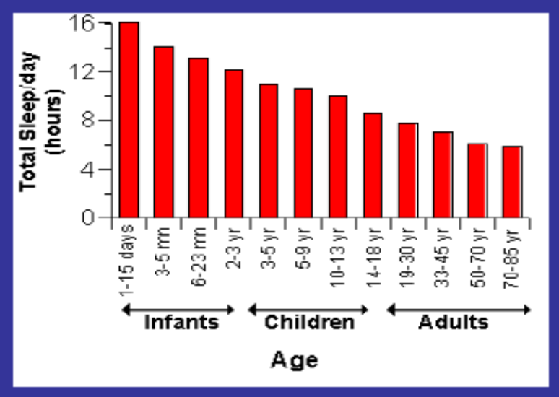
Role of sleep
• Essential for survival.
• Total sleep deprivation fatal.
• Restorative function. R and R.
• Activation of cortex.
• Dreaming as a result of activity.
• Important that cycle be preserved.
• Sleeping pills and alcohol disrupt cycle.

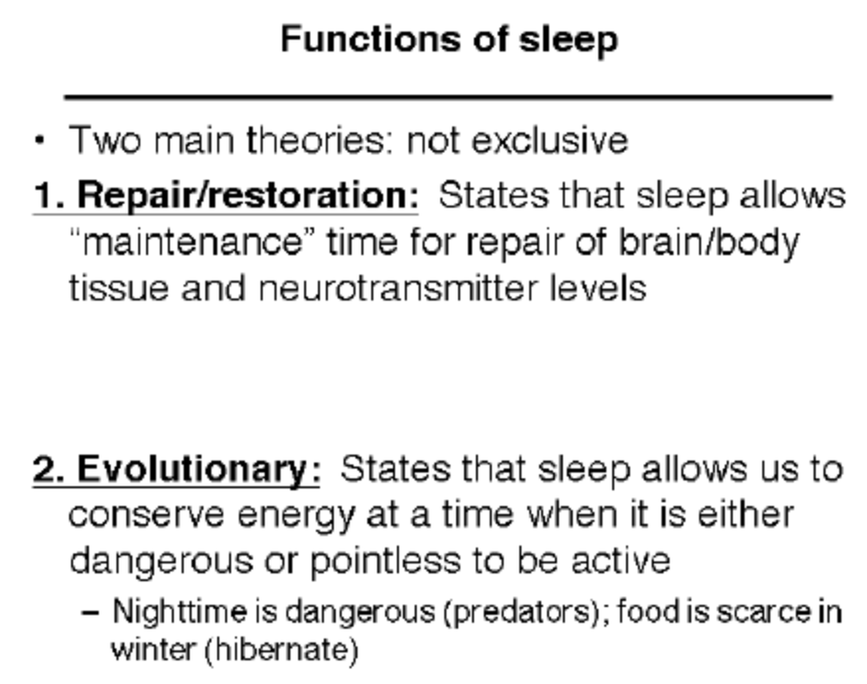
Sleep Deprivation
• Effects of Sleep Loss
– fatigue
– impaired concentration
– immune suppression
– irritability
– slowed performance
• accidents
– planes
– autos and trucks
Do we need sleep? Repair & Rest
1965 – Randy Gardner
Science fair project…break world record of
No sleep (260 hrs) 􀃆 264 hr 12 min = 11 days!!!
“mind over matter”
First night: 15 hrs
Next night: 9 hrs
too bad randy, Mrs. Maureen Weston (1977)
18 days!!!! Rocking chair marathon
Sleep deprivation (3 to 4 hrs)
Humans
1. Increase in sleepiness
2. Mood test
3. Perform poorly on test of vigilance (ex: tones)
2 to 3 days (continuous sleep deprivation)
“Microsleeps” (2 to 3 sec long)
1. Eye lids droop
2. Less responsive to stimuli
3. Still standing
Performance on complex cognitive tasks?????
Performance in motor tests???????
1929, a German psychiatrist: Hans Berger,
Found the it was possible to record the
feeble electric currents generated on the brain,
without opening the skull, and to depict them
graphically onto a strip of paper.
Berger named this new form of recording as
the electroencephalogram (EEG, for short)
First EEG recorded by Hans Berger, circa 1928.
EEG (electroencephalograph)
records electrical activity of
the brain via electrodes
attached to the scalp
•Gross measurement of neuronal activity
takes an average of the whole population
of cells in the area under the electrode
•Output of the electrodes are amplified
and recorded
􀃎EEGs tell you whether a person is asleep,
awake or excited
EEG lingo: Measurement of Brain Waves
Amplitude: index of voltage = larger
the voltage the higher the amplitude
(Height)
Frequency: index of waves across time,
cycles per second (hertz, Hz)
(how often they occur)
2 Basic EEG Patterns:
1. Desynchronized: neurons in the brain
firing at many different times
􀃎 produces EEG patterns of low
amplitude & high frequency
(wakefulness)
2 Basic EEG Patterns:
2. Synchronized: neurons are firing at
the same time – produces well defined
waves of low frequency high
amplitude (characteristic of deep
sleep)
EEG/EMG/EOG
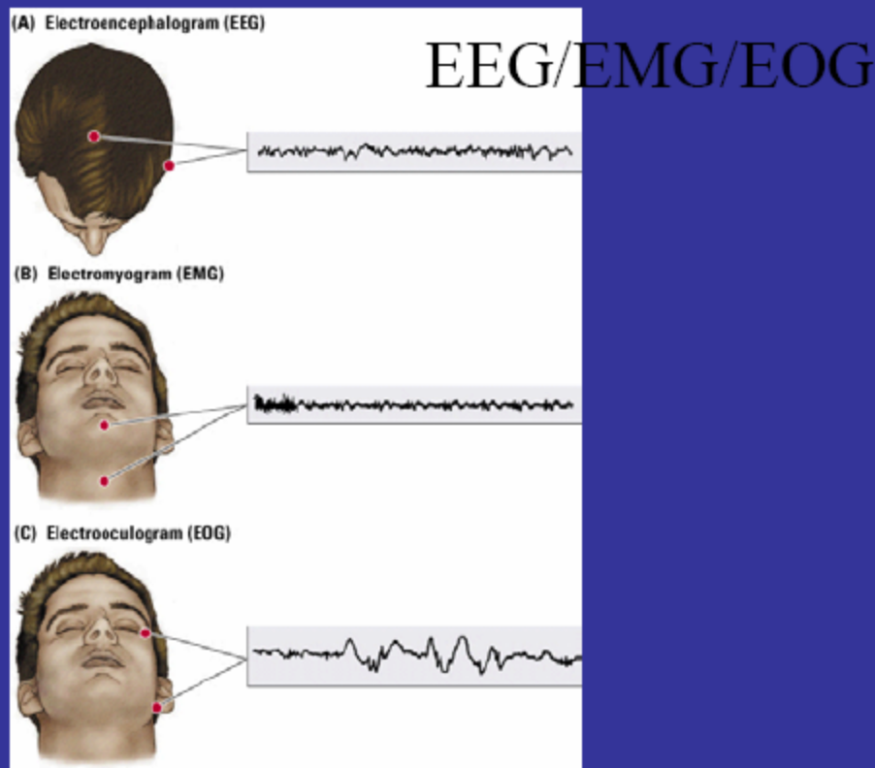
EMG: Electromyogram
- Leg
EOG: Electroculogram
- Eye muscle
There are two divisions of sleep
1. non-rapid eye movement (NREM)
2. rapid eye movement (REM)
Non-Rapid Eye Movement Sleep
About 80% of adult sleep is NREM sleep. NREM sleep is
divided into four stages:
•Stage 1—the drowsy transition from waking to sleeping
•Stage 2—intermediate sleep, when arousal is more
difficult
•Stage 3—the beginning of "deep," or slow-wave, sleep
•Stage 4—the deepest sleep, when there is little contact
with external sensations
During NREM: breathing, heart rates, body temperature, blood pressure decrease.

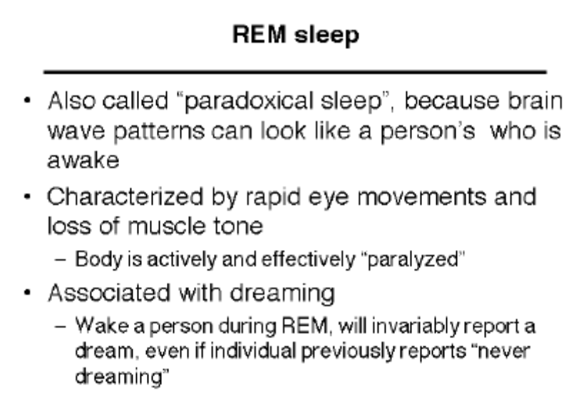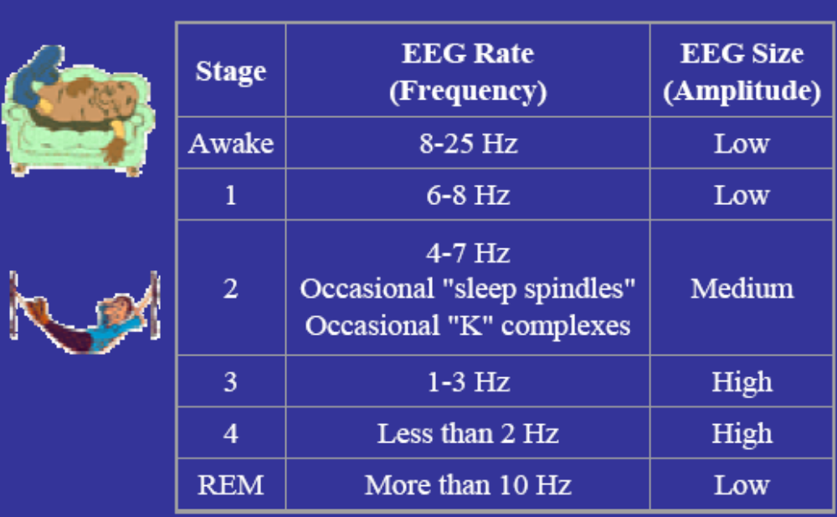
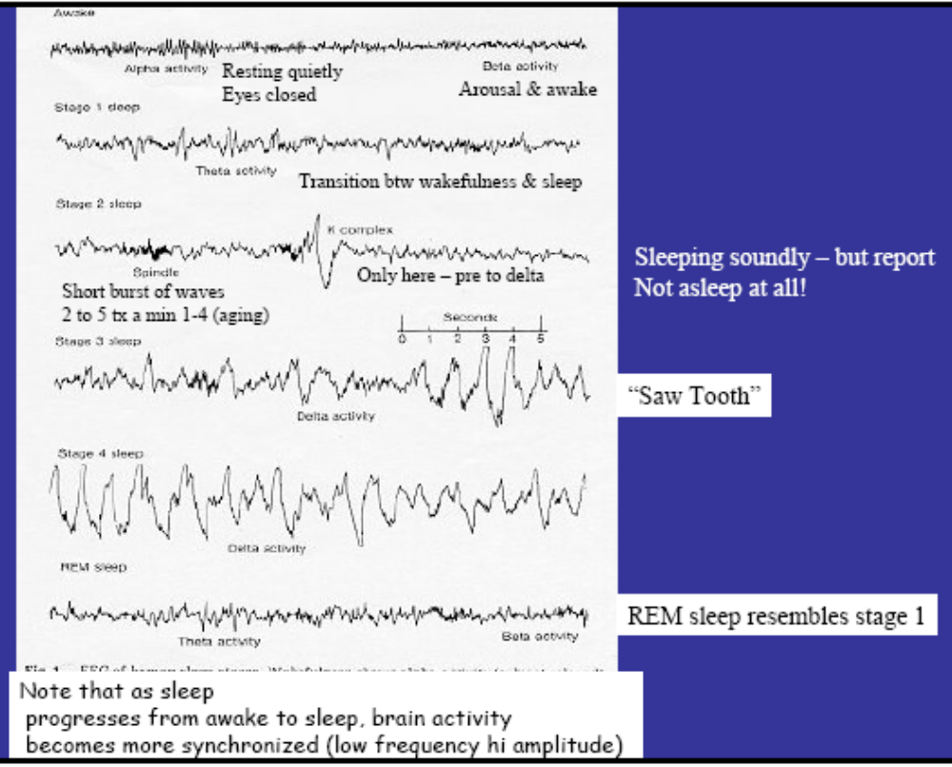
Stage EEG Rate
(Frequency)
EEG Size
(Amplitude)
Awake 8-25 Hz Low
1 6-8 Hz Low
2
4-7 Hz
Occasional "sleep spindles"
Occasional "K" complexes
Medium
3 1-3 Hz High
4 Less than 2 Hz High
REM More than 10 Hz Low
Note that as sleep
progresses from awake to sleep, brain activity
becomes more synchronized (low frequency hi amplitude)
Resting quietly
Eyes closed Arousal & awake
Transition btw wakefulness & sleep
Short burst of waves
2 to 5 tx a min 1-4 (aging)
Only here – pre to delta
Sleeping soundly – but report
Not asleep at all!
REM sleep resembles stage 1
“Saw Tooth”

Dreaming
• Are external stimuli incorporated into
dreams?
– Water was sprayed on dreaming subjects; 14 of
33 dreamed of water.
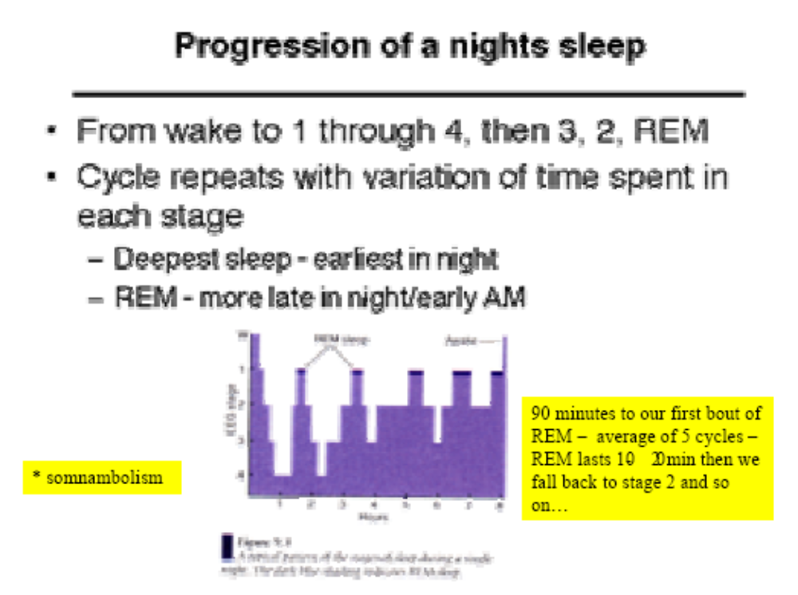
90 minutes to our first bout of
REM – average of 5 cycles –
REM lasts 10- 20 min then we
fall back to stage 2 and so
on…
* somnambolism

REM SLEEP
PGO spiking : Pontine-Geniculate-Occipital
Triggers the onset of REM
1. Waves of neural activity first in the pons
2. Then in the lateral geniculate
3. Then in the occipital cortex
- Wave is synchronized with eye movement
- At this time Pons is also sending inhibitory
messages to the spinal cord 􀃆 motor neurons
Neurochemistry: Pons releases ACh stimulate LGN
(inject carbachol=Ach agonist=REM)

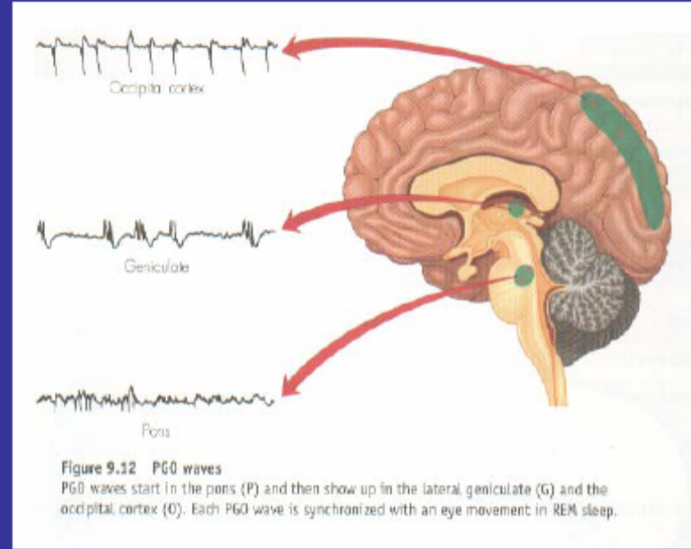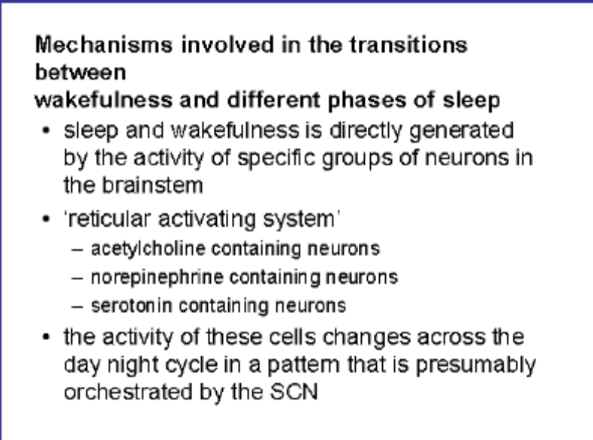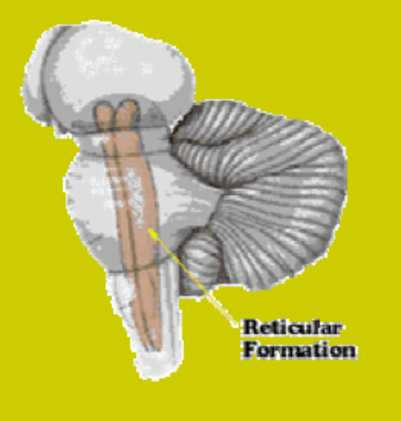
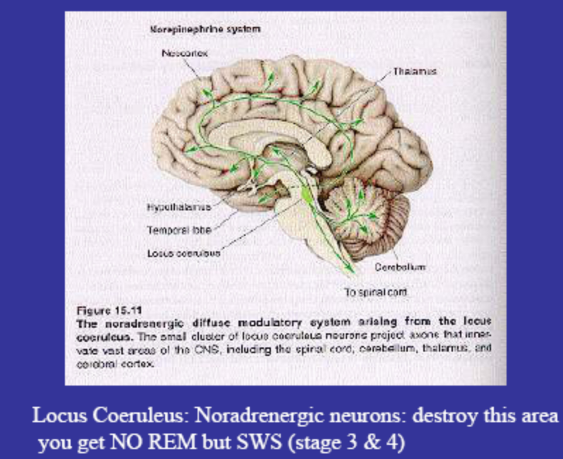
Locus Coeruleus: Noradrenergic neurons: destroy this area
you get NO REM but SWS (stage 3 & 4)

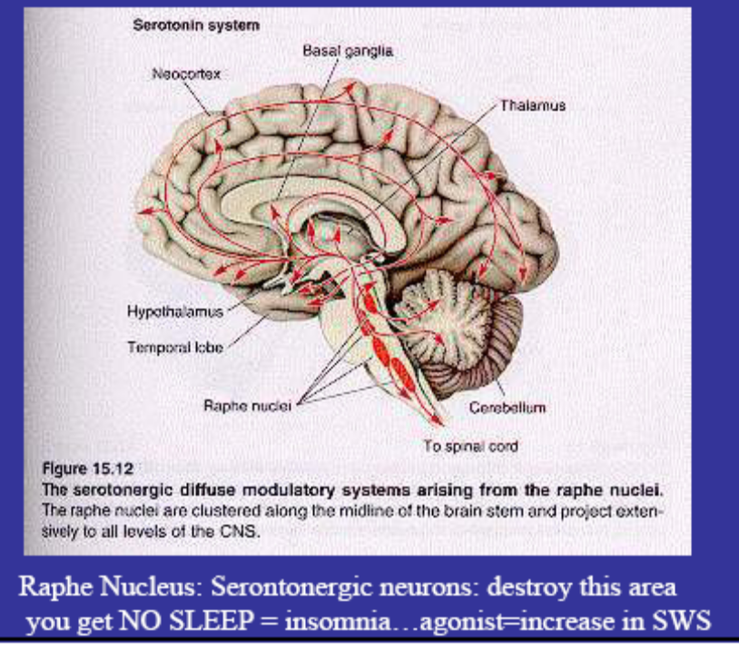
Raphe Nucleus: Serontonergic neurons: destroy this area
you get NO SLEEP = insomnia…agonist=increase in SWS

Narcolepsy (hypersomnia):
- sleeping disorder (1 of 2000)
characterized by periods of
irresistible sleepiness
- "sleep attacks" happen without
warning and can occur even after a
good night's rest
- normally last about 20 minutes
- after waking up, the person feels
refreshed, only to feel sleepy again
a few hours later
- There is no known cause of this
chronic sleep disorder
TX: Antidepressants
Antidepressants tend to
suppress REM sleep
So need more 5HT
Gene found in dogs
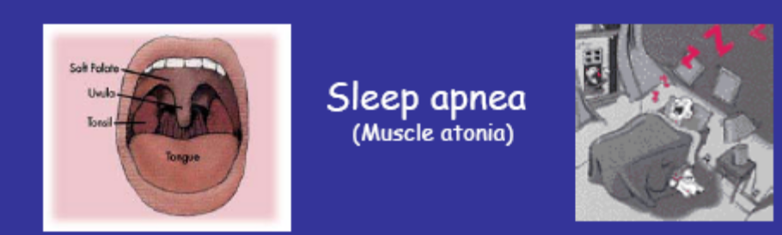
Apnea is a Greek word meaning "want of breath”
disorder characterized by periods of time
when the sleeper stops breathing (apnea) or experiences
a sharp reduction in breathing (hypopnea)
These periods normally last between 10 and 30 seconds,
but can last longer 􀃆 males, overweight & elderly (SIDs)
The person wakes up shortly and falls back asleep, usually not
knowing there had been any interruption in sleep at all. These
"apneic events" can occur as many as 20 or 30 times an hour.
Sleep apnea
(Muscle atonia)
Sleep Disorders
􀂙Insomnia
􀂙Excessive Daytime
Sleepiness
􀂙Narcolepsy
􀂙Sleep Apnea
􀂙Nightmare/Night
terror
􀂙Sleepwalking
􀂙Restless leg

Pathology:
All the disorders discussed by DR. Gall: i.e. sleep disorders

obesity: in some of the common problems associated with obesity: i.e. obstructive sleep apnea (OSP). In OSP, respiratory effort occurs but an airway obstruction stops air from reaching the lungs. It is common in the obese and patients often snore.

Sleep disorders:
Classification:
- DSV-IV-TR classifies sleep into two major categories
  - Dyssomnias
  - Parasomnias

Dyssomnias:
- characterized by problems in the timing, quality, or amount of sleep.
- They include insomnia, narcolepsy, and breathing-related sleep disorder (sleep apnea), as well as circadian rhythm sleep disorder, nocturnal myoclonus, restless leg syndrome and the primary hypersomnias (e.g. Kline-Levin syndrome and menstrual-associated syndrome)

Parasomnias:
- characterized by abnormalities in physiology or in behavior associated with sleep
- they include bruxism (teeth grinding) and sleepwalking as well as sleep terror disorder, REM sleep behavior and nightmare disorders.

Insomnia: Difficulty falling asleep or staying asleep.
- Occurs 3 times per week for at least one month
- Leads to sleepiness during the day
- Causes problems fulfilling social or occupational obligations
- Present in 30% of the population

Psychological causes of insomnia
- include affective and anxiety disorders
- major depressive disorder
- characteristics of the sleep pattern in depression:
  - normal sleep onset
  - repeated nighttime awakenings
  - waking too early in the morning (terminal insomnia) is the most common sleep characteristics of depressed patients
- characteristics of sleep stages in depression:
  - short REM latency: appearance of REM within 4t minutes of falling asleep (what is normal REM latency?)
  - increased REM early in the sleep cycle and decreased REM later in the sleep cycle may lead to waking too early in the morning
  - long first REM period and increased total REM
  - reduced delta sleep (which is the deepest, most relax stage of sleep)

Bipolar disorder:
- manic or hypomanic Pt’s have trouble falling asleep or sleep fewer hours

Anxiety:
- anxious PT’s often have trouble falling asleep

Physical Causes:
- use of CNS stimulants is the most common cause of insomnia. i.e. caffeine
- withdrawal of drugs with sedating action can result in wakefulness
  - ex. Alcohol, benzodiazepines, opiates
- medical conditions causing pain can result in insomnia, as do endocrine and metabolic disorders

Sleep Apnea:
- breathing related sleep disorder
- PT’s with sleep apnea stop breathing for brief intervals
- Low Oxygen or high CO2 levels in the blood awakens the Pt repeatedly during the night
- Resulting in daytime sleepiness
  - central sleep apnea
  - more common in elderly
  - little or no respiratory effort occurs
  - resulting in less air reaching the lungs
  - obstructive sleep apnea
  - respiratory efforts occur, but airway obstruction prevents air from reaching the lungs
  - more common in people between 40-60 year of age
  - more common in men (8:1 male to female ratio)
  - occurs in obese people
  - (pickwinian syndrome is a related condition)
  - characteristic snore
- the exact cause of OSA remains unclear
  - site of obstruction in most Pt’s is soft palate, that extends to region at base of tongue
  - no rigid structures present: i.e. cartilage or bone, in this area to hold airway open
  - during the day, muscles in the region keep the passage wide open. But as a person with OSA falls asleep, these muscles relax to a point where the airway collapses and becomes obstructed
  - when the airway closes, breathing stops, and the sleeper awakens to open the airway
  - the arousal from sleep usually lasts only a few seconds, but brief arousals disrupt continuous sleep
  - once normal breathing is restored, the person falls asleep only to repeat the cycle throughout the night
  - typically, the frequency of waking episodes is somewhere between 10 and 60
    - a person with severe OSA may have more than 100 waking episodes in a single night
  - RISK FACTORS:
    - Excessive weight gain is primary risk factor
      - Accumulation of fat on sides of upper airway becomes narrow and is predisposed to closure when muscle relaxes
  - Pickwinian syndrome affects pt’s with extreme obesity
    - Symptoms include:
      - Excessive daytime sleepiness
      - Shortness of breath
        - Due to elevated CO2 pressure in blood
      - Disturbed sleep at night
      - Flushed face
      - Bluish tint on skin
      - High blood pressure
        - Enlarged liver
        - Abnormally high red blood cell count

Sleep apnea occurs in 1% - 10% of population
- related to depression, headaches, and pulmonary hypertension
- may result in sudden death during sleep in ELDERLY and INFANTS

Central Sleep Apnea:
- rare: caused by lesions in brain stem or metabolic disorder
  - more common in elderly
- cessation of air flow 2ndary to lack of respiratory effort
- Rx: mechanical ventilation or nasal CPAP

Narcolepsy:
- sudden and uncontrollable, (though often brief), attacks of deep sleep, sometimes accompanied by paralysis and hallucinations
- despite having normal amount of sleep at night
  - e.g. may fall asleep suddenly while driving

Other characteristics of Narcolepsy:
- hypnagogic and hypnopompic hallucinations
  - these are strange perceptual experiences which occur just as the patient falls asleep or wakes up, respectively
    - occurs in 20% - 40% of pt’s with narcolepsy
  - very short REM latency -< 10 min
- cataplexy
  - this is sudden physical collapse caused by the loss of all muscle tone after a strong emotional stimulus
    - occurs in 70% of pt’s
- sleep paralysis:
  - inability to move body for a few seconds after waking:
    - occurs in 30% - 50% of pt’s

Narcolepsy is uncommon:
- occurs most frequently in adolescents and young adults
- may be linked to genetic component

Other sleep disorders:
- sleep terror disorder:
  - repetitive experiences of fright in which a person (usually a child) screams in fear during sleep
  - person cannot be awakened and has no memory of having a dream
  - occurs during delta sleep
  - onset in adolescence may indicate temporal lobe epilepsy
- nightmare disorder:
  - repetitive, frightening dreams that cause nighttime awakenings
  - person can usually recall the nightmare
  - occurs during REM sleep
  - how is this different from night terrors?
- Sleepwalking disorder:
  - Repetitive walking around during sleep
  - No memory of the episode
  - Begins in childhood (usually 4-8 years of age)
  - Occurs during delta sleep\
- Enuresis:
  - Delta sleep disorder
  - Boys twice as likely as girls
  - Often history with same sex parent
  - Common after change or new sibling born
    - Rx:
      - Behavioral therapy
      - Imipramine
- Circadian rhythm sleep disorder:
  - Inability to sleep at appropriate times
  - Delayed sleep phase type involves falling asleep and waking later than wanted
  - Jet lag type lasts 2-7 days after a change in time zones
  - Shift work type
  - For example: in physician training
  - Can result in physician error
- Resident should not have more than 80 duty hours/week averaged over a 4 week period:
  - Residents should not have more than 24 hours of continuous duty hours (although 3 hours of “sign out” is allowed)
- Residents must have at least
  - 8-10 hours off between assignments (8 per NYS or 10 per ACGME); residents must have at least one 24 hour duty free period per week

Nocturnal myoclonus:
- repetitive, abrupt muscular contractions in the legs from toes to hips
- causes nighttime awakenings
- more common in elderly

Restless leg syndrome:
- uncomfortable sensation in the legs necessitating frequent motion
- repetitive limb jerking during sleep
- cause difficulty falling asleep and causes nighttime awakenings
- more common with agining, pregnancy, and kidney disease

Primary hypersomnias:
- kleine-Levin syndrome and menstrual-associated syndrome
- recurrent periods of excessive sleepiness occurring almost daily for at least 1 month
- sleepiness is not relieved by daytime naps
- often accompanied by hyperphagia (overeating)
- kleine-levin syndrome is more common in adolescence males

Menstrual associated syndrome:
- hypersomnia and hyperphagia occurring only in the premenstrual period

Sleep drunkenness:
- difficultly awakening fully after adequate sleep
- rare, must be differentiated from substance abuse or other sleep disorder
- associated with genetic factors

REM sleep behavior disorder:
- REM sleep without skeletal muscle paralysis
- Pt’s can injure themselves or their sleeping partners

Treatment of Major Sleep Disorders:
- insomnia:
  - avoid caffeine (especially before bedtime)
  - development of a series of behaviors associated with bedtime
    - e.g. sleep ritual or sleep hygiene
  - maintaining a fixed sleeping and waking schedule
  - daily exercise
  - relaxation techniques
  - psychoactive agents
  - for e.g.: limited use of sleep agents to establish an effective sleep pattern and antidepressants or antipsychotics if appropriate
- Obstructive sleep apnea:
  - Weight loss
  - Continuous positive airway pressure (CPAP)
    - A device applied to the face at night to gently more air into the lungs
  - Surgery to enlarge the airway (uvulopalatoplasty)
  - Tracheostomy (as a last resort)
- Narcolepsy
  - Stimulant drugs
    - E.g. methylphenidate (Ritalin)
      - If cataplexy is present, antidepressants may be added
  - Timed daytime naps

Question:
A Pt reports that he is sleepy all day despite having 8 hours of sleep each night.
His wife reports that his loud snoring keeps her awake
Of the following, the best Rx for this Pt is?
- continuous positive airway pressure: answer
- an antipsychotic agent
- a stimulant agent
- development of a “sleep ritual”

You can leave CFS and Neurostamia:

Chronic Fatigue Syndrome:
Also named:
CEBV: chronic Epstein-barr syndrome
Duncan syndrome: CFS resembles and mimics in the same way and may complain of weight lost and fatigue
CFIDS: Chornic fatigue immune dysfunction syndrome:
ME : myalgic encephalitis
Yuppie flux :
- usually strikes middle aged people, but not exclusively
- under diagnosed in younger people. (under 20 years of age)
- comes and goes

part of high yield: READ SELECTIVELY
Ethics
Oaths
and
Declarations
Who Makes Them?
Why?
I SWEAR by Apollo the physician, and Aesculapius, and Health, and All-heal, and all the gods and goddesses, that,
according to my ability and judgment, I will keep this Oath and this stipulation- to reckon him who taught me this Art
equally dear to me as my parents, to share my substance with him, and relieve his necessities if required; to look upon his
offspring in the same footing as my own brothers, and to teach them this art, if they shall wish to learn it, without fee or
stipulation; and that by precept, lecture, and every other mode of instruction, I will impart a knowledge of the Art to my
own sons, and those of my teachers, and to disciples bound by a stipulation and oath according to the law of medicine, but
to none others.
I will follow that system of regimen which, according to my ability and judgment, I consider for the benefit of my
patients, and abstain from whatever is deleterious and mischievous.
I will give no deadly medicine to any one if asked, nor suggest any such counsel; and in like manner I will not give to a
woman a pessary to produce abortion. With purity and with holiness I will pass my life and practice my Art.
I will not cut persons labouring under the stone, but will leave this to be done by men who are practitioners of this work.
Into whatever houses I enter, I will go into them for the benefit of the sick, and will abstain from every voluntary act of
mischief and corruption; and, further from the seduction of females or males, of freemen and slaves.
Whatever, in connection with my professional practice or not, I see or hear, in the life of men, which ought not to be
spoken of abroad, I will not divulge, as reckoning that all such should be kept secret.
While I continue to keep this Oath unviolated, may it be granted to me to enjoy life and the practice of the art, respected
by all men, in all times! But should I trespass and violate this Oath, may the reverse be my lot!
Hippocrates I SWEAR by Apollo the physician, and Aesculapius, and
Health, and All-heal, and all the gods and goddesses,
that, according to my ability and judgment, I will keep
this Oath and this stipulation- to reckon him who taught
me this Art equally dear to me as my parents, to share
my substance with him, and relieve his necessities if
required; to look upon his offspring in the same footing
as my own brothers, and to teach them this art, if they
shall wish to learn it, without fee or stipulation; and that
by precept, lecture, and every other mode of instruction,
I will impart a knowledge of the Art to my own sons, and
those of my teachers, and to disciples bound by a
stipulation and oath according to the law of medicine,
but to none others.
I will follow that system of regimen which, according to my
ability and judgment, I consider for the benefit of my patients,
and abstain from whatever is deleterious and mischievous.
I will give no deadly medicine to any one if asked, nor
suggest any such counsel; and in like manner I will not give
to a woman a pessary to produce abortion.
*******
I will not cut persons labouring under the stone, but will leave
this to be done by men who are practitioners of this work.
***
With purity and with holiness I will pass my life and
practice my Art.
***
Into whatever houses I enter, I will go into them for the
benefit of the sick, and will abstain from every voluntary
act of mischief and corruption; and, further from the
seduction of females or males, of freemen and slaves.
Whatever, in connection with my professional practice or
not, I see or hear, in the life of men, which ought not to be
spoken of abroad, I will not divulge, as reckoning that all
such should be kept secret.
Whatever, in connection with my professional practice or not,
I see or hear, in the life of men, which ought not to be spoken
of abroad, I will not divulge, as reckoning that all such should
be kept secret.
While I continue to keep this Oath unviolated, may it be
granted to me to enjoy life and the practice of the art,
respected by all men, in all times! But should I trespass and
violate this Oath, may the reverse be my lot!
1. Medicine is of all the arts the most noble; but, owing to the
ignorance of those who practice it, and of those who,
inconsiderately, form a judgment of them, it is at present far
behind all the other arts. Their mistake appears to me to arise
principally from this, that in the cities there is no punishment
connected with the practice of medicine (and with it alone)
except disgrace, and that does not hurt those who are familiar
with it. Such persons are the figures which are introduced in
tragedies, for as they have the shape, and dress, and personal
appearance of an actor, but are not actors, so also physicians
are many in title but very few in reality.
The Law of Hippocrates
2. Whoever is to acquire a competent knowledge of medicine,
ought to be possessed of the following advantages: a natural
disposition; instruction; a favorable position for the study;
early tuition; love of labour; leisure. First of all, a natural
talent is required; for, when Nature leads the way to what is
most excellent, instruction in the art takes place, which the
student must try to appropriate to himself by reflection,
becoming an early pupil in a place well adapted for
instruction. He must also bring to the task a love of labour
and perseverance, so that the instruction taking root may
bring forth proper and abundant fruits.
3. Instruction in medicine is like the culture of the
productions of the earth. For our natural disposition, is, as it
were, the soil; the tenets of our teacher are, as it were, the
seed; instruction in youth is like the planting of the seed in the
ground at the proper season; the place where the instruction is
communicated is like the food imparted to vegetables by the
atmosphere; diligent study is like the cultivation of the fields;
and it is time which imparts strength to all things and brings
them to maturity.
4. Having brought all these requisites to the study of
medicine, and having acquired a true knowledge of it, we
shall thus, in travelling through the cities, be esteemed
physicians not only in name but in reality. But inexperience is
a bad treasure, and a bad fund to those who possess it,
whether in opinion or reality, being devoid of self-reliance
and contentedness, and the nurse both of timidity and
audacity. For timidity betrays a want of powers, and audacity
a lack of skill. They are, indeed, two things, knowledge and
opinion, of which the one makes its possessor really to know,
the other to be ignorant.
5. Those things which are sacred, are to be imparted only to
sacred persons; and it is not lawful to impart them to the
profane until they have been initiated into the mysteries of the
science.
“Next in ingenuity to the old marriage custom is their
[Babylonians’] treatment of disease. They have no doctors,
but bring their invalids out into the street, where anyone who
comes along offers the sufferer advice on his complaint,
either from personal experiences or observation of a similar
complaint in others. Anyone will stop by the sick man’s side
and suggest remedies which he himself proved successful in
whatever the trouble may be, or which he has known to
succeed with other people. Nobody is allowed to pass a sick
person in silence; but everyone must ask him what is the
matter.” Herodotus Bk 1, 197.
Ancient Ways
“The practice of medicine they [Egyptians] split up into
separate parts, each doctor being responsible for the treatment
of only one disease. There are, in consequence, innumerable
doctors, some specializing in diseases of the eyes, others of
the head, others of the teeth, others of the stomach, and so on;
while others again deal with the sort of troubles which cannot
be exactly localized.”
Herodotus Bk 2, 84.
Trials: 1945-1949
International Tribunal: Major War Crimes.
24 accused= 12 death penalty, 7 imprisonment, 3 acquitted,
1 unfit, 1 suicide.
US Military tribunal: Doctors’ Trial
23 accused= 7 death penalty, 9 imprisonment, 7 acquitted.
Nuremberg
Doctors’ Trial: the accused faced four charges:
• Conspiracy to commit war crimes and crimes against
humanity as described in counts 2 and 3; (charge dropped)
• War crimes: performing medical experiments without the
subjects' consent on prisoners of war and civilians of
occupied countries, as well as participation in the massmurder
of concentration camp inmates.
• Crimes against humanity: committing crimes described
under count 2 also on German nationals.
• Membership in a criminal organization, the SS.
Nuremberg
Doctors’ Trial:
“Generally, the difference between a prison term and the
death sentence was membership in "an organization
declared criminal by the judgement of the International
Military Tribunal" — namely the SS.”
1933: Law for the protection of Hereditary Health. Prescribed
sterilization for :feeblemindedness, schizophrenia, manic-depression,
epilepsy, hereditary blindness, deafness, Huntingdon’s, alcoholics.
Drawn up by the Nazi party, which was very Nationalistic, and anti-
Bolschevik, under guidance of Dr. Rudin, University of Munich.
Nuremberg
Studied in Munich 1930, Philosophy and Medicine.
Nationalism stirring.
Eugenics, and anthropology: PhD on racial morphology of lower jaw.
1937: appointed, Institute for Hereditary, Biology and Racial
Purity, Frankfurt, as research assistant to von Vershuer,
who became father figure.
Became Nazi Party member, and later allowed to join the SS
Joined Army, awarded Iron Cross twice, wounded;
1943: Assigned to Auschwitz (Birkenau). Aborted a typhus
epidemic by killing a thousand (non-German) gypsies.
Carried out research, especially on twins (“Mengele’s
Children”), dwarfs and cripples
Josef Mengele
6 Million European Jews (4.5 m from Poland or Russia,
125,000 from Germany)
3.5 – 6 million ‘Slavs’
3.5 million non-Jewish Poles
Approx 4 million Russian PoW
Approx 1.5 million political dissidents
500,000 Gypsies
15,000 Homosexuals
2,000 Jehovah’s Witnesses
‘Holocaust’
Hypothermia
Genetics: defects and eugenics
Infectious diseases
High altitude experiments
Traumatic wounds and infection
Sterilization
Twin anthropology.
Experiments
• Full, voluntary, informed, consent
• Well planned and necessary and justifiable
• Based on knowledge and previous work (or animal
experiments)
• Avoid unnecessary physical and mental suffering
• Not if death or disabling injury likely, save on the
experimenters themselves
• Risk justified by the importance of the anticipated results
• All adequate precautions against injury or death
• Experimenters must be qualified skilful, careful scientists
• Experiment terminated at request of subject
• Or if likely to terminate in injury, disability or death.
WMA
Nuremberg Code
Declaration of Geneva (1948, 1968, 1983, 1994, 2005)
International Code of Medical Ethics (1949, 1968, 1983)
Declaration of Helsinki: Ethical Principles for Medical Research Involving Human Subjects
(1964, 1975, 1883, 1989, 1996, 2000, 2002, 2004)
Declaration of Oslo on Therapeutic Abortion (1970, 1983)
Declaration of Tokyo: Guidelines for Medical Doctors Concerning Torture and Other Cruel,
Inhuman or Degrading Treatment or Punishment in Relation to Detention and
Imprisonment (1975, 2005)
Declaration of Lisbon on the Rights of the Patient (1981, 1995, 2005)
Declaration of Venice on Terminal Illness (1983)
Declaration of Madrid on Professional Autonomy and Self- Regulation (1987)
Declaration of Hong Kong on the Abuse of the Elderly (1989, 1990)
Declaration of Hamburg Concerning Support for Medical Doctors Refusing to Participate in,
or to Condone, the Use of Torture or Other Forms of Cruel, Inhuman or Degrading
Treatment (1997)
Declaration of Ottawa on the Right of the Child to Health Care (1998)
Declaration on Ethical Considerations Regarding Health Databases (2000)
Declaration of Washington on Biological Weapons (2002)
WMA Declaration of Geneva
DUTIES OF PHYSICIANS IN GENERAL
A PHYSICIAN SHALL always maintain the highest standards of
professional conduct.
A PHYSICIAN SHALL not permit motives of profit to influence the
free and independent exercise of professional judgement on behalf of
patients.
A PHYSICIAN SHALL in all types of medical practice, be dedicated to
providing competent medical service in full technical and moral
independence, with compassion and respect for human dignity.
A PHYSICIAN SHALL deal honestly with patients and colleagues, and
strive to expose those physicians deficient in character or
competence, or who engage in fraud or deception.
WMA Declaration of Geneva
The following practices are deemed to be unethical conduct:
1. Self advertising by physicians, unless permitted by the
laws of the country and the Code of Ethics of the National
Medical Association.
2. Paying or receiving any fee or any other consideration
solely to procure the referral of a patient or for prescribing
or referring a patient to any source.
WMA Declaration of Geneva
A PHYSICIAN SHALL respect the rights of patients, of
colleagues, and of other health professionals and shall
safeguard patient confidences.
A PHYSICIAN SHALL act only in the patient's interest
when providing medical care which might have the effect
of weakening the physical and mental condition of the
patient.
A PHYSICIAN SHALL use great caution in divulging
discoveries or new techniques or treatment through nonprofessional
channels.
A PHYSICIAN SHALL certify only that which he has
personally verified.
WMA Declaration of Geneva
DUTIES OF PHYSICIANS TO THE SICK
A PHYSICIAN SHALL always bear in mind the obligation
of preserving human life.
A PHYSICIAN SHALL owe his patients complete loyalty
and all the resources of his science. Whenever an
examination or treatment is beyond the physician's
capacity he should summon another physician who has
the necessary ability.
A PHYSICIAN SHALL preserve absolute confidentiality on
all he knows about his patient even after the patient has
died.
A PHYSICIAN SHALL give emergency care as a
humanitarian duty unless he is assured that others are
willing and able to give such care.
WMA Declaration of Geneva
DUTIES OF PHYSICIANS TO EACH OTHER
A PHYSICIAN SHALL behave towards his colleagues as he
would have them behave towards him.
A PHYSICIAN SHALL NOT entice patients from his
colleagues.
A PHYSICIAN SHALL observe the principles of the
"Declaration of Geneva" approved by the World Medical
Association.
WMA Declaration of Geneva
AT THE TIME OF BEING ADMITTED AS A MEMBER
OF THE MEDICAL PROFESSION:
I SOLEMNLY PLEDGE to consecrate my life to the service
of humanity;
I WILL GIVE to my teachers the respect and gratitude that is
their due;
I WILL PRACTISE my profession with conscience and
dignity;
THE HEALTH OF MY PATIENT will be my first
consideration;
I WILL RESPECT the secrets that are confided in me, even
after the patient has died;
I WILL MAINTAIN by all the means in my power, the
honour and the noble traditions of the medical profession;
MY COLLEAGUES will be my sisters and brothers;
I WILL NOT PERMIT considerations of age, disease or
disability, creed, ethnic origin, gender, nationality,
political affiliation, race, sexual orientation, social
standing or any other factor to intervene between my duty
and my patient;
I WILL MAINTAIN the utmost respect for human life;
I WILL NOT USE my medical knowledge contrary to the
laws of humanity, even under threat;
I MAKE THESE PROMISES solemnly, freely and upon my
honour.
AMA
Principles of medical ethics
A physician shall be dedicated to providing competent medical care, with
compassion and respect for human dignity and rights.
A physician shall uphold the standards of professionalism, be honest in all
professional interactions, and strive to report physicians deficient in
character or competence, or engaging in fraud or deception, to
appropriate entities.
A physician shall respect the law and also recognize a responsibility to
seek changes in those requirements which are contrary to the best
interests of the patient.
A physician shall respect the rights of patients, colleagues, and other
health professionals, and shall safeguard patient confidences and
privacy within the constraints of the law.
A physician shall continue to study, apply, and advance scientific
knowledge, maintain a commitment to medical education, make
relevant information available to patients, colleagues, and the
public, obtain consultation, and use the talents of other health
professionals when indicated.
A physician shall, in the provision of appropriate patient care, except in
emergencies, be free to choose whom to serve, with whom to
associate, and the environment in which to provide medical care.
A physician shall recognize a responsibility to participate in activities
contributing to the improvement of the community and the
betterment of public health.
A physician shall, while caring for a patient, regard responsibility to the
patient as paramount.
A physician shall support access to medical care for all people.
Adopted by the AMA's House of Delegates June 17, 2001.
GMC
The duties of a doctor registered with the General Medical Council
Patients must be able to trust doctors with their lives and well-being. To
justify that trust, we as a profession have a duty to maintain a good
standard of practice and care and to show respect for human life. In
particular as a doctor you must:
• make the care of your patient your first concern;
• treat every patient politely and considerately;
• respect patients' dignity and privacy;
• listen to patients and respect their views;
• give patients information in a way they can understand;
• respect the rights of patients to be fully involved in decisions
about their care;
• keep your professional knowledge and skills up to date;
• recognize the limits of your professional competence;
• be honest and trustworthy;
• respect and protect confidential information;
• make sure that your personal beliefs do not prejudice your
patients' care;
• act quickly to protect patients from risk if you have good reason
to believe that you or a colleague may not be fit to practise;
• avoid abusing your position as a doctor; and
• work with colleagues in the ways that best serve patients'
interests.
In all these matters you must never discriminate unfairly
against your patients or colleagues. And you must
always be prepared to justify your actions to them.

Problems solved?
Tuskegee
Willowbrook
Jewish Chronic Disease Hospital
OC trial, Mexico (exp. pgcy)
Irradiation
Castration

• 1929, USPHS was interested in the
prevalence of syphilis among blacks
(originally to see if mass treatment
feasible)
• Macon County, Alabama had highest rates
• In 1932, Taliaferro Clark, Chief of USPHS
VD division devised a “study in nature”
• Because syphilis was so prevalent, they
wanted to study natural history of it
The Tuskegee Syphilis Study
copied from a lecture by Julie Fagan MD
10
Erroneous assumptions:
– Blacks were more prone to disease, vice, and crime
– Black males had excessive sexual desire, especially of
white women
– Treatment for VD in blacks was impossible, because
they would only accept treatment when symptomatic,
but not for latent infection
• USPHS believed that antisyphilis treatment might prove
unnecessary
– Based on Oslo study (1890-1910), which began when
only ineffective treatment (mercurials) available
– Because syphilis becomes latent (undetectable), 70% of
untreated pts unaffected
The Tuskegee Syphilis Study
However, every textbook at the outset of the Tuskegee
study (1932) recommended treating it, even at
advanced (latent) stages
• Rationale: though treatment difficult, it allayed
development of CV and CNS disease
– Also, treatment prevented transmission to partners and
offspring
• Study design: 400 Black males 25-60 with syphilis, who
were given an examination, X-rays, and a spinal tap
to document neurosyphilis (200 controls)
• Although they offered treatment to entice men to enroll,
the USPHS had no intention of treating
• Original study to last 6 months--it lasted 40 years
The Tuskegee Syphilis Study
• Deception: men given ineffective treatment (mercurial
ointment and arsenic compounds) to maintain
interest
• PHS decided to continue study until death of subjects in
1933
• $50 for burial given as an inducement for autopsy
consent
• Results published regularly beginning in 1936
• Documented the ravages of untreated syphilis--
– 84% of subjects had complications vs. 39% of control
subjects
• Life expectancy reduced by 20%
• Over 30% of deaths due directly to advanced syphilis in
“test” group
The Tuskegee Syphilis Study
HEW Final Report in 1972
• Concluded that the 40-year longitudinal study was
ethically unjustified
– Failed to obtain informed consent
– However, they did not expose the egregious fact of
deception: men were promised treatment and were
observed, despite availability of penicillin
Clinton issued formal apology in 1997
The Tuskegee Syphilis Study
11

Willowbrook
Institution for Mentally Retarded in NY with long waiting
list
• High prevalence of Hep B (almost 100%)
• Subjects injected with Hep B to assess antibody
response, and those whose parents gave consent
were admitted preferentially
• Patients kept in special quarters and supervised
• Hep B vaccine developed successfully.

Jewish Hospital
1963
22 terminally ill patients injected with live
cancer cells, so that spread or rejection
could be assessed at autopsy
Had given oral consent ot experiment, but
not told they wouyld be injected with
cancer

OC Trial
1971. Placebo controlled OC trial in 76
patients (placebo being a vaginal cream,
though participants not told less
effective)
Showed that OC were effective: 10 preg. In
placebo group.
Abortion not legally available
Most subjects were RC

Others
Prisoners offered early discharge if agreed
to irradiation of testicles.
Patients receiving radiotherapy were given
excessive doses to assess effect of
irradiation, (at request of Military)
Etc, etc, etc.

Conclusions
Were all these experimenters
monsters?
Task: is there an alternative scenario for
the Tuskegee study?
Medical Ethics
Truthful Disclosure
Medical Ethics

Truthful Disclosure
• “Being honest with the patient”
• Supported by moral principles:
Fidelity & Autonomy
• Need truthful facts

What if you are not been honest?
• Omitting a fact (success rate=10%)
or distorting information
• Therefore are DECEPTIVE
• Deception= to lie or omission of info
• “therapeutic privilege”
– If harm of disclosure outweighs harm of nondisclosure.
• Trend: Now is Absolute Honesty
• If you “mess up” - you inform the pt’/family
• Disclosure of medical mistakes:
• “If it can’t be fixed,why break it more?”
Reasons against Disclosure
• 1)Legal- fear against Law suit
• 2)Causes unnecessary distress
• 3)Decreased competency as viewed by
colleagues hence getting less referrals (i.e.
poor/unsuccessful post-op result)
• 4)Decrease in trust from patients
Reasons for Disclosure
1)Respect for autonomy-
Allows patient to:
*Decide whether they want to continue
seeing this Dr
*Remedy the mistake
*Opportunity to sue
*Honesty in physician/patient relationship
2)Legal risk of not disclosing
*Fear of patient finding out
3) Obligation to make changes to prevent
recurrence of mistakes.
• Eg. Phenol & LA ankle block.
• Phenol injected instead of local anaesthetic
• BK amputation
• Doctor reads cartridge,shown by nurse
• Label better
• Common practice= check name,dose,dates
• USA- 44,000-98,000 deaths per year 2ndary
to medical mistakes
Use of placebos
• A substance that is administered as a drug
but has no medicinal content, either given to
a patient for its reassuring or used in a
clinical trial of a real drug.
Use of placebos
• Psychological or biological effect?
1) Pain + placebo:
decrease in pain= 1st effect
• Do endogenous opiates(endorphins)
decrease pain?
• How to test?
Give opiate antagonists. So:
• 2) Pain + opiate antag^ + placebo:
No change in pain
Is it ethical to do this?
To have not told patient you are not giving
them real drug in this pain trial.
Types of placebo
1)Therapeutic
2) Diagnostic tool
3) Clinical research
Types of placebo
1)Therapeutic
• Pure- sugar pill. Very few
• Impure- Most common
Is a drug & will have an action but
not for pt’s symptoms
Problems: Deceiving them & therefore
violating informed consent & violating
fidelity (pt expects you to be honest)
Justification for therapeutic
placebo
• Patient insists on prescription
• Alternative is toxic
• High placebo response
Types of placebo cont...
2) Diagnostic tool
• Aids diagnosis
• eg. Pseudoseizures:
• attack resembles epileptic seizure but has
purely psychological causes. Lacks EEG
changes of epilepsy. Sometimes stopped
just by act of will.
• give patient placebo to control “seizure”.
• Helps rule out “fake” seizures
• 3) Clinical research
• Require informed consent eg. placebos used
in drug trials
• Continued monitoring needed
Truthful Disclosure- Unethical
Cases
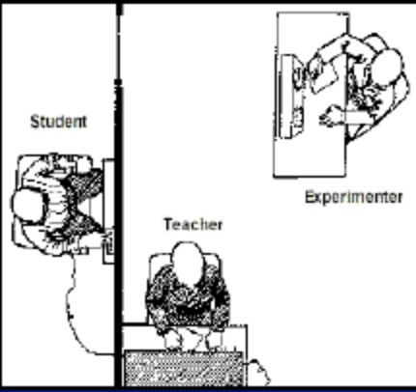
• Stanley Milgram’s study on
Obedience
• 1961-1962
• Subjects= teachers
• Experiment to implement
punishment using shock.
• Wrong answers then shock
• Caused significant distress to
subjects

Case
“Don’t Tell Mother”
Withholding Information from a
Patient
The Case
• Lillian 84 y.o.
• Developed dysphagia
• Not concerned by sx (mild,”eats too fast”)
• Son concerned. Persuades medical eval^
• Workup: reveals mediastinal mass
impinging on esophagus
• Biopsy recommended
• If Ca- need immediate surgery(incl.
Laryngectomy & tracheostomy)to avoid
obstruction
• Radiotherapy & chemotherapy produce
palliation but not cure expected
• Even with rx obstruction likely but later
date
• Otherwise appears healthy. Severe hearing
loss
• Time & patience for explanations. Alert,
orientated & appears mentally intact.
• Apartment next to son & family
• Transport dependent on them
• Able to make decisions(daily living)
• Not asked many specific questions about
current situation (Dr’s relief)
• Son tells Dr not to tell mother diagnosis b/c
will not tolerate news nor disfiguring
operation
• Son reports hx of pt’s depression & takes
appearance as top priority
• Son argues her sx are mild & have not
progressed significantly over 2 years
• Tumor unusual & no radical rx need
perhaps
• Even if it is malignant son states, mother is
84yrs & may die of an unrelated cause so
this invasive plan of care is not appropriate.
1)How valid is the son’s argument that the
progress of his mother’s tumor eliminates the
need for an invasive care plan?
Progress of tumor has been slower than
expected; her sx have not progressed & no
loss of weight.
Incidence of cancer increases with age & only
a few specific malignancies are more
aggressive in older individuals. Majority in
the elderly population are less aggressive,
non-metastatic & less often the cause of
death.
• Any apparent reduction in cancer
aggressiveness may represent vulnerability
to higher prevalence of CVS or
cerebrovascular dz.
• Controversy over prognosis of CA among
very old in general remains unresolved.
• In any case, it is not possible to predict the
course of Lillian’s tumor.
Ethical & Legal Considerations
• 2) Should Lillian be told her diagnosis?
• Physician’s primary obligation is to the
patient-Lillian.
• The principle of truthful disclosure/selfdetermination
requires the physician to
disclose to patient all reasonable
information relevant to her condition and
treatment options so can make individually
appropriate decision.
• Info included upset Lillian but sensitive
approach to deliver news.
• Information upsetting is not justification to
withhold from pt.
• Physician in this case take time to
communicate if hearing impairment is a
barrier. Written explanations effective or
son assist in disclosure in the doctor’s
office.
• News not be delivered quickly. Gradual
process adopt & inform in a way
emotionally tolerated.
• Only way to confirm if Lillian wants
shielding from distressing info is to hear her
own thoughts thro dialogue.
• Statistics- Most people want to hear details
of their situation, even if info is burdensome
or devastating.
• Physicians should directly inquire to
particular preferences of individual pt’s
rather than presume.
• Lillian has right to decide whether wants
treatment. Can only decide if informed of
dx.
• Important to know if palliative approach or
more aggressive cure-orientated approaches
to her condition required
2)Could a decision be made to withhold
info from Lillian based on her son’s
warning about her emotional state?
• There are limited situations where justified.
• Physician may be excused from disclosing
info to pt where sufficient evidence that pt
is not psychiatrically or emotionally
equipped to consider the info or that
disclosure of info itself would pose serious
& immediate harm to pt.
• Eg. by inducing some physiologic response
such as a MI or prompting suicidal
behaviour
• Known as therapeutic exception to informed
consent process.
• In this limited scenario: benefit to be
achieved by disclosure is outweighed by the
harm induced from the disclosure itself.
• In this case: son believes info could harm
Lillian, perhaps causing deep depression.
Given the apparent closeness of his
relationship with mother, cannot lightly
dismiss his concerns.
10
• However, important to further explore
Lillian’s psychiatric hx, values & current
state of mind before concluding that son
was right.
• Even if therapeutic exception utilized here,
physician is not relieved of the obligation to
continually attempt to involve the pt in
decision process & prepare her for problems
that may arise.
3)Can it be concluded that Lillian has
delegated her decision-making authority
to her son?
• Clearly, son heavily involved in medical
decisions(started diagnostic path)
• The fact that a pt would rely on her son for
advice & support is natural & even
justifiable in view of their close
relationship.
• Not clear though is if Lillian wishes son to
take her place in decision making.
• If she wishes, then has right to make
delegation of authority.
• She could execute a health care power of
attorney or proxy, formalizing her decision
to have her son make medical decisions on
her behalf. Authority usually activated once
decisional capacity lost.
• The pattern in this case certainly suggests
Lillian;s son be authorized decision maker.
• Delegation of decisional authority clearly
established by physician. Not presumed.
• If pt has decisional capacity then physician
has no right to discuss pt’s medical care
with others unless the pt gives permission
for this (info is confidential)
• Physician ask directly whether she wants
son to be involved in the decision process &
to what extent, & whether she wants all or
part of info about her condition disclosed to
him.
• In this case: No conclusion of delegation
authority to son. Finally….
11
• The information he has conveyed could
well be highly pertinent; furthermore,
excluding him outright would alienate him
& might disrupt a therapeutic relationship
between physician & patient.

LOW YIELD: for those aiming for 100%

IMPORTANT
Legal definition of minor- In most states, any person under 18 years of age. All minors must be under the care of a competent adult (parent or guardian) unless they are "emancipated"--in the military, married or living independently with court permission. Property left to a minor must be handled by an adult until the minor becomes an adult under the laws of the state where he or she lives.

Emancipated minor- married, or in military, or have children, or independent- make their own decision.
- You are at least 14 years old.
- You willingly want to live separate and apart from your parents with the consent or acquiescence of your parents. (Your parents do not object to you living apart from them.)
- You can manage your own finances.

Truthful disclosure- TUSEGEE CASE:

Low yield
Justification for therapeutic placebo-
Placebos can be physical (e.g., a manipulation), pharmacological (e.g., a pill) or psychological (e.g., a conversation). Double-blind and placebo-controlled trials have sometimes been the source of anxiety on the part of the public or of prospective participants, usually because an element of deception seems to be involved, or because patients who are allocated to the control group (which might, e.g., not receive a new treatment) may seem to be at an unfair disadvantage. Anxiety on both of these counts is quite understandable if certain conditions fail to be met when the trial is proposed.
The scientific justification for the use of placebo preparations is set out above. Their use is ethical if patients give consent in advance. However, there is "little evidence in general" that placebos had powerful clinical effects. The authors state "outside the setting of clinical trials, there is no justification for the use of placebos."

Rights and privileges.

• Next case of violation:
• Jehovah witness 11 y.o. girl
• Trauma patient- child unconscious
• Needs surgery & blood transfusion
• Mother refuses transfusion b/c of religion.
• Even if child will die, mother refuses rx
• Court rules- BEST INTEREST
• Therefore rx^ed the patient
Termination of Treatment
• Federal Law- Child Abuse Amendments
of 1984
• Includes regulations to ensure
appropriate medical therapy for
disabled infants
• Mandates life supporting/saving medical
treatment(LSMT)
• Exceptions= permanent
unconsciousness, futile rx imposing
excessive burdens
AMA’s position on seriously ill infants
• LSMT may be withheld if pain overrides
comfort or no experience of emotion
due to brain damage.
• Law & ethics state, if suffering & no joy
then “plug” can be pulled.
Research with Children
• FDA Modernization Act:
• Pediatric drug trials are mandated on all
drugs which are approved for adults
before they can be routinely used for
children.
• Federal regulations:
• Parental consent always
• Childs consent usually ( but if refuses
then not in trial)

The Case
A man was injured when his car was
rear-ended by another car. The other
car was being driven by a person
diagnosed with epilepsy.
The Case, continued
The patient diagnosed with epilepsy had
a seizure right before the collision,
causing him to lose control of his
automobile and crash into the car
ahead of him.
15
The Case, continued
The man in the first car sued the patient
and received a settlement award of
$100,000.
The Suit
After this settlement, the man also sued
the patient’s physician.
This suit claimed negligence by failing to
warn the patient not to drive while
under the influence of an anti-seizure
medication (Dilantin with
phenobarbital).
The Court
• The trial court dismissed the case.
• On appeal the court affirmed the
dismissal order.
• The case was dismissed based on
proximate cause.
What Do You Think?
• What does proximate cause mean?
• Who/what caused the accident?
• Was the physician directly responsible
for the accident?

Summary
• There was no evidence that the
accident had been proximately caused
by the physician’s failure to warn the
patient about taking the anti-seizure
medication.
• Contrary, evidence suggested the
accident was proximately caused by the
patient’s seizure.
Werner v. Varner, Stafford & Seaman, P.A., 659 So. 2d 1308 (Fla.
Dist. Ct. of App., Sept. 6, 1995).

Stages of life ? According to Erickson

Erickson theory deals with the ego part of Freud’s idea. He believed that if stages wasn’t managed well, it would result in malignancy (too much negativity, less positivity) and Maladaptation (too much positive, little negative).

Stage 1: Infant- 0 to 1 yr old
- Trust vs Mistrust – (oral sensory stage)

Stage 2: Toddler - 2 to 3yrs
- Autonomy vs shame and doubt
- Regulaton of child’s behaviour e.g. Toilet training
  - If rewarded child develops sense of autonomy.
  - Impulsiveness, compulsiveness (everything must be done perfectly)

Stage 3: Pre school stage : 5 to 6
- Initiative vs guilt
- Ruthlessness (don’t care who they step on to achieve their goals)
- Inhibition…too much guilt, too afraid to try, loose and to feel. In future, they could develop impotency and be frigid.

Stage 4: School age - 7 to 12
- Industry vs Inferiority
- Child competes with peers in development of intellectual, social and physical environment.
- Sense of self accomplishment and confidence
- Inferiority (too little success) leading to sexism, racisms etc..

Stage 5: Adolescent stage – 12 to 18yrs
- Ego Identity vs Role confusion
- Stage focuses on development of interpersonal relationships with peers
- Becomes sexually intimate

Stage 6: Young adult – 20’s
- Intimacy vs isolation
- Achieves real intimacy with life partner as opposed to being isolated
Stage 7: Middle Adulthood - 20 to 50’s
  - Generativity vs self absorption
  - Provides for family
  - Can experience midlife crisis

Don’t bother with 8th stage
PREGNANCY,
Growth & Development
PREGNANCY
- According to CDC national statistics, total pregnancy count in 2002 includes about 4 million live births, 1.3 million induced abortions and 1 million other causes of fetal losses. (miscarriages, stillbirths)
- Cessation of sexual activity is required during last 4 weeks of pregnancy
- Extramarital affairs are likely to be in third trimester due to reduction or cessation of sexual activity---- if that is the reason.
- Spousal abuse occurs in 6% of women and is most likely to occur in first trimester. Increases risk for miscarriage, abortion and neonatal death.
- Mood changes are very common in pregnancy due to biological factors and psychological factors

Teenage pregnancy
About 1 million teenage become pregnant each year
- 10% of all teenage girls
- 50% of all unwed mothers are teenagers
- 50% actually have the child
- 33% have elective abortions
- About 17% have spontaneous abortion
- About 33% of girls aged 15-19 have at least one unwanted pregnancy
- Single mothers account for 70% of births to girls aged
15-19

Teenage pregnancy
CONSEQUENCES
FOR MOTHER:
LEADING CAUSE OF SCHOOL DROPOUT
HIGH RISK OF OBSTETRIC COMPLICATIONS
FOR CHILD:
NEONATAL DEATH AND PREMATURITY
LOWER LEVEL OF INTELLECTUAL FUNCTIONING
PROBLEMS OF SINGLE PARENT FAMILY
( DELINQUENCY, SUICIDE)

BIRTH RATE, INFANT MORTALITY AND CESAREAN
- ABOUT 4 MILLION CHILDRENS ARE BORN EACH YEAR IN UNITED STATES
- INFANT MORTALITY
- RATES PER 1000 LIVE BIRTH ARE AS:
- WHITES 6.0
- BLACKS 14.3
- HISPANICS 6.1-8.6
- NATIVE AMERICANS 8.8
- OVERALL 7.2
- 3 MAIN REASONS FOR INFANT MORTALITY:
- BIRTH DEFECTS 24%
- LOW BIRTH WIEGHT AND RDS 18%
- SUDDEN INFANT DEATH SYNDROME 16%

- KEY FACTS:
- AFRICAN AMERICANS HAVE HIGHEST RATE DUE TO LOW BIRTH WIEGHT AND INFECTIONS
- SIDS IS SECOND MAIN CAUSE IN AF’S.
- NATIVE AMERICANS HAVE HIGHEST SIDS RATES
- SIDS RATES HAVE REDUCED SHARPLY BY:
- HAVING INFANTS SLEEP ON THEIR BACK
- AVOIDING INFANTS ON TOO SOFT OR FLUFFY SURFACE
- MOTHER AVOIDING SMOKING DURING PREGNANCY
- AVOID ALL SMOKING IN THE INFANTS HOUSEHOLD

CESAREAN BIRTH
- NUMBER WAS INCREAED BETWEEN 1960 TO 1990 MAILY DUE TO FEAR OF MALPRACTICE DUE TO DEATH AND INJURY DURING VAGINAL DELIVERIES
- CURRENTLY LEVELS OF CESAREAN BIRTHS ARE REDUCED TO 21% MAINLY DUE TO INCREASED AWARENESS OF SUGICAL COMPILCATIONS AND UNNECESSSARY SURGICAL PROCEDURE
MATERNAL DRUG ABUSE AND EFFECT

- SMOKING------- LOW BIRTH WIEFHT AND WITHDRAWL AT BIRTH

- CRACK COCAINE-----INCREASED IRRITIBILITY AND CRYING AND DECREASED DESIRE TO FOR A HUMAN CONTACT

- FETAL ALCOHOL SYNDROME---- LEADING KNOWN CAUSE OF MENTAL RETARDATION(DOWN SYNDROME IS SECOND)
- INTRAUTERINE GROWTH RETARDATION-IUGR
- MICROPTHALMIA
- MIDFACE HYPOPLASIA
- MICROCEPHALY
- DELAYED DEVELOPMENT
- ATTENTION DEFECIT
- LEARNING DISABILITIES
- INTELECTUAL DEFICIT AND SIEZURES
- LIMB DISLOCATION

PREMATURE BIRTH
- PREMATURITY IS DEFINED AS GESTATION OF LESS THAN 34 WEEKS OR IN WHICH BIRTH WIEGHT IS UNDER 2500GMS.
- OCCURS IN 6% IN BIRTHS TO WHITE WOMEN AND 13% OF BIRTH TO AFRICAN AMERICAN WOMEN.
- IS ASSOCOATED WITH:
- LOW INCOME
- MATERNAL ILLNESS OR MALNUTRITION
- YOUNG MATERNAL AGE

- PREMAURITY AND INCREASED RISK TO INFANT:
- EMOTIONAL PROBLEMS
- BEHAVIORAL PROBLEMS
- LEARNING PROBLEMS
- PHYICAL DISABILITY
- MENTAL RETARDATION
- INCREASED RISK OF ABUSE
POSTPARTUM REACTION

POSTPARTUM BLUES (BABY BLUES)
- SEEN WITH 33-50% OF PREGNANCIES
- ONSET IS WITHIN FEW DAYS AFTER DELIVERY
- SYMPTOMS LAST UPTO I WEEK AFTER DELIVERY
- DUE TO PSYCHOLOGICAL AND PHYSIOLOGICAL FACTORS
- CLINICALLY:
- EXAGGERATED EMOTIONAL STATE TEARFULNESS
- NORMAL INTERACTION
- WELL GROOMED
TX: JUST PROVIDE SUPPORT , ASK THE PATIENT TO CALL YOU WHEN FEELING DOWN

- MAJOR DEPRESSIVE EPISODE:
- SEEN WITH 5-10% OF WOMEN
- ONSET WITHIN 4 WKS AFTER DELIVERY
- LAST UPTO 3-66 WKS WITH TX AND UPTO 1YR WITHOUT TX\
- CLINICALLY:
- HOPELESSNESS AND HELPLESSNESS
- LACK OF PLEASURE AND INTREST IN USUAL ACTIVITIES
- POOR GROOMING
- TX:
SUPPORTIVE TX & ANTIDEPRESSENTS

- POSTPARTUM PSYCHOSIS:
- SEEN IN 0.1-0.2% OF PREGNANCIES
- ONSET WITHIN 2-3 WKS AFTER DELIVERY
- LAST UPTO ONE MONTH
- CLINICALLY:
- HALLUCINATIONS
- DELUSIONS
- OTHER PSYCHOTIC SYMPTOMS
- MOTHER CAN EVEN HARM INFANT
- TX:
- ANTIPSYCHOTIC TX
- PROVIDE SUPPORT & OBSERVATION
AFFECTS OF CHILD BIRTH CLASSES
- SHORTER LABOR
- FEWER MEDICAL COMPLICATIONS
- LESS NEED OF MEDICATION
- BETTER INITIAL INETERACTION WITH THEIR INFANT (BONDING)
GROWTH AND DEVELOPMENT

Cognitive Development
By Jean Piaget

Cognitive Development
- The process of organization information and is in constant adaptation
- Schemas – pattern in our heads
- Adaptation: occurs through:
Assimilation :current models of organization are used to deal with new situations.
Accommodation: schemas are adapted to account for new information and new experiances.
Stages
1. Sensorimotor (birth to 2 y/o)
2. Preoperational thought (2 – 7 y/o)
3. Concrete operations (7 – 11 y/o)
4. Formal Operations (11y/o through the end of adolescence)
Stage 1.
Sensorimotor Stage – Birth to 2 years
- Infants learn through sensory observation, and they gain control of their motor functions through activity, exploration, and manipulation of the environment
- Develop learning behavior from the blend of biology and experience.
- As children become more mobile, experiences build on one another
Sensorimotor Stage

- The critical achievement of this period –

- the development of object permanence. Maintain the mental image of an object even when it is not present and visible.

- Symbolization (– uses symbolic representations of events and objects
Stage 2.
Preoperational Thought – 2 – 7 years
- Use of symbols and language more extensively
- No reasoning. No sense of cause and effect
- Resolution of separation anxiety
- Egocentric: see themselves as the center of the universe- have a limited point of view

Characteristics (preop thoughts)
- Imminent justice: punishment for bad deeds is inevitable
- Animistic thinking: physical events and objects are endowed with lifelike psychological abilities such as feelings and intentions
- Magical thinking- events that occur together are thought to cause one another
even when there is no relationship
Stage 3.
Concrete Operations 7 – 11 years
- Egocentric thought is replaced by operational thought
- Learn through paying more attention to their environment
- Able to understand others point of view
- Can serialize, order, and group things according to common characteristics.
- 6-7 y/o – Law of conservation (changing the shape does not change the quantity)

Law of Conservation (6-7 y/o)
number, length, liquid volume
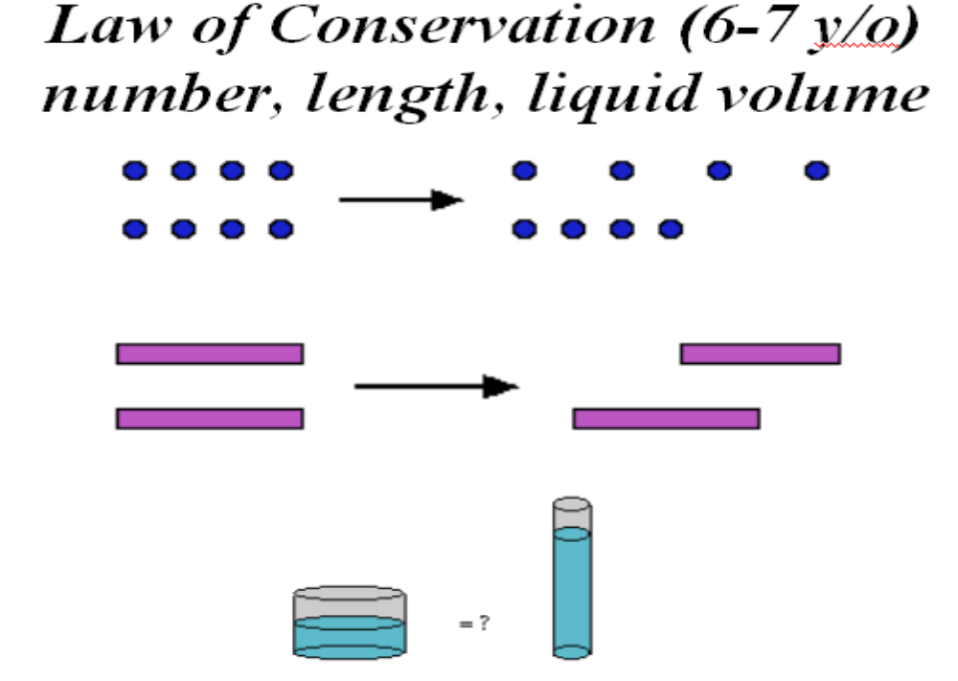
Law of Conservation (7-8, 9-10 y/o)
substance, area
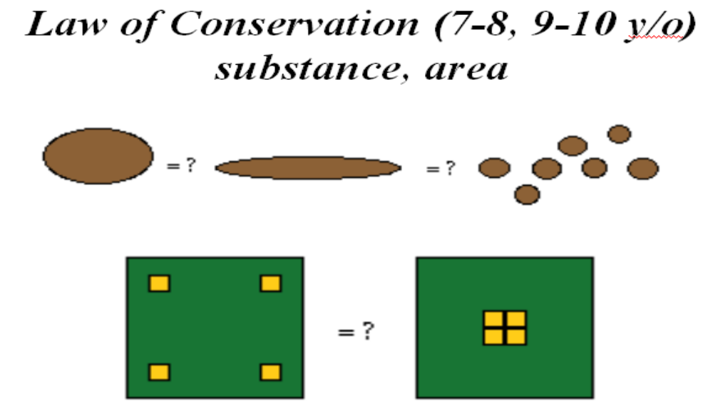

Concrete Operations

CRITICAL ACHIEVEMENT:
- Reversibility – understand the relation between things (ice/ water)
- Seriation – putting things in order (by size, volume…). Child is ready for formal education.
- Mnemonic Strategies (key words, visual links)
- 6-7 y/o – Law of conservation (changing the shape does not change the quantity)

Concrete Operations
- “Right order” (to eat, to dress…)
- Listen to everything you say and point on contradictions.
- Personal sense of right and wrong

Stage 4.
Formal Operations 11- end of adolescence
- Thinking – formal, highly logical, systematic, and symbolic manner
- Can think abstractly, reason deductively and define abstract concepts.
- Hypothetical thinking
- Deals with past, present, and future
- More complex schemas. Larger understanding
EMOTIONAL DEVELOPMENT

Emotional Development
Birth Pleasure, surprise, disgust,
distress
6-8 weeks Joy
3-4 months Anger
8-9 months Sadness, fear
12-18 mon. Tender affection, shame
24 months Pride
3-4 years Guilt, envy
5-6 years Insecurity, humility, confidence
THEORIES OF DEVELOPMENT

Margaret Mahler

- Describes early development as sequential process of separation of the child from mother or primary caregiver…..
Margaret Mahler.
Stages of Separation-Individuation
- Normal Autism: birth – 2 months.
Periods of sleep outweigh periods of arousal
- Symbiosis: 2 – 5 months.
Developing ability to distinguish inner from outer world.
Mother-infant – single fused entity.

Stages of Separation-Individuation
3. Differentiation: 5 – 10 months.
Progressive neurological development, increased alertness draw infant attention away from self to the outer world. Physical and psychological distinctiveness from the mother is gradually appreciated.
4. Practicing; 10 – 18 months.
The ability to move autonomously increases children’s exploration of the outer world.
Stages of Separation-Individuation
5. Rapprochement: 18 – 24 months.
As children slow realize their helplessness and dependence, the need for independence alternates with the need for closeness. Children move away from the mothers and come back for reassurance.
6. Object constancy: 2 – 5 years.
Children gradually comprehend and are reassured by the permanence of mother and other important people, even when not in their presence.
Harry Harlow and study of attachment
Harry Harlow
- Studied social learning and effects of social isolation in monkeys
- The isolates were withdrawn, unable to relate to peers, unable to mate, and incapable of caring for their offspring
- Male were affected more than female by such isolation
- Monkeys isolated for less than 6 months can be rehabilitated by playing with normal young monkeys.
- Due to such findings , ‘Foster Care System’ was established for young children who do not have adequate home situation .Foster families are approved and funded by state to take care of child in their homes.

Sigmund Freud

Sigmund Freud
- Oral stage: birth -18 months. The focus of pleasure is the mouth. Sucking and biting are favorite activities.
- Anal stage: 18 months – 3-4 years old. The focus of pleasure through mastery of anal function. The child also experiences the pressure of social expectations related to learning control of anal functions.
- Phallic stage: 3 – 6years old. The focus of pleasure is the genitalia. Masturbation is common. Child also learns sexual identification and sexual differentiation.childrens are suffering from oedipal complex. Boys have castration anxiety and girls have penis envy.

Sigmund Freud
- Latent stage: 6– 12 years old.
- In this stage, the sexual impulse was suppressed as children's are encourage to identify with cultural role models. They also learn acceptable form of expression for aggressive and sexual drives through competitions and sports..
- Genital stage: 12+
- After having completed all other stages, the individual is now able to redirect his/her urges to genital sexual activity.
ERIK ERIKSON

Erik Erikson
Erik Erikson
- Is a Freudian ego-psychologist. He accepts Freud’s ideas as basically correct. However, Erikson is much more society and culture-oriented than most Freudians

- He believed that human emotional and social development were dependent not on maturation and control of sexual and aggressive impulses but on the evolution of human interaction.
- He divides human emotional and social development into 8 stages.
Erik Erikson
- If stage is managed well, we carry away certain virtue or psychosocial strength which will help us through the rest of the stages of our lives.
- If we don’t do so well, we may develop maladaptations and malignancies.
- Malignancy – is worse of the two, too little of the positive and too much of the negative.
- Maladaptation – to much of the positive and but little of the negative

Stage I: 0-1 y/o. Infant: Trust vs mistrust
- Oral-sensory stage
- The task is to develop trust without completely eliminating the capacity for mistrust.
- In this stage child relies on adults to anticipate and care for all of its needs.
- Through repeated experience of caring, the child develops a basic trust in others .
- If treated right child develops trust in others but if not develop sense of anxiety and or uncertainty about the behavior of others, developing mistrust, depression, paranoia.
- If treated well child develops hope & faith

Stage II: 2 – 3 y/o. Toddler
Autonomy vs shame and doubt
As parents begin to regulate child behavior (toilet training) , does the child develops a sense of joy& pride as he interacts meaningfully with her body and environment for the first time. OR is the nature of parent interaction is such that either child has few accomplishments or is never rewarded for her accomplishments.
If rewarded child develops sense of autonomy but if not develop a sense that his efforts are useless and ineffectual and thus will always require the intervention of others.

- Impulsiveness – shameless willfulness that lead you, in later childhood and even adulthood, to jump into things without proper consideration of your abilities.
- Compulsiveness (too much shame or doubt) – everything must be done perfectly. Take lot of anxiety if things are not done certain manner.
- If the proper balance is achieved, the child will develop the virtue of willpower or determination.
- “I know I can do it”.

Stage III 3/4 - 5/6 y/o. Preschooler.
Initiative vs guilt.
Child who is basically characterized by egocentric thinking and whose development has been yet managed by parents now begins to interact with family and neighborhood.
Goal is to adjust in this expanded environment ,which is not as understanding as parent.
If the child learns to adjust with other people it will increase his confidence and he will form positive relationships. If not will develop sense of guilt , that is he will not be able to adapt properly to society and will invite rejections from others .

- Ruthlessness – too much initiative too little guilt. They do not care who they step on to achieve their goals.
- Inhibition – too much guilt. Afraid to try, to lose, to feel. In future: impotent, frigid.

Stage IV: 7 – 12 y/o. School age.
Industry vs inferiority.
In this stage the child basically competes with his peers in development of intellectual, social , emotional and physical development.
If the child is able to accomplish these task better than peers it will bring him sense of accomplishment and confidence but if he is not able to compete with his peers it will give him the sense of inferiority.

- If child is allowed too little success, he develops a sense of inferiority or incompetence. Racism, sexism… Success is about who you are rather than how hard you try, then why try?
- Narrow virtuosity – too much industry. “Children are not allowed to be children”. Children – musicians, athletes…
- Inertia (more common) – too much inferiority. “If at first don’t succeed don’t ever try again!”
- Psychosocial virtue - competency

Stage V: 12 – 18/20 y/o. Adolescence.
Ego-identity vs role-confusion.
- This stage focuses on development of interpersonal relationships
- Primary relationships are with Peers. These relationships become increasingly sexual and intimate.
- Individual develops sense of self and is productive, goal directed and able to engage in sexual behavior with peers.
- A person who successfully negotiate this phase will actively construct a self identity rather than simply receive passively receive from others.
- A unsuccessful person, will be continually confused about his role and abilities in this new peer focused and sexually activated world.

- Fanaticism – too much ego identity. No room left for tolerance. Their way is the only way. Do not accept other’s rights to disagree.
- Repudiation – lack of identity. “Fuse” with the group: religious cults, militaristic organizations… Destructive activities: drugs, alcohol or withdraw into their own psychotic fantasies.
- Psychosocial virtue – fidelity, loyalty, the ability to live by societies standards despite their imperfections

Stage VI: the 20’s. Young adult.
Intimacy vs isolation.
- The task is to achieve some degree of intimacy with a life partner, as opposed to remaining in isolation.
- Second goal is the choice of a means of livelihood and development of career that will sustain the new couple.
- Intimacy – the ability to be close to others, as a lover, a friend, and as participant in society.
- Those who are not able to achieve these tasks find themselves increasingly isolated from others on both fronts.

Stage VII: late 20’s to 50’s. Middle adult.
Generativity vs Self-absorption.
- The task is to cultivate the proper balance of generativity and stagnation.
Generativity – to produce, to generate, to provide for your family. extension of love into the future. It is a concern for the next generation and all future generations.
- Stagnation – self-absorption, caring for no-one.

- Overextension – so generative that they no longer allow time for themselves, for rest and relaxation.
- Rejectivity – too little generativity and too much stagnation, eventually get isolated.
- “Midlife crisis” – “What am I doing for?” Panic of getting older and not having experienced or accomplished what they imagined they would when they were younger, they try to recapture their youth. Men leave their wives, quit their jobs, buy some “hip” clothes, and start hanging around singles bars.

Stage VIII: late 50’s and beyond.
Integrity vs despair.
- The task is to develop ego integrity with a minimal amount of despair.
- Integrity – the sense of satisfaction that a person feels in reflecting on a life productively lived
- Despair – the sense that life has had little purpose or meaning
- Those who have found contentment devote themselves not to self interest butt to the passing on of the wisdom of their experiences and culture to others before the end of life.

- Sense of usefulness, parenting duties come to close.
- Women – menopause. Men – can no longer “rise to the occasion”. Illnesses of old age. Concerns of death.
- In response to this despair, some older people become preoccupied with the past. “Things were better”.

- Psychosocial virtue – wisdom.
- Erik Erikson: “Healthy children will not fear life if their parents have integrity enough not to fear death”.

1. There are 4 kids on the playground. They all are
about the same age. There are two boys and two
girls. Each of the girls makes a cake, one boy plays
with a car, and the other boy builds a castle. How
old most likely those children are?

- 2-3 years
- 4-5 years
- 6-7 years
- 8-9 years
E. 10-11 years

The answer is A.
Children demonstrate a parallel play.
Cooperative (joint) play starts at 4 years of
age.

2. A mother brings her 5-months-old infant to the
physician for a well-baby checkup. At this time
the physician should expect to see:

- Stranger anxiety
- Playing peek-a-boo
- Speech using meaningful words
- Sitting with support
- Stands with help

The answer is D.
Child can sit with support, it starts at 4 months
of age.

3. Medical student holds the baby and suddenly
moves his hands down. The baby extends arms
with hands open, flexes legs, then returns arm
forward and starts crying. What reflex student
demonstrates?

- Babinski Reflex
- Tonic Neck Reflex
- Perez Reflex
- Galant Reflex
- Moro reflex

The answer is E.
Child demonstrates Moro reflex.

4. A young child plays with his toys, but often
comes to his mother for comfort and reassurance.
This behavior is most common in children of
what age?

- 8 – 11 months
- 12 – 15 months
- 16 – 24 months
- 30 – 36 months
- 36 – 48 months

The answer is C.
Margaret Mahler called the period when the
child moves away but returns to the mother
for comfort and reassurance the
rapprochement phase. This behavior occurs
most commonly in toddlers 16 – 24 months of
age. This is the period when the child begins
to develop physical and emotional distance
from the mother.

5. At which age are children likely to form the
same-sex groups?

A. 2 – 4 years
B. 4 – 6 years
C. 6 – 11 years
D. 11 – 13 years
E. 13 – 16 years

The answer is C.
Latency age children (i.e. those 6 – 11 years of age)
prefer to play with children of the same sex.Younger
children do not have a preference for playing with
same-sex children; adolescents often seek the
company of those of the opposite sex.

6. Which one of the following developmental
theorists described the first month of postnatal
life as the normal autistic phase?

- Mahler
- Freud
- Erikson
- Piaget
- Harlowe

The answer is A.
Mahler described the first month of postnatal life as the
normal autistic phase because the infant has little interaction
with people or with the external environment at this age.
Freud described early infant development as the oral phase
because the major site of gratification is the mouth. Erikson
described the first year of life as the stage of trust versus
mistrust, when the child learns to rely on and trust the
caregiver to provide for needs. Piaget described the period
from birth to 2 years of age as the sensoriomotor stage, when
the child learns to master her environment through
assimilation and accomodation. Harlowe studied the role of
attachment in early infant development in monkeys.

7. A 7-month-old boy who previously smiled at
everyone begins to cry when he sees an individual
he does not recognize. This behavior

- Is normal
- Is more likely to occur in infants who have multiple caregivers
- Occurs primary in anxious infants
- It is an indication that child in not developing normally
- Indicates that the child cannot distinguish between strangers and people that he knows.

The answer is A.
This child demonstrating stranger anxiety (I.e., the infant’s
tendency to cry and cling to the mother when a stranger
approaches). Stranger anxiety is normal in infants between
6 and 12 months of age (max – 8 months). Stranger anxiety
indicates that the infant has a specific attachment to his
mother and is able to distinguish her from stranger. Infants
exposed to multiple caregivers are less likely to show
stranger anxiety than those exposed to only one caregiver.

8. The “Band-Aid” phase occurs most
commonly at what age?

- 6 – 12 months
- 12 – 18 months
- 18 – 24 months
- 24 – 30 months
- 30 – 60 months

The answer is E.
The “Band-Aid” phase occurs most
commonly in preschool children between 2,5
and 6 years of age. At this age, children
become overly concerned about illness and
injury; they want to put a bandage on every
injury.
Thank You!
Have fun raising your kids or helping others!
SCHOOL AGE, ADOLESCENCE AND ADULTHOOD

LATENCY OR SCHOOL AGE (7-11 YRS)

MOTOR, SOCIAL AND COGNITIVE DEVELOPMENT
- MOTOR:
- ENGAGES IN COMPLEX MOTOR TASKS
- PLAYS BALL, SKIPS ROPE ,ETC
- SOCIAL:
- PREFERS TO PLAY WITH CHILDRENS OF SAME SEX
- IDENTIFIES WITH PARENT OF SAME SEX
- HAS RELATIONSHIPS WITH ADULTS OTHER THAN PARENTS
- DEMONSTRATE LITTLE INTEREST IN PSYCHOSEXUAL ISSUES
- HAS INTERNALIZED MORAL SENSE OF RIGHT OR WRONG (CONSCIENCE)
- UNDERSTANDS HOW TO FOLLOW RULES

- COGNITIVE:
- IS INDUSTRIOUS AND ORGANIZED
- HAS A CAPACITY FOR LOGICAL THOUGHTS
- UNDERSTANDS THE CONCEPT OF ‘CONSERVATION’,THAT IS, QUANTITY OF A SUBSTANCE REMAINS SAME REGARDLESS OF THE SIZE OF THE CONTAINER IT IS IN.
ADOLESCENCE:11-20 YRS

EARLY ADOLESCENCE(11-14 )
- PUBERTY OCCURS IN EARLY ADOLESCENCE AND IS MARKED BY:
- DEVELOPMENT OF PRIMARY AND SECONDARY SEXUAL CHARACTERISTICS (FOLLOW TANNER STAGES ON NEXT SLIDE) AND SKELETAL DEVELOPMENT
- MENARCHE IN GIRLS OCCURS B/W 11-12 YRS
- FIRST EJACULATION IN BOYS OCCURS BETWEEN AGE 13-14 YRS
- FORMATION OF PERSONALITY
- SEXYUAL DRIVES ARE EXPRESSED THRUOUGH PHYSICAL ACTIVITY AND MASTURBATION
- SHOW SENSTIVITY TO PEERS OPINIONS
- GENRALLY OBEDIENT AND UNLIKELY TO CHALLENGE PARENTAL AUTHORITY
- ALTERATION IN PHYSICAL DEVELOPMENT CAN LEAD TO PSYCHOSOCIAL PROBLEMS. (ACNE, OBESITY, LATE BREAST DEVELOPMENT)

MIDDLE ADOLESCENCE (14-17)
- GREATER INTREST IN GENDER ROLES,BODY IMAGE AND POPULARITY
- HETEROSEXUAL CRUSHES
- LOVE FOR UNATTAINABLE PERSON SUCH AS ROCK STAR
- HOMOSEXUAL EXPERIANCES
- EFFORTS TO DEVELOP A IDENTITY
- PREFERENCE FOR SPENDING MORE TIME WITH PEERS THAN FAMILY, MAY LEAD TO CONFLICT WITH THE FAMILY
- ADOPT RISK TAKING BEHAVIORS
- CHALLENGE PARENTAL RULES
- FEELINGS OF OMNIPOTENCE
- EDUCATION IN RESPECT TO SHORT TERM BENEFITS RATHER THAN LONG TERM EFFECTS IS MORE LIKELY TO DECREASE UNWANTED BEHAVIOR.
LATE ADOLESCENCE (17-20)
- DEVELOP MORAL , ETHICS AND SELF CONTROL
- REALISTIC APPRAISAL FOR THEIR ABILITIES
- BECOME CONCERNED WITH HUMANITARIAN ISSUES AND WORLD PROBLEMS
- SOME DEVELOP ABILITY TO ABSTRACT REASONING
- IF ONE IS UNABLE TO DEVELOP ONE’S OWN IDENTITY ,IDENTITY CRISES DEVELOPS
- CAN LEAD TO ROLE CONFUSION AND IN WHICH THEY DON’T KNOW WHERE THEY BELONG
- WITH ROLE CONFUSION, MAY DISPLAY ABNORMALITIES LIKE CRIMINALTY AND INTREST IN CULTS
TEENAGE AND SEXUALITY
- IN US, FIRST SEXUAL INTERCOURCE OCCURS AT THE AGE OF 16 YRS
- BY 19 YRS 80% OF MEN AND 70% OF WOMEN HAVE HAD SEXUAL INTERCOURCE
- 65% OF TEENAGE DO NOT USE CONTRACEPTIVE FOR RESONS SUCH AS
- CONVICTION THAT THEY WOULD NOT GET PREGNANT
- LACK OF ACCESS TO CONTRACEPTIVE
- LACK OF EDUCATION ABOUT WHICH METHOUD IS MOST EFFECTIVE
- PHYSICIANS CAN COUNSEL AND PROVIDE MINORS WITH CONTRACEPTIVES WITHOUT PARENTAL CONSENT
TEENAGE PREGNANCY
- 500,000 INFANTS ARE BORN EVERY YEAR TO TEENAGE MOTHERS
- HAVE ABOUT 400,000 ABORTIONS ANNUALLY
- OVERALL TEENAGE PREGNANCY AND ABORTION RATE IN DECREASING IN TEENAGES
- ABORTION IS LEGAL IN US, BUT IN HALF OF THE STATES MINOR NEEDS A PARENTAL CONSENT TO HAVE ONE
- FACTOR PREDISPOSING TO TEENAGE PREGNANCY INCLUDE:
- DEPRESSION
- POOR SCHOOL ACHIEVEMENT
- HAVING DIVORCED PARENTS
- HAVE HIGHER RISK OF OBSTETRIC COMPLICATIONS AND LESS LIKELY TO GET PRENATAL CARE
SPECIAL ISSUES IN CHILD DEVELOPMENT
ILLNESS AND DEATH IN CHILDHOOD AND ADOLESCENCE:

1-DURING TODDLER YEARS( 18 MO-2.5 YRS):

HOSPITALIZED CHILFDREN FEAR SEPERATION FROM PARENTS MORE THAN FRAR OF BODILY HARM, PAIN, OR DEATH.
2- DURING PRESCHOOL YEARS( 2.5-6YRS)
CHILDS GREATEST FEAR WHEN HOSPITALIZED IS OF BODILY HARM.THEY DONOT UNDERSTAND FULL MEANING OF DEATH .THAEY EXPECT DEAD FRIEND, PET OR RELATIVE WILL COME BACK TO LIFE.
3-SCHOOL AGE CHILDRENS(7-11 YRS):
COPE RELATIVELY WELL WITH HOSPITALIZATION.BEST AGE TO PERFORM ELECTIVE SURGERY. BY THIS AGE ,CHILDREN UNDERSTAND FINALITY OF DEATH.

SPECIAL ISSUES IN CHILD DEVELOPMENT
ADOPTION
1-ADOPTIVE CHILDREN ESPECIALLY THOSE ADOPTED AFTER INFANCY, MAY BE AT INCREASED RISK OF BEHAVIORAL PROBLEMS IN CHILDHOOD AND ADOLESCENCE.
2-CHILDRENS SHOULD TOLD BY THEIR PARENTS AT THE EARLIEST AGE THAT THEY ARE ADOPTED TO AVOID A CHANCE OF OTHERWS TELLING THEM FIRST

SPECIAL ISSUES IN CHILD DEVELOPMENT

CHILD ABUSE

1-MORE THAN 6000 CHILDRENS ARE KILLED BY PARENTS OR CARETAKERS EACH YEAR IN US
MORE THAN 3 MILLION ARE ANNUALLY REPORTED ABUSE, 50% OF THESE ARE CONFIRMED BY INVESTIGATIONS
LIKELY THAT MANY CASES ARE UNREPORTED
2-DEFINING ABUSE:
TISSUE DAMAGE
NEGLECT
SEXUAL EXPLOITATION
MENTAL CRUELTY
3-IS A MANDATORY REPORTABLE OFFENSE UP TO AGE 18;
FAILURE TO DO SO IS A CRIMINAL OFFENSE
IF THE CASE IS REPORTED IN ERROR , PHYSICIAN IS PROTECTED BY LEGAL LIABILITY
YOU HAVE DUTY TO PROTECT CHILD,SO SEPARATE FROM PARENT

4-CLINICAL SIGNS:
BROKEN BONES
SEXUAL TRANSMITTED DISEASES IN A YOUNG CHILD
92% INJURIES ARE OF THE SOFT TISSUE
5%HAVE NO PHYSICAL SIGNS
NON ACCIDENTAL BURNS HAVE VERY POOR PROGNOSIS
ASSOCIATED WITH DEATH OR FOSTER HOME PLACEMENT
IF BURN ON ARM & HAND, CAN BE ACCIDENT
IF BURN IS ON ARMS NOT HAND, LIKELY TO BE ABUSE
SHAKEN BABY SYNDROME:LOOK FOR BROKEN BLOOD VESSELS IN THE EYES (SUBCONJUCTIVAL BLEEDS)

:

CUPPING
- A CUP OF IGNITED ALCOHOL IS PLACED OVER AN AFFECTED PART OF THE BODY
- AS THE HEATED AREA COOLS, THE SKIN IS SUCKED UP INTO THE CUP, PRODUCING REDNESS AND BURNS

- CHILDRENS AT RISK OF ABUSE
- YOUNGER THAN1 YEAR OLD
- STEPCHILDEN
- PREMATURE CHILDREN
- VERY ACITVE (ADHD)
- DEFECTIVE CHILDRENS (MENTAL RETARDED)
- PARENTS LIKELY THEMSELVES TO HAVE BEEN ABUSED AND /OR PERCIEVE CHILD AS UNGRATEFUL OR CAUSE OF THEIR PROBLEMS
- DONOT MISTAKE BENIGN CULTURAL PRACTICES AS CHILD ABUSE. KEY IS WHETHER PRACTICE CAUSES ENDURING PAIN OR LONG TERM DAMAGE TO CHILD.(SUCH AS FEMALE CIRCUMCISION)
- CHILDRENS WHO ARE ABUSED ARE MORE LIKELY TO:
- BE AGGRESSIVE IN THE CLASSROOM
- PERCIEVE OTHERS AS HOSTILE
- VIEW AGRESSION AS A GOOD WAY TO SOLVE PROBLEMS
- HAVE AENORMALLY HIGH RATE OF WITHDRAWLS
- USUALLY ARE UNPOPULAR WITH PEERS AND IF HAVE ANY FRIENDS ,THEY ARE USUALLY YOUNGER THAN THEM.

CHILD SEXUAL ABUSE
- 150,000-200,000 CASES ARE REPOTED EACH YEAR
- 50% OF SEXUALLY ABUSES CASES ARE WITHIN THE FAMILY
- 60% OF THE VICTUMS ARE FEMALE
- MOST VICTIMS ARE AGED 9-12 YERS
- 25% 0F VICTIMS ARE YOUNGER THAN 8 YEARS
- MOST LIKELY SOURCE:UNCLES AND OLDER SIBLINGS,ALSO STEPFATHERS
- IN GENERAL, MALES ARE MORE LIKELY SOURCE
- RISK FACTORS:
- SINGLE PARENT FAMILY
- MARITAL CONFLICT
- HISTORY OF PHYSICAL ABUSE
- SOCIAL ISOLATION
- MORE THAN 25% OF ADULT WOMEN REPORT HAVING SEXUALLY ABUSED AS A CHILD.(DEFINED AS SEX EXPERIENCE BEFORE AGE 18 WITH THE PERSON 5 YEAR OLDER).50% TOLD A FAMILY MEMBER AND 50% TOLD NO ONE.

- SEXUALLY ABUSED WOMEN ARE MORE LIKELY TO:
- HAVE MORE SEXUAL PATNERS
- HAVE THREE OR FOUR TIMES MORE LEARNING DISABILITIES
- HAVE TWO TIMES MORE PELVIC PAIN AND INFLAMMATION
- BE OVERWIEGHT
ADULTHOOD

EARLY ADULTHOOD (20-30YRS)
- ADULTS ROLE IN SOCIETY IS DEFINED
- PHYSICAL DEVEOLPMENT PEAKS
- ADULTS BECOME INDEPENDENT
- FORM AN INTIMATE RELATIONSHIP WITH ANOTHER PERSON
- BY AGE 30, MOST AMERICANS ARE MARRIED AND HAVE CHILDRENS
- DURING THE MIDDLE THIRTIES , MANY WOMEN RETURN TO WORK OR SCHOOL OR BY RESUMING THEIR CAREERS.ACCORDING TO ERIKSON, INTIMACY VS ISOLATION,INDIVIDUALS THAT ARE UNABLE TO SUSTAIN A INTIMATE RELATIONSHIP BY THIS STAGE OF LIFE WILL SUFFER EMOTIONAL ISOLATION IN THE FUTURE

MIDDLE ADULTHOOD(30-46 YR)
- HAVE MORE POWER AND AUTHORITY THAN AT ANY OTHER STAGE OF LIFE
- ACCORDING TO ERIKSON PERSON EITHER MAINTAINS A CONTINUED SENSE OF PRODUCTIVITY OR DEVELOPS A SENSE OF EMPTINESS (GENERATIVITY VERSUS STAGNATION)
- 70-80% OF MEN IN THEIR LATE FORTIES OR EARLY FIFTIES EXHIBIT A MIDLIFE CRISES. THIS MAY LEAD TO:
- A CHANGE IN PROFESSION OR LIFESTYLE
- INFIDELITY , SEPERATION OR DIVORCE
- INCREASED USE OF ALCOHOL OR DRUGS
- DEPRESSION
- MIDLIFE CRISES IS ASSOCIATED WITH AN AWARENESS OF ONES OWN AGING & DEATH AND SEVERE AND UNEXPECTED LIFESTYLE CHANGE( DEATH OF A SPOUSE, LOSS OF A JOB, SERIOUS ILLNESS)
LATE ADULTHOOD (46-60)
- SEXUAL ACTIVITY CONTINUES TO DECLINE
- CLIMACTERIUM: IS THE PHYSIOLOGICAL CHANGE THAT OCCURS DURING MIDLIFE

- IN MEN, HORMONE LEVEL DO NOT CHANGE SIGNIFICANTLY, A DECREASE IN MUSCLE STRENGHT, ENDURANCE AND SEXUAL PERFORMANCE OCCURS IN MIDLIFE
- IN WOMEN,MENOPAUSE OCCURS (51.1YRS)
- OVARIES STOP FUNCTIONING AND MENTURATION STOPS IN LATE FORTIES OR EARLY FIFTIES
- ABSENCE OF MENTURATION FOR ONE YEAR IS DEFINED AS MENOPAUSE.TO AVOID UNWANTED PREGNANCY, CONTECEPTIVE MEASURE SHOULD BE USED UNTILL ONE YEAR FOLLOWINF THE LAST MISSED MENTURAL PERIOD.
- MOST WOMEN FEEL MENOPAUSE WITH RELATIVELY FEW PHYSICAL OR PSYCHOLOGICAL PROBLEMS.
- ESTROGEN REPLACEMENT THERAPY.
OLD AGE (60 AND OVER)
- DEATH AND SICKNESS IS THE MAIN CONCERN.
- ACCORDING TO ERIKSON THIS IS A AGE OF INTEGRITY VERSUS DISPAIR.EITHER INDIVIDUAL FINF SATISFACTION FROM WHAT THEY HAVE ACCOMPLISHED AND LIKE TO SHARE THEIR WISDOM WITH OTHERS OR ARE BITTER AND RESENTFULL FROMLACK OF ACHIEVEMENTS.
- FREQUENCY OF SEXUAL ACTIVITY IN THIS AGE IS RELATED TO HEALTH CONCERN AND NOT TO LOSS OF LIBIDO.

SEXUALITY.
• Psychiatrists are bound to like some
patients more than others, but if a
physician feels a strong attraction to a
patient and is tempted to act on the
attraction, stepping back and
dispassionately assessing the situation
is essential.

Beginning the Interview
• How a physician begins an interview
provides a powerful first impression to
patients, and the manner in which a
doctor opens communication with a
patient has potentially powerful effects
on the way the remainder of the
interview proceeds.
• All physicians should initially make sure
that they know the patients' names and
that patients know physicians' names.

How to Begin
• Most patients do not speak freely unless
they have privacy and are sure that
their conversations cannot be
overheard.
• A patient may appear frightened or
resistant at the beginning of an
interview and may not want to answer
questions.
• Another important initial question is,
"Why now?"

Specific Techniques.
• OPEN-ENDED VERSUS CLOSED-ENDED QUESTIONS
• REFLECTION
• FACILITATION.
• SILENCE.
• CONFRONTATION
• CLARIFICATION
• INTERPRETATION.
• SUMMATION
• EXPLANATION
• TRANSITION
• SELF-REVELATION.
• POSITIVE REINFORCEMENT.
• REASSURANCE
• ADVICE.

REFLECTION
• a doctor repeats to a patient in a
supportive manner something that the
patient has said.
• i.e., if a patient is speaking about fears
of dying and the effects of talking about
these fears with his or her family, the
doctor may say, "It seems that you are
concerned with becoming a burden to
your family.

FACILITATION
• Doctors help patients continue in the
interview by providing both verbal and
nonverbal cues that encourage patients
to keep talking.
• Nodding the head, leaning forward in
the chair, and saying, "Yes, and then
?" or "Uh-huh, go on," are all examples
of facilitation.

SILENCE
• Silence can be used in many ways in normal
conversations, even to indicate disapproval or
disinterest.
• In the doctor–patient relationship, however,
silence may be constructive and in certain
situations may allow patients to contemplate,
to cry, or just to sit in an accepting,
supportive environment where the doctor
makes it clear that not every moment must
be filled with talk.

CONFRONTATION
• To point out to a patient something that
the doctor thinks the patient is not
paying attention to, is missing, or is in
some way denying.
• Confrontation must be done skillfully, so
that patients are not forced to become
hostile and defensive.

CLARIFICATION.
• In clarification, doctors attempt to get
details from patients about what they
have already said. For example, a
doctor may say: "You are feeling
depressed. When is it that you feel
most depressed?"

INTERPRETATION.
• Most often used when a doctor states
something about a patient's behavior or
thinking that a patient may not be
aware of.
• The technique follows on the doctor's
careful listening to the underlying
themes and patterns in the patient's
story. Interpretations usually help
clarify interrelationships that the patient
may not see.

SUMMATION
• Periodically during the interview, a doctor can
take a moment and briefly summarize what a
patient has said thus far.
• Doing so assures both patient and doctor that
the doctor has heard the same information as
the patient has actually conveyed.
• For example, the doctor may say, "OK, I just
want to make sure that I've got everything
right up to this point."

EXPLANATION.
• Doctors explain treatment plans to patients in easily
understandable language and allow patients to
respond and ask questions.
• For example, a doctor may say: "It is essential that
you come into the hospital now because of the
seriousness of your condition. You will be admitted
tonight through the emergency room, and I will be
there to make all the arrangements. You will be given
a small dose of medication that will make you sleepy.
The medication is called triazolam (Halcion), and the
dose you will be getting is 0.125 mg. I will see you
again first thing in the morning, and we'll go over all
the procedures that will be required before anything
else happens. Now, what are your questions? I know
you must have some."

TRANSITION.
• The technique of transition allows doctors to
convey the idea that enough information has
been obtained on one subject; the doctor's
words encourage patients to continue on to
another subject.
• For example, a doctor may say: "You've
given me a good sense of that particular time
in your life. It would be good now if you told
me a bit more about an even earlier time in
your life."

REASSURANCE.
• can lead to increased trust and
compliance and can be experienced as
an empathic response of a concerned
physician.
• False reassurance, however, is
essentially lying to a patient and can
badly impair the patient's trust and
compliance.

ADVICE.
• In many situations it is not only acceptable
but desirable for physicians to give patients
advice.
• To be effective and to be perceived as
empathic rather than as inappropriate or
intrusive, the advice should be given only
after patients are allowed to talk freely about
their problems, so that physicians have an
adequate information base from which to
make suggestions.

Ending the Interview
• Physicians want patients to leave an
interview feeling understood and
respected and believing that all the
pertinent and important information has
been conveyed to an informed,
empathic listener.
• To this end, doctors should give
patients a chance to ask questions and
should let patients know as much as
possible about future plans.

COMPLIANCE
• Compliance, also known as adherence,
is the degree to which a patient carries
out the clinical recommendations of a
treating physician.
• Examples of compliance include keeping
appointments, entering into and
completing a treatment program, taking
medications correctly, and following
recommended changes in behavior or
diet.

Difficult Patients
• Depressed Patients.
• Histrionic Patients.
• Dependent Patients.
• Impulsive Patients
• Narcissistic Patients
• Obsessive Patients.
• Paranoid Patients.
• Isolated Patients
• Demanding and Passive-Aggressive Patients.
• Malingering Patients.

BURNOUT
• Trained physicians not only have
learned the knowledge base and
techniques of the profession but also
must confront, resolve, and incorporate
many significant attitudinal issues
involved in becoming skilled and
effective in their fields
• A lack of balance can lead physicians to
feel overwhelmed, depressed, and
burned out.
• Many physicians are at risk for this lack
of balance because of particular
personality and coping styles prevalent
among those drawn to the practice of
medicine.
• For instance, many medical students
are perfectionistic, controlling, and
obsessive.
• These traits can be adaptive for
physicians when balanced with healthy
doses of self-knowledge, humility,
humor, and kindness.
AGE, DEATH AND
BEREAVEMENT
• The aged are the fastest-growing group in the population
• Treatment of geriatric patients requires thorough understanding of their unique attributes and special needs:
– Differences in medication administration and dosing
– Greater awareness of Bio-Psycho-Social aspects of late life
• By the year 2030 there will be 65 million people over the age of 65, roughly 20% of the population
• Currently, 25% of people over 65 years of age have some form of mental illness
- In the year 2030, that percentage will equate to 16 million individuals with mental illness

Why 65???
• Based on standard set forth by government
• The federal government defines persons over 65 years of age as “senior citizens”
– Age 65 = eligible to collect Social Security and Medicare
• Thus, common age for retirement

Normal Aging
• Average life expectancy in US is 76 years:
– Women: 78 years
– Men: 72 years
• Longest life expectancy is for Chinese-American females
• Shortest life expectancy is for African-American men

Erickson’s Theory of Development Throughout the
Lifecycle
• Late adulthood: ages 65 to death
• Satisfaction and pride in past accomplishments vs. feelings of a wasted
life
– Has life has had meaning (lived well), or was it a series of missed opportunities and
disappointments

Integrity vs. Despair
• Positive Outcome: If the adult views life with sense of fulfillment and unity with others, he will accept death, not fear it
• Negative outcome: If there is despair, death is something that is feared, it is viewed as failure and emptiness

Dimensions of the aging process
• Biological
• Psychological
• Social

Biological Dimension
Biological Dimension
• Hormonal Changes: Decreased growth
hormone leads to:
– Increased body fat, decreased muscle
mass/strength
–Weight loss
– Thinner skin
– Decreased renal blood flow
– Decreased bone density: osteoporosis

Biology of Age and Sex
• Hormones and Sexuality
– Decreased Estrogen causes Menopausal
symptoms: hot flashes, decreased libido
– Decreased Testosterone usually causes
decreased libido…
• BUT NOT ALWAYS…

Biological Changes with Age
• Skin/Hair Changes
– Wrinkling, thinner skin
– Pallor from decreased skin vascularity and
melanocytes
– Gray hair

Biological Dimension cont.
• Blood pressure
– Systolic blood pressure increases with age
due to decreased vessel compliance
– Postprandial hypotension can occur following
high carbohydrate meals (due to excessive
release of vasodilatory hormones)
• Nutrition
– Decreased appetite due to decreased resting
metabolic rate and decreased physical
activity, and sometimes decreased sense of
smell

Biological Dimension cont.
• Neurological changes
– Decreased cerebral blood flow
– Decreased brain weight

Biological: Metabolic Changes
• Hepatic function is decreased due to:
– Reduced blood flow and cardiac output
• Enzyme activity is reduced
• Absorption is decreased
• Renal excretion is delayed due to
– Changes in glomerular filtration rate and blood flow

Metabolic Changes with Age
• Protein-binding and albumin levels are
diminished
• Volume of distribution is increased due to:
– Reductions in muscle mass, total body water
and cardiac output
• Total body fat increases relative to total
body weight:
– Lipophilic drugs will be diluted (most
psychotropic medications are highly lipophilic)
• Decrease hearing
• Decrease vision
• Immune system
• Reduced bladder control.
• Cardiac disorder
• DM
• Alzheimer’s
• Malignancy

PSYCHOLOGICAL
DIMENSION
Cognitive Aging
• Verbal task performance (defining words,
reading comprehension) remains stable
• Nonverbal task performance (rapid
response to novel situation) declines with
age

Cognitive Aging
• Learning and Memory
– Normal maintenance of small amounts of
information for short-term memory
– Decline in working memory
• Reasoning and Cognitive Flexibility
– Decline with age on abstract reasoning skills

Personality, Mood, and Morale
• Personality remains fairly constant with
age (introversion-extroversion,
aggressiveness, hostility)
• Majority of older persons view their lives
as enjoyable and productive
• 25% of elderly have mental illness
• Morale is maintained through intimate
social companions

SOCIAL DIMENSION
Social Dimension: Longevity
• Longevity most closely associated with:
– Continued physical and occupational activity
– Advanced education
– Presence of SOCIAL SUPPORT
Social Dimension:
Independence
• Most elderly live independently
– Only a quarter of elderly individuals are cared
for by younger family members
– Only 5% of the elderly spend their last years
in a nursing home
– Assisted living facilities allow for further
independence
Social Dimension: Losses
• Losses are Prominent
– Loss of social status, occupational status
– Loss of spouses, family members, friends
– Loss of functioning
• Coping with these losses, and
appropriately grieving them are an
important part of successfully navigating
the geriatric period

Complicated/Pathological Grief
• Often evolves into Major Depression
• Onset may be delayed
• Symptoms often excessive or intense
• May be associated with active suicidal
thoughts or psychotic symptoms
• May be complicated by Alcohol use

Abnormal/Pathologic Grief
• People at risk for pathologic grief include
– Those who suffered a sudden or horrific loss
– Socially isolated
– Those with a history of traumatic losses
– Those with an ambivalent relationship to the
deceased
Grief Therapy
• Most who are grieving do not need or seek
therapy
• Grief therapy involves working thru the
stages of grief and serves to normalize
the grieving process
Grief Therapy
• Therapy is more complicated if the
deceased and the bereaved had an
ambivalent relationship
• Patients are encouraged to talk about their
angry or ambivalent feelings about the
deceased
Grief Therapy
• Goal is not to “have things back the way
they were”, but to work thru loss and move
on
• Stress that the grieving process is not
easy
Grief Therapy
• Often well-intended friends, family, even
physicians try to “distract” person from
grieving. This may be counterproductive
– Delaying onset of grieving process may mean
loss of support system that naturally evolves
after loss. Society often intimates that person
should be “done grieving” after certain amount
of time. Then, support network from
friends/family disappears
Grief Therapy
• Mild sedatives for sleep may be useful, but
long term use should be avoided
• In order for patients to work through the
grief stages, use of medications (such as
benzodiazepines) as quick fixes or to
“numb” symptoms may interfere with and
delay the grieving process
• Suicide

